
Network Youth
Church Leader:
Appleby Deanery, Cumbria

RECRUITMENT INFORMATION
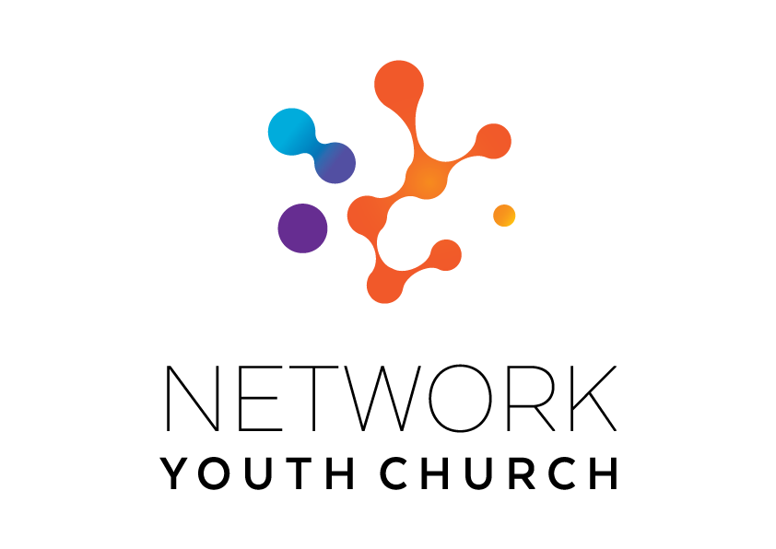

In this pack you will find:
Introduction to NYC
About Growing Younger in the Diocese of Carlisle
About the role
Information on the local area
Job Description and Person Specification
Key links for more information
Introduction to Network Youth Church
We are seeking to appoint new leaders for Network Youth Church. Network Youth Church is a new way of doing and being church with young people across Cumbria. As Cumbria operates as an ecumenical county NYC also operates ecumenically where possible and relates to the ecumenical mission communities in the deanery where it sits. We create spaces which are safe and welcoming, but don’t shy away from the big questions of life, working to encourage confidence, participation, understanding and growth. It is a part of the county-wide God for All and Growing Younger strategies, which recognise that we need to develop different and new ways of being church, alongside those that already exist. This means that our work is informed by the strengths of the local church, but everything we do is governed by what works best for our young people, and that may mean doing things differently.

We began in response to low numbers of young people engaging with church in Cumbria thirteen years ago and have since grown into one of the most creative faith-based youth projects in the UK. We take a pioneering and inclusive youth work approach to support the personal, social and spiritual development of young people across the county. NYC is inclusive and welcoming to all young people.
NYC runs everything from drop-in youth clubs to question spaces, cafe spaces to prayer spaces, schools work to street-based youth work, outdoor activities, days out residentials and summer camps. There are activities happening in halls, churches, cafés and classrooms. There are large scale events which happen once a year, gathering all the young people from across NYC Cumbria, and there are smaller, more local events where young people from different areas can meet. We also provide opportunities for young people to go on different events: both locally and nationally.

When the NYC is at full strength there are 11 NYC Leaders, each responsible for the development of ministry across a deanery. We employ different approaches in different areas depending on the context and geography and each NYC has a local Ministry Council to help set strategy, develop local connections and support the local NYC Leader.

NYC Leaders are employed by the diocese and local work expenses are covered by the deanery. A local line manger helps oversee the work in partnership with the Growing Younger Enabler for Youth who oversees the whole of NYC.

About Growing Younger and the Diocese of Carlisle

This is a significant, hope-filled but challenging time for the Church of England in Cumbria.

Alongside our ecumenical partners we have recently renewed our vision and strategy, God for All, as we look to the next decade.

The vision centres around four key values which frame our priorities:

1. Follow Daily:
We will help each other to follow Jesus more closely, seeking to grow as his disciples in all aspects of life, both corporately and as individuals
2. Care Deeply:
We will listen to our local communities and respond in loving service, seeking to transform injustice, challenge oppression and pursue peace & reconciliation.
3. Speak Boldly:
We will share our faith in Jesus Christ in everyday ways, seeking to connect with everyone, especially those currently unrepresented in our churches. We’ll do this in both time-honoured & pioneering ways.
4. Tread Gently:
We will strive to safeguard the integrity of God’s creation, seeking to sustain and renew the life of the earth.

These are the building blocks that help us define our core purpose as Church and our main tasks.

The Diocese of Carlisle covers (more or less) the County of Cumbria and is part of an ecumenical covenanted partnership with three other denominations - the United Reformed Church, the Methodist Church and The Salvation Army. The county is divided into 34 Mission Communities: local ecumenical groupings of parishes and other churches. Mission Communities bring together churches in a geographical location to share ministry and work together in mission and outreach.

One of our strategic areas is Growing Younger. As in so many places, our congregations are generally getting older and smaller. In the ten years from 2010 to 2019, numbers worshipping on Sunday in the diocese fell by 27% from 13,100 to 9,500. This decline has happened across all sizes of churches. Church attendance and membership in our less affluent, urban areas is particularly low.

Over the last 13 years the diocese has invested in Network Youth Church (NYC) as a response to the challenges we are facing. NYC is a way of doing and being church that helps young people discover life in all its fullness, explore the Christian faith, and develop the skills they need to live, learn, work, and interact successfully with others. Last year, almost 2000 young people interacted with NYC, with around 800 engaging regularly in Christian discipleship.

We also have a strategic objective of growing younger in our leadership. Currently just under half of our clergy could potentially retire in the next 10 years, and only 9.4% of our ordained leaders are aged under 40. In 2022, the diocese relaunched its Intern Scheme, the Northern Young Leaders Project. This scheme is part of the Ministry Experience Scheme for the Church of England. We also partner with the Norwegian Mission Society to accept interns from across the globe. Working in placement churches, this year long scheme offers opportunities for young people to grow in leadership and explore their calling to ministry. This year, we have re-launched our Young Leaders training programme, the Youth Labyrinth. We are currently recruiting for the 2027 intake for both of these exciting projects.

About the Appleby Area

Appleby Deanery is experiencing a vibrant phase of ministry and community engagement, with efforts focused on nurturing growth within our local churches, youth groups, schools and clubs in three Church of England Benefice areas, centred on Kirkby Stephen (Upper Eden), Appleby (Heart of Eden) and the villages around Shap (North Westmorland). There is also an increasing number of Network Youth Church 'cell groups' that are actively engaging with young people, alongside initiatives aimed at supporting children in local schools.

Geographically, Appleby Deanery boasts stunning landscapes, ranging from the rolling hills of the Pennines to the picturesque Eden Valley. This predominantly rural area consists of charming villages and towns such as Appleby, Kirkby Stephen, Brough, Tebay, Shap and the Morland areas, all known for their rich history and community spirit.
As we move further into 2026, there are plans to enhance collaboration within and between these communities, ensuring a unified approach to our mission work, working with our ecumenical colleagues across this area.

The diversity, sparsity and size of the Appleby Deanery presents both challenges and opportunities. From agriculture to artisan crafts, and from local markets to vibrant community events, the area is a tapestry of activities and interests that brings people together.

Family life is central to our community, particularly the well-being of our young people. This mirrors the broader ethos of the Diocese of Carlisle, where we value the importance of families staying connected and building their futures within their home communities.

Appleby Deanery is wholeheartedly devoted to supporting the diocesan initiatives, such as 'Growing Younger,' and is focused on empowering our Network Youth Church to flourish and make a lasting impact. In addition to supportive ordained ministers and congregations, the NYC leader will have specialist ministerial colleagues with whom to collaborate. There is already a Growing Younger Minister (with an NYC background) in the North Westmorland Benefice, and a Methodist Youth and Children’s Worker who covers the whole Deanery.

NYC Activity in Appleby Deanery
We are looking for someone special to continue the great work that has begun in Appleby NYC. We are not looking for a traditional church-based youth worker, but rather an experienced Christian leader, with a passion for discipling young people and the leadership skills needed to nurture and equip our committed team of volunteers for their vital roles in Appleby Network Youth Church.

These are some of the current projects that we would like to see developed and flourishing:

Lunchtime and After School Clubs
Network Youth Church runs a number of lunchtime and after school clubs in the area. Including Let’s Talk, an active listening space at Kirkby Stephen Grammar School. A weekly youth group at Kirkby Thore, A mental health focused lunch club at Appleby Grammer School, where it is ok not to be ok, and
Kirkby Stephen Youth Club. These groups are open access and young people are invited to come along for food, games, prayer and faith-based teaching.

Young Leaders
We run the Diocesan Young Leaders Labyrinth, a leadership training course for young people. This year, two young leaders successfully completed this training and were awarded their certificates by the Bishop of Carlisle. Five young people are interested in joining the next cohort in September.

Transition to Secondary School Support
Our NYC Leader works with our primary schools across the deanery to offer support to young people in Year 6 during the summer term as they prepare to move to secondary school.

County-wide Faith Building Opportunities
Appleby Deanery is one of eleven NYCs throughout Carlisle Diocese. Together, they collaborate on county-wide projects throughout the year. Young people from Appleby Deanery enjoy going to Dreaming the Impossible (DTI), a Christian Summer Camp hosted by Vineyard. They also attend the bi-monthly Sedbergh Youth Service and The Big One.

Where next for Appleby Network Youth Church?

It is an exciting time to take the reins at Appleby Network Youth Church. Future challenges might include:

- Building on the current activities, links to institutions and relationships with our young people.
- Working in partnership with the other Church of England and Methodist ministers involved in Children and Families, Youth and Schools ministry across the three Benefices of the Deanery, to resource and support their work, recruit and develop volunteers and innovate new worshipping communities.
- Working within the Diocesan Growing Younger strategy and ensuring effective transition from the NYC age range to 18-25 groups.
- Further building a leadership capability in our senior younger people so they become a significant part of the future direction of NYC.
- Developing the volunteer team so the new worker can expand activities or grow new initiatives.
- Building a larger pipeline of donations and other income streams.
- Developing our social media presence in collaboration with the Diocesan strategy for social media outreach and the social media strategy of the three Benefices of the Deanery.
- Building closer ties with local congregations so that the work of the NYC is integrated into the life of the church in this area.

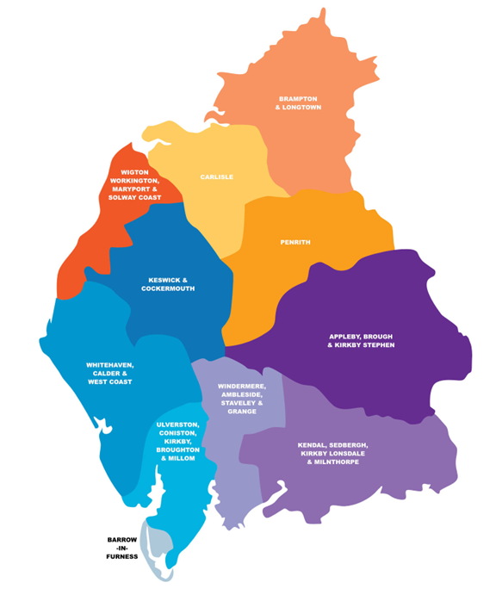
Appleby Deanery

Job Description
JOB TITLE: Appleby Network Youth Church Leader
REPORTS TO: Local Line Manager and Growing Younger Enabler for Youth
DEPARTMENT: Appleby Deanery (this includes communities of: Appleby, Kirkby Stephen, Brough, Shap, Morland and the surrounding rural areas).
PURPOSE OF ROLE:

- To grow, develop and lead a Network Youth Church in the local deanery, for young people aged 11-18.

- To create opportunities for young people to explore and experience the Christian faith whilst growing and developing personally, socially, spiritually and emotionally.

- To develop a strategy for outreach work with ecumenical partners and schools, in line with the Growing Younger strategy and wider God for All strategy.

- To establish new and exciting, relevant forms of church that are brave and creative whilst being sensitive to time honoured church and in-line with the wider God for All strategy.

KEY ACCOUNTABILITIES:
- To develop the growth of youth church across the deanery, using the NYC / New Worshipping Communities model as appropriate with particular attention to the key areas where secondary schools are located.
- To develop a strategy for engagement with young people outside of church contexts which will include a bespoke approach across the area.

- To provide and develop an environment/context in which young people can explore Christianity and be nurtured in the Christian faith.

- Work with churches and existing youth work projects across the deanery, to equip, resource and model, high quality Christian youth ministry as God leads.
- To provide pastoral and safeguarding oversight of the young people including use of social media.
- To pray for the young people of Cumbria, particularly those in the local deanery.

- To develop the talents and spiritual gifts of young people and volunteers, supporting them to grow their leadership skills and service among the NYC as we partner with churches and charities to train and grow NYC and young, Christian leaders.

- To identify, develop and equip volunteers for leadership roles within the Network Youth Church and to enable young people to participate in the Youth Labyrinth.
- To be an advocate and educator about youth culture, youth church and youth mission with local clergy, church members, church leaders and the wider community.
- To meet at regular intervals (once a term) with the local NYC Ministry Council and the wider NYC team.
- To work collaboratively with NYC Leaders, clergy, ecumenical partners, and others involved in youth ministry across the deanery.
- To work with the Ministry Council in the development and delivery of the growing younger strategy, including supporting young people’s faith development across the key transition points. E.g. between Year 6/7 and post 18.

- To develop age compliant and appropriate social media profiles with effective safeguarding at the centre.

- Facilitate opportunities for young people to participate in both local and national events and residentials (e.g. The Big One and Dreaming the Impossible).

- To promote the work of the Network Youth Church to Christians in the Deanery, reporting on its work to each Deanery Synod.

- To be part of the Deanery Chapter/s as a church leader in the Deanery, and to attend other ecumenical meetings if appropriate.

NETWORK (Key people with whom the role liaises)
INTERNAL: Children and Families Workers and other Lay Leaders, local Clergy, NYC Leaders, Diocesan Safeguarding Team, Archdeacons, Diocesan Ministry, Mission and Innovation Team, Programme Office, other employees.
EXTERNAL: Volunteers, Secondary schools in the area, various appropriate external organisations and statutory bodies, and where appropriate local councillors.

Person Specification

Experience
- An occupational requirement exists for the post holder to be a practising Christian in accordance with the Equality Act 2010.
- A proven track record in work with young people principally of secondary school age.
- Experience of contextual youth mission and outreach.
- Experience in leading groups that nurture and disciple young people in the Christian faith.
- Able to demonstrate experience in growing young, Christian leaders.
- Recruiting and training volunteers.

Knowledge
- Ability to demonstrate an understanding of the world of young people aged 11-18.
- Hold a recognised qualification in youth work or other related qualification or have relevant experience working with young people.
- Be aware of issues affecting young people living in rural communities & market towns
- Have knowledge and experience of contextual youth ministry and outreach and pioneering youth ministry.
- Able to demonstrate a knowledge of safeguarding/health & safety requirements when working with under 18s, young leaders, vulnerable young people and volunteers.

Skills and Aptitude
- Able to build and maintain respectful, child-centred relationships with children and young people.
- Able to effectively communicate with children, young people and families in ways which value them.
- Have a proactive commitment to mission embodied in a pioneering spirit.
- Demonstrable resilience which is supported by effective spiritual and wellbeing practices.
- Able to build and lead a team of volunteers.
- Be willing to work collaboratively with others involved in youth ministry.
- Be willing to work with the clergy and ecumenical partners and attend Chapter meetings.
- Be willing to work ecumenically with fellow Christians and other youth agencies.
- Computer literate.
- Able to write and deliver reports to Deanery Synod, Circuit and Mission Communities on the work as appropriate.
- Able to plan a course of action and develop a ministry with support from others.
- Be open to ongoing professional training.
- Be able to work with young people from a diverse range of backgrounds and identities across a diverse geographical area.

Other
- Be a committed member of a local church, in addition to worshipping at Network Youth Church.
- A willingness to work flexible hours to fulfil the requirements of the role, includes evenings & weekends.
- The post-holder will be required to complete enhanced DBS checks.
- Awareness of Health and Safety and Safeguarding procedures and practice.
- Holds full UK driving license and has access to own transport.
- Due to the geography of the area and relational nature of the post ideally the candidate would be willing to live within the local deanery.

Desirable Criteria

Experience
- Experience of involvement with secondary schools.
- Experience of detached youth work.

Terms and Conditions

Salary: £31,795

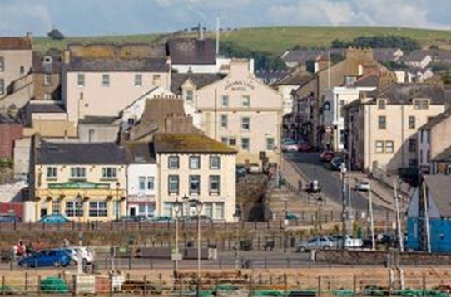
Pension: Church of England Pensions Board Church Workers non-contributory, defined contributions scheme (employer’s contribution is 15% of salary).

Car: mileage paid at 45ppm.

Office provision: TBC.

Equipment: A laptop and smartphone with remote access to email is provided.

Working expenses: fully funded through the deanery.

Other benefits: 34 days annual leave including public holidays.

Hours: 35 hrs per week with a flexi-time and TOIL system in operation. There will be a requirement to work outside normal office hours for some of the time.

This post is subject to an occupational requirement that the post holder be a practicing Christian under Part 1 of Schedule 9 of the Equality Act 2010.

Useful Links and Further Information:
Diocese of Carlisle: https://www.carlislediocese.org.uk/
God for All General: www.godforall.org.uk
Network Youth Church: https://www.networkyouthchurch.org.uk/
Northern Young Leaders Project: https://nylp.co.uk/

