
Human Resources Manager

Are you an experienced HR Manager looking for a new challenge?
Do you inspire confidence in colleagues?
Can you handle a diverse workload?

The Diocese of Carlisle is looking for a
Human Resources Manager

who will:

- provide high quality, reliable advice on HR law, policy and practice for clergy office holders and lay employees
- advise-on and implement HRM strategies, policies and procedures
- manage multiple recruitments
- oversee the development and operation of HR systems
- promote wellbeing and occupational health support across the Diocese
ensure data protection compliance

Salary: £50,703 per annum (FTE), 28/35 hours per week
plus 15% non-contributory pension

Closing date for applications: 9am 16th March 2026

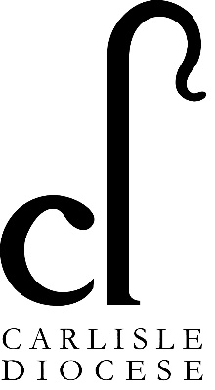
Interviews: 26th March 2026 at Church House, Penrith

For more information about the role please contact Helen @HumanResources@carlislediocese.org.uk
and to apply please visit https://www.carlislediocese.org.uk/vacancies/

Please return completed applications to: HumanResources@carlislediocese.org.uk

