
Administrative Assistant- Programme Office

Can you handle a diverse workload?
Do you inspire confidence in colleagues?
Do you want a new challenge?

The Diocese of Carlisle is looking for a
Administrative Assistant

who will:

- Support the Programme Management Office
- Be flexible, positive, with a ‘can-do’ attitude
- Work with colleagues to coordinate project reporting
- Monitor and collate data against programme and strategic objectives

This is a part time position, for 21hrs (0.6FTE) a week

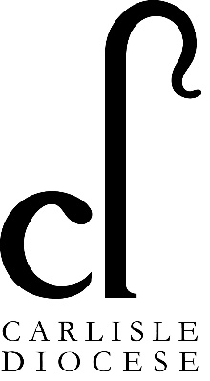
Salary: £23,668 FTE

Closing date for applications: 9am 24th November 2025

Interviews: Thursday 27th November 2025 at Church House, Penrith

If you would like an informal chat about the role, please email Kerry Roughton,
Head of Programme Management, on kerry.roughton@carlislediocese.org.uk

Please return completed applications to: HumanResources@carlislediocese.org.uk

