
Network Youth
Church Leader –
Solway Deanery, Cumbria

RECRUITMENT INFORMATION
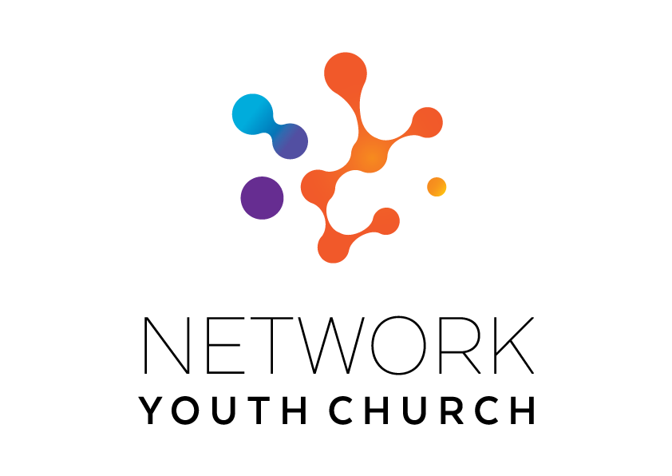

In this pack you will find:
Introduction to NYC
About Growing Younger in the Diocese of Carlisle
About the role
Information on the local area
Job Description and Person Specification
Key links for more information
Introduction to Network Youth Church
We are seeking to appoint new leaders for Network Youth Church. Network Youth Church is a new way of doing and being church with young people across Cumbria. NYC seeks to create Deanery based youth churches that network local Christian cells to create generation specific congregations within a mixed ecology of church. NYC sits as a church alongside other churches in each Deanery. As Cumbria operates as an ecumenical county NYC also operates ecumenically where possible and relates to the ecumenical mission communities in the deanery where it sits. We create spaces which are safe and welcoming, but don’t shy away from the big questions of life, working to encourage confidence, participation, understanding and growth. It is a part of the county-wide God for All strategy, which recognises that we need to develop different and new ways of being church, alongside those that already exist. This means that our work is informed by the strengths of the local church, but everything we do is governed by what works best for our young people, and that means doing things differently.

We began in response to low numbers of young people engaging with church in Cumbria ten years ago and have since grown into one of the most creative faith-based youth projects in the UK. We’re one of the largest providers of youth services in Cumbria, welcoming all young people. We take a pioneering and inclusive youth work approach to support the personal, social and spiritual development of young people across the county. NYC is open to all young people, regardless of who they are or what they believe.
NYC runs everything from drop-in youth clubs to question spaces, cafe spaces to prayer spaces, schools work to street-based youth work, outdoor activities, days out, and indoor sports. There are activities happening in halls, churches, cafés, classrooms and bus stops. There are large scale events which happen once a year, gathering all the young people from across NYC Cumbria, and there are smaller, more local events where young people from different areas can meet. We also provide opportunities for young people to go on different residentials: both locally and nationally run.

When the NYC is at full strength there are 11 NYC leads each responsible for the development of ministry across a deanery. We employ different approaches in different areas depending on the context and geography and each NYC has a local steering group to help set strategy, develop local connections and support the worker.

Staff are employed by the diocese and local work expenses are covered by the deanery. A local line manger helps oversee the work in partnership with Growing Younger Enabler for Youth who oversees the whole of NYC.

About Growing Younger and the Diocese of Carlisle

This is a significant, hope-filled but challenging time for the Church of England in Cumbria.

Alongside our ecumenical partners we have recently renewed our vision and strategy, God for All, as we look to the next decade.

The vision centres around four key values which frame our priorities:

1. Follow Daily:
We will help each other to follow Jesus more closely, seeking to grow as his disciples in all aspects of life, both corporately and as individuals
2. Care Deeply:
We will listen to our local communities and respond in loving service, seeking to transform injustice, challenge oppression and pursue peace & reconciliation.
3. Speak Boldly:
We will share our faith in Jesus Christ in everyday ways, seeking to connect with everyone, especially those currently unrepresented in our churches. We’ll do this in both time-honoured & pioneering ways.
4. Tread Gently:
We will strive to safeguard the integrity of God’s creation, seeking to sustain and renew the life of the earth.

These are the building blocks that help us define our core purpose as Church and our main tasks.

The Diocese of Carlisle covers (more or less) the County of Cumbria and is part of an ecumenical covenanted partnership with three other denominations - the United Reformed Church, the Methodist Church and The Salvation Army. The county is divided into 34 Mission Communities; local ecumenical groupings of parishes and other churches. Mission Communities bring together churches in a geographical location to share ministry and work together in mission and outreach.

We have recently been awarded funding from the national ‘People Capacity Funding’ enabling the recruitment of a Growing Younger Enabler for Youth to join us and help oversee Network Youth Church and the wider work with 10-25yrs.

One of our strategic areas is Growing Younger. As in so many places, our congregations are generally getting older and smaller. In the ten years from 2010 to 2019, numbers worshipping on Sunday in the diocese fell by 27% from 13,100 to 9,500. This decline has happened across all sizes of churches. Church attendance and membership in our less affluent urban areas is particularly low.

NYC has been a key element and over the last 10 years the diocese has invested in Network Youth Church (NYC) as a response to the challenges we are facing. NYC is a way of doing and being church that helps young people discover life in all its fullness, explore the Christian faith, the skills they need to live, learn, work, and interact successfully with other people, and engage with the wider world. Between 2016 and 2022, NYC has grown in core attendance by 33%. There are almost 2000 young people who interact with NYC, and around 800 core (regular) members.

We also have a strategic objective of growing younger in our leadership. Currently just under half of our clergy could potentially retire in the next 10 years, and only 9.4% of our ordained leaders are aged under 40. In 2022, the diocese relaunched its Intern Scheme, the Northern Young Leaders Project. This scheme is part of the Ministry Experience Scheme for the Church of England. We also partner with the Norwegian Mission Society to accept interns from across the globe. Working in placement churches, this year long scheme offers opportunities for young people to grow in leadership and explore their calling to ministry. We are currently recruiting for the 2025 intake.

About the Solway Area

Solway Deanery has had many years of successful ministry through Network Youth Church and now is an exciting time as we seek to see this develop further across the Deanery, especially in our local churches and Mission Communities. Currently we have three mission communities – Workington, Criffel View and Solway Plain. There are also a growing number of Network Youth Church ‘cell groups’ within the Deanery, together with work with children in Year 6 and above in some of our local schools.
The Deanery covers a large geographical area, stretching from Distington as its southernmost point to Bowness on Solway in the north. To the west it covers the coastline of the Solway Firth and to the east reaches the edges of the western lake district at Caldbeck and the boundary of the Solway Deanery in the Cockermouth area. It is predominantly a rural deanery with numerous small village communities, together with the larger more urbanised towns of Workington, Maryport and Wigton.
The great diversity of the deanery is one if its greatest challenges but also one of its greatest strengths. From farming to football, retail to rugby, and fishing to factories, it can all be found in the Solway Deanery.
There are currently discussions taking place to split the Deanery, creating two smaller deaneries of Workington, and Solway. This will not deter our efforts to grow new disciples through Network Youth Church and to strengthen our church families.
Family is also of great importance in this area of Cumbria, especially our young people, as it is across the whole of the Diocese of Carlisle, with sons and daughters often staying close to home and starting their own families.
Solway Deanery is fully committed to supporting the diocesan ‘Growing Younger’ and seeing our Network Youth Church thrive and go from strength to strength.

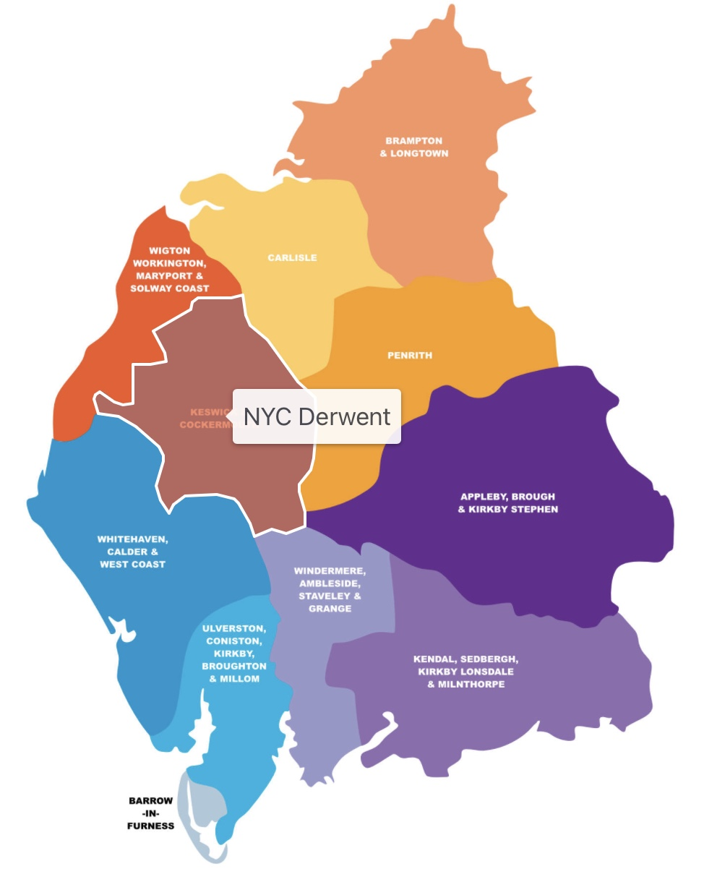
Solway NYC

Solway NYC Activity

Student Leadership:
In September 2024, Solway Network Youth Church in partnership with King's Church Cockermouth, started a Student Leadership Programme. Young people in school years 11-13, have had the opportunity to learn more about leadership from a Biblical perspective and are then given the chance to put this into practice.

Each month, the student leaders have taken part in a training session where we have looked at an aspect of Christian leadership through activities, Bible study and discussion after sharing a meal together.
The young people have then been given opportunities to serve and lead at the Knock weekends away and in the cell group sessions and ministry in their area.

It has been great to see these young people learn and grow through the last few months as they put what they have learnt into practice. The training sessions have brought out interesting and challenging discussions as we have looked at different examples of leadership and how we can be servant leaders.
Here are some quotes from our Student Leaders about what they have enjoyed over the last few months:
'I've enjoyed being able to help out (and still be able to have a good time)'
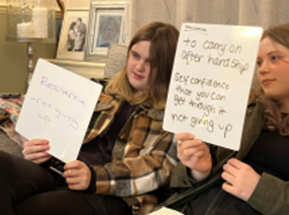
'I've really enjoyed the discussions we've had, they've been really interesting and helpful'
'I've enjoyed being involved in helping out with activities'
'I've enjoyed that extra responsibility and being there for people'
'I've enjoyed helping out with everything while still being able to have fun with my friends'
'I have enjoyed having more responsibility and being able to help out with activities'
'I have enjoyed being able to be there for the young people'
'I've enjoyed everything about it, and could not pick one thing (that I've enjoyed most)'

Silloth Cell
Silloth Cell meets fortnightly and have 8-9 young people who consistently attend. They are all growing up fast and it’s wonderful to see and hear how they are navigating life.

In the first half of last year amongst lots of fun activities, a film night, litter pick and sponsored walk the young people enthusiastically participated in looking at what the Bible says about what gives us our identity and worth, how we are created and known by God, and God’s love.

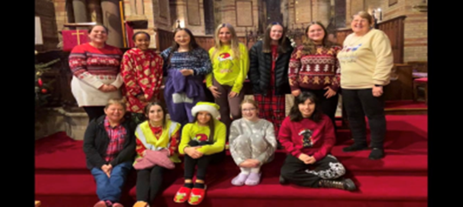
In the second half of the year, we decided to start each session by having a meal together and we began the Youth Alpha course, which the young people have really engaged with.
We’ve has lots of interesting conversations about Jesus and faith and we’ll be completing Youth Alpha in January 2025. God has certainly been at work opening their hearts and minds to the possibility of him being a reality in their lives.
Most of Silloth cell attended and really enjoyed the two residential camps, Ablaze and showcasing their cheer leading their skills at ‘Abbeylive’ an open-mic talent show in Holme Cultram Abbey.

Wigton Cell
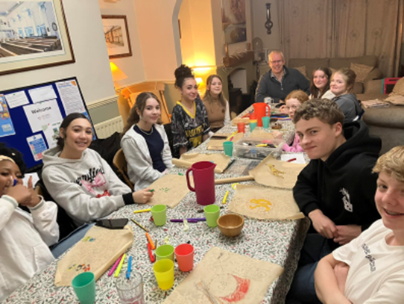
Wigton Cell continue meets each week on a Wednesday night. Sharing a meal and then some kind of activity or discussion.

Last year started ‘cultural night’ where we have had food and explored a bit more about specific countries or cultures. This has been led by some of the members of Wigton Cell who have enjoyed sharing an insight into their culture and heritage. Alongside this we have carried out the usual social action bit, litter picks etc.

Volunteers Adrain and Francess give up their Wednesday nights to come and hang out and share with us.

Maryport after school club
Each week there is a different activity, e.g. craft making, baking, watching a video, treasure hunt, board games, active games, drama and competitions. At the beginning of each week, the children arrive and sign in and are offered a drink and something to eat (toast and hot chocolate). There is also a tuck shop where the children can spend up to a pound.
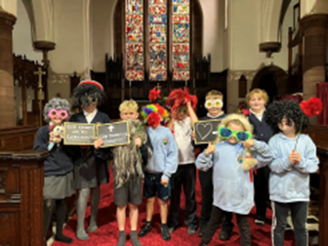
Once all the children have arrived and settled, the activity for that week is started. In small groups or as a whole group activity. There is always an alternative available like colouring, a game or small craft for those who don’t wish to join in with the main activity . Although we try to encourage everyone to join in and often that is the case.

Sometimes the Young People can be quite lively at the start, after all they have been at school all day, and letting them run off a bit of steam at the beginning often means they focus better for the rest of the planned activities.

Since the club has started, more Christian and spiritual input has begun. Some of the Children already have good knowledge and understanding of the Christian faith and the club seeks to build on this foundation before the pupils move on to secondary school.

Parents are very supportive of the club and when we have put on events for the parents, which are run by the children, it has always been very well attended.

Having the church as a venue is a great asset it gets the children used to being inside the church.

)

Schools work

Our previous NYC Leader contributed in various ways to Maryport Church of England Primary School, providing wellbeing sessions for children, guidance for staff and the leadership team, enriching their understanding of Biblical texts and empowering them to enhance their educational practices. She was also involved in weekly collective worships, the facilitation of prayer stations, and mentorship of collective worship leaders. She also coordinated with church volunteers to cultivate a thriving community connection.
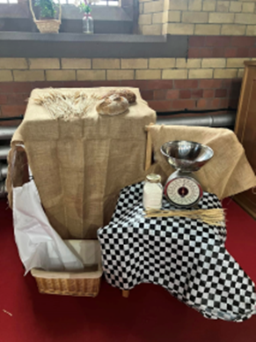

Prayer spaces in schools

Last year we have enjoyed working with local churches to deliver these prayer spaces. Hundreds of young people have accessed them and have had a chance to explore faith.

Rosley value launch days 1-day Holy Trinity Church Rosley
January- Hope and courage
April- Compassion and Thankfulness
September - Friendship and Joy in God’s tent
January - Perseverance and forgiveness

Experience Easter in Maryport 5 days 18th- 22nd March St Mary’s Maryport
Maryport primary school
Ellenborough infants
Ellenborough juniors

25th and 26th March At Mary’s Wigton
Wigton juniors experience Easter

1st, 2nd and 3rd October in All Souls Maryport
Experience Harvest
Maryport Primary school
Ellenborough infants

Maryport primary school
3rd, 4th and 5th December
All Christmas stations

Deeper
Deeper, as the name suggests, allows the young people to go deeper with their faith. From September 2024, at the young people's request, we moved to a fortnightly session (previously monthly). These sessions allow the young people to delve deeper into the bible and seek answers to faith-based questions in a safe environment, as they progress from their respective positions on their faith journey.

During the year we introduced a specific prayer time (though the writing of individual prayer diaries which are then shared) and enjoy a period of worship, often led by the young people themselves, at each session. It has been good to watch them become bolder in their questioning and, for those attending, to be comfortable to share what they believe God does in their lives, their hopes (and fears) and importantly where they feel the presence of God in daily living (for some it is music, for others arts and crafts etc). We are fortunate that those attending are from families with different backgrounds and cultures which allows for a well-rounded debate, views and experiential learning.
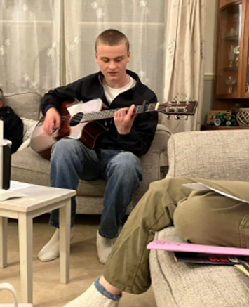

Advent Calendars

Each year for the last few years, we have offered advent calendars out across the Deanery with thanks to funding received form the Diocese.
Solway packed and handed out 200 calendars a further 550 were made for the rest of the Diocese. Our young people really enjoyed taking a journey through advent with us.

Each day they opened a card and sweet treat which had something to watch, verses to read from the Bible, quotes from famous Christian, challenges and much more to go on a journey through advent together.

Ablaze
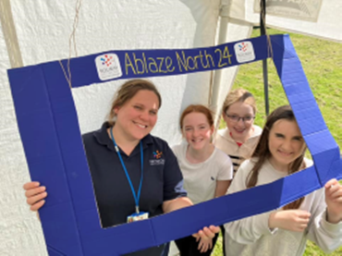
Each year, young people from across the Solway area have gathered for the SNYC Ablaze event. With inflatables, samba drumming, football, crafts, hair wrapping, nerf wars and circus skills on offer, there was lots of fun to be had on the field there was also the 'God Tent', where young people could enjoy a quiet moment whilst taking a moment to reflect on who God is and write a prayer.

Last year we also provided a chillout marquee with board games and a selfie photobooth, as well as a tuckshop where young people could purchase snacks, drinks, popcorn and the very popular candy floss made on site.

Over 70 young people attended in 2025. From around 5pm, the young people gathered for burgers and hot dogs from the BBQ. After everyone was fed, it was time for the annual tug of war between different teams followed by the young people taking on the leaders.

The event is a great introduction for new young people to the weekend away that happens in October and it is always lovely to see some of the young people who came to Ablaze come to the Knock weekend for the first time in October.

Residentials
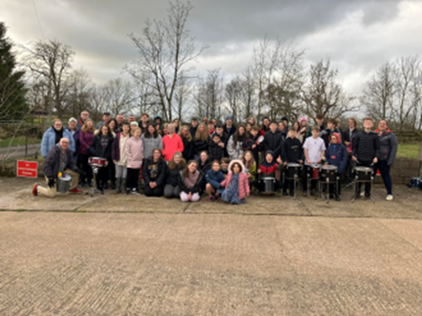
Each year we run 2 residential weekends at Knock Christian Centre near Appleby.
One weekend takes place in February and the other in October.
In 2024, the themes included mysteries in the Bible looking at parables and what they are trying to tell us and how that might have a challenge for how we live, treat others and grow in our faith.
A highlight included a 3-course mystery dinner with activities and challenges in between the course followed by a silent Disco.
February saw us explore the Easter story. Our youth services took on the titles
- Easter What’s it all about?
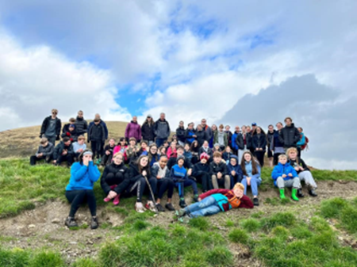
- The thief on the cross
- What does Easter mean for us today?

We were fortunate to be able to look at photos from the Holy land and learning about some of the myths around events documented In the Bible.
We gathered junk and turned it in to amazing catwalk outfits. Ran around playing football, nerf wars and enjoyed lots of crafts.

Camp Out
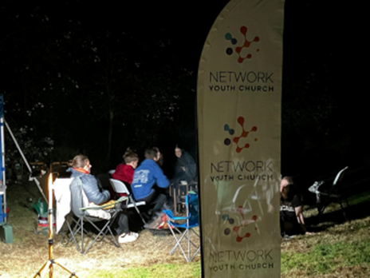
It has become a tradition, in August each year, to camp out in the Archdeacon’s Garden in Abbeytown. We enjoy hanging out, playing games and eating together.

The campfire is a particular highlight. A night under canvass is always fun with friends in the summer. It’s a great chance to get back together, celebrate the end of the school year, end of exams etc and look forward to the year that is to come.

Leaders support
Throughout the year, the cell leaders gather for training sessions to look at relevant topics which will help us as we lead the youth cell groups. At some of the sessions, we have speakers who are brought into speak on a specific topic, such as Paul who came from LADO (Local Authority Designated Officer), LADO are responsible for managing allegations against adults who work with children or young people. It was helpful to hear about the process of how the LADO deals with allegations and how the system works.
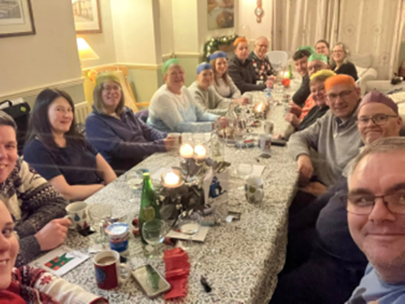
We also had a visit from a lady who working in a school as their SENCO (which is a qualified teacher who’s responsible for leading the school’s provision for young people with special educational needs). She came and spoke to us about behaviour management in our cell groups and we were able to ask about some of the challenges we face and get some hints on tips as to what we might do differently to help that specific young person.
These sessions are great for youth cell leaders, not only because of the training we receive but also because we are able to connect with other youth leaders, share ideas, talk through different resources we’ve tried whilst also giving support to one another.

The Big One

In September each year, over 300 young people and their leaders gather together for the Network Youth Church's county-wide event, "the Big One". During the day the young people are able to make craft, watch movies, bounce around on Inflatables, play laser quest, enjoy some video games and listen to live music.
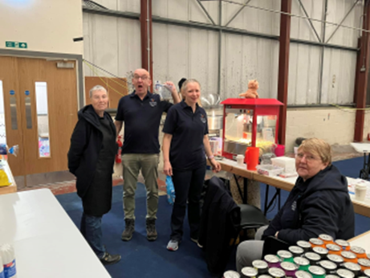

Wellbeing sessions

Thursday afternoons are spent in Maryport primary school working with a group of year 5 students and a group of year 6 students. Giving them a chance to have some time away from class working with myself.
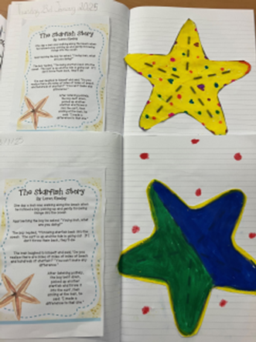
We spend the 45 minutes sharing highs and lows from the week,
playing games and doing crafts all around something we can learn from the Bible to support us with our wellbeing. Last year some of the topics we looked at were. Jesus being our friend, Helper in the storms, Ever-present and much more.
It is always a joyous time with lots of care for each other, honesty and fun and it is definitely a highlight of the week,

Worship leaders
We support 3 different schools worship leaders. Working with a small team of young people to enhance their schools’ worship and take part themselves.

Our previous leader, Yvette, worked with a group of yr4-6 pupils who put themselves forward to be worship leaders, she met with them regularly and has supported them to take a greater role in leading and organising worship in our school.
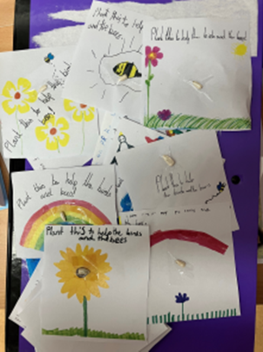
Children are keen to put themselves forward and they have a much greater presence in school thanks to the work of Solway NYC. The daily call to worship and school prayer written by the children, have been a big step forwards for us and is now an embedded feature of our school worship.
All the children are made to feel welcome there is no expectation for them to have a Christian faith. The travelling nativity sets (posadas) and the interactive advent calendars were also nice additions this year and well received by children and their families.

Finances

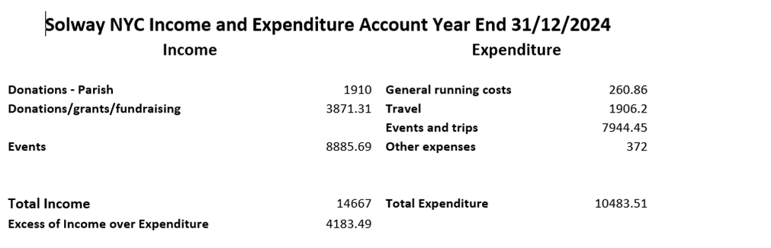

Job Description

JOB TITLE: Solway Network Youth Church Lead
REPORTS TO: Local Line Manager and Growing Younger Enabler for Youth
DEPARTMENT: Solway Deanery (this includes communities of: Wigton, Aspatria, Silloth, Maryport, Workington and the surrounding rural areas).
PURPOSE OF ROLE:

- To grow, develop and lead a Network Youth Church in Solway Deanery for young people aged 11-18.

- To create opportunities for young people to grow and develop personally, socially, spiritually and emotionally, including exploring and experiencing the Christian faith.

- To develop a strategy for outreach work with ecumenical partners and schools, in line with the Growing Younger strategy and wider God for All strategy.

- To establish new and exciting, relevant forms of church that are brave and creative whilst being sensitive to time honoured church and in-line with the wider God for All strategy.

KEY ACCOUNTABILITIES:
- To develop the growth of youth church across the Deanery using the NYC / New Worshipping Communities model as appropriate with particular attention to the key areas where secondary schools are located.
- To develop a strategy for engagement with young people outside of church contexts which may include a phased approach across the area.

- To provide and develop an environment/context in which young people can explore Christianity and be nurtured in the Christian faith.

- Work with the existing youth work and churches across the Mission Communities to creatively form youth cells and develop church as God leads.
- To provide pastoral and safeguarding oversight of the young people including use of social media.
- To pray for the young people of Cumbria, particularly Solway deanery.
- To develop the talents and spiritual gifts of young people and volunteers, supporting them to grow their leadership skills and service among the NYC as we partner with churches and charities to train and grow NYC and young leaders.

- To identify, develop and equip volunteer leadership for roles within the Network Youth Church.
- To be an advocate and educator about youth culture, youth church and youth mission with Deanery clergy, church members, church leaders and the wider community.
- To meet at regular intervals (once a term) with the area NYC steering group and the wider NYC team
- To work collaboratively with NYC, Deanery clergy, ecumenical partners, others involved in youth ministry.
- To work with the steering group in the development and delivery of strategy and work that connects across the generations, e.g. transitions work with Year 6s and the Children’s and Families workers or 18+ with church youth leaders

- To develop age compliant and appropriate social media profiles with effective safeguarding ways of working at the centre to connect to new young people and develop online communities that link into onsite groups and churches and teach them how to use them safely.

- Facilitate opportunities for young people to go on both local and national events and residentials (e.g. Ablaze and 3Generate).

- To promote the work of the Network Youth Church to Christians in the Deanery, reporting on its work to each Deanery Synod.

- To be part of the Deanery Chapter as a church leader in the Deanery.

NETWORK (Key people with whom the role liaises)
INTERNAL: Local Line Manager (currently Revd Dom de Mattos, Rector of Harrington and Distington), Lay Leaders, local Clergy, NYC Leaders, Safeguarding Adviser, Archdeacons, Diocese Ministry, Mission and Innovation Department, Employees.
EXTERNAL: Links with all the key secondary schools in the area, various appropriate external organisations and statutory bodies, and where appropriate local councillors.
Person Specification

Experience
- An occupational requirement exists for the post holder to be a practising Christian in accordance with the Equality Act 2010.
- A proven track record in work with young people principally of secondary school age.
- Experience of contextual youth mission and outreach.
- Experience in leading cell groups to nurture and disciple young people in the faith.
- Able to demonstrate experience in growing young leaders.

Knowledge
- Ability to demonstrate an understanding of the world of young people of secondary school age.
- Hold a recognised qualification in youth work or have relevant experience with young people or be willing to undertake training.
- Be aware of issues affecting young people living in rural communities & market towns
- Have knowledge and experience of contextual youth ministry and outreach and pioneering youth ministry.
- Able to demonstrate a knowledge of safeguarding/health & safety requirements when working with 11-18 year olds.

Skills and Aptitude
- Able to build and maintain respectful, child-centred relationships with children and young people.
- Able to effectively communicate with children, young people and families in ways which value them.
- Have a proactive commitment to mission embodied in a pioneering spirit.
- Demonstrable resilience which is supported by effective spiritual and wellbeing practices.
- Able to build and lead a team of volunteers.
- Be willing to work collaboratively with others involved in youth ministry.
- Be willing to work with the clergy of the Mission Communities and attend Chapter meetings.
- Be willing to work ecumenically with fellow Christians and other youth agencies.
- Computer literate.
- Able to write and deliver reports to Deanery Synod, Circuit and Mission Communities on the work as appropriate.
- Able to plan a course of action and develop a ministry with support from others.
- Be open to ongoing training.
- Be able to work with young people from a diverse range of backgrounds and identities across a diverse area.

Other
- Be committed to Network Youth Church and make it part of your worship practice.
- A willingness to work flexible hours to fulfil the requirements of the role, includes evenings & weekends.
- The post-holder will be required to complete enhanced DBS checks.
- Awareness of Health and Safety and Safeguarding procedures and practice.
- Holds full UK driving license and has access to own transport.
- Due to the geography of the area and relational nature of the post ideally the candidate would be willing to live in the Solway Deanery.

Desirable Criteria

Experience
- Experience of involvement with secondary schools.
- Experience of detached youth work.

Terms and Conditions

Salary: £30,720

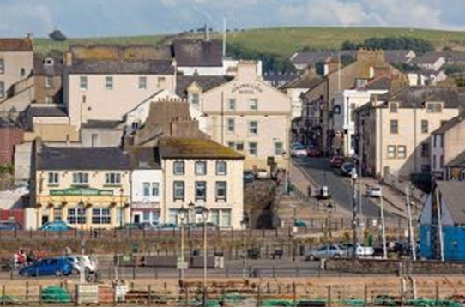
Pension: Church of England Pensions Board Church Workers non-contributory, defined contributions scheme (employer’s contribution is 15% of salary).

Car: mileage paid at 45ppm

Office provision: TBC

Equipment: A laptop and smartphone with remote access to email.

Working expenses: fully funded through the deanery.

Other benefits: 34 days annual leave including public holidays.

Hours: 35 hrs per week with a flexi-time and TOIL system in operation. There will be a requirement to work outside normal office hours for some of the time.

This post is subject to an occupational requirement that the post holder be a practicing Christian under Part 1 of Schedule 9 of the Equality Act 2010.

Useful Links and Further Information:
Diocese of Carlisle: https://www.carlislediocese.org.uk/
God for All General: www.godforall.org.uk
Network Youth Church: https://www.networkyouthchurch.org.uk/
Northern Young Leaders Project: https://nylp.co.uk/

