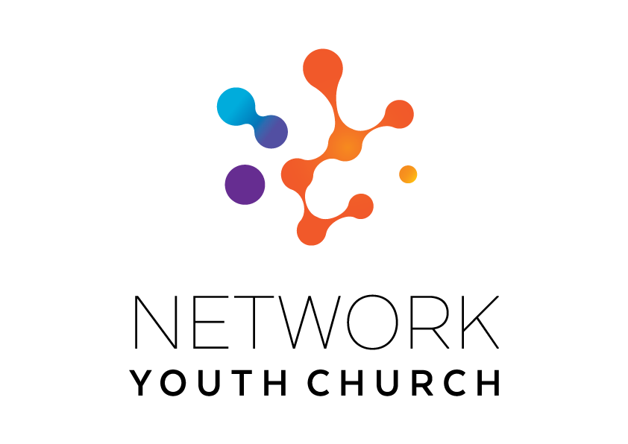

RECRUITMENT INFORMATION

Network Youth
Church –
Trainee Leader

In this pack you will find:
Introduction to NYC
About Growing Younger in the Diocese of Carlisle
About the role
Information on the local area
Job Description and Person Specification
Key links for more information
Introduction to Network Youth Church

We are seeking to appoint new leaders and trainee leaders for Network Youth Church. Network Youth Church is a new way of doing and being church with young people across Cumbria. We create spaces which are safe and welcoming, but don’t shy away from the big questions of life, working to encourage confidence, participation, understanding and growth. It is a part of the county-wide God for All strategy, which recognises that we need to develop different and new ways of being church, alongside those that already exist. This means that our work is informed by the strengths of the local church, but everything we do is governed by what works best for our young people, and this may mean doing things differently.

We began in response to low numbers of young people engaging with church in Cumbria ten years ago and have since grown into one of the most creative faith-based youth projects in the UK. We take a pioneering and inclusive youth work approach to support the personal, social and spiritual development of young people across the county. NYC is open to all young people, regardless of who they are or what they believe.
NYC runs everything from drop-in youth clubs to question spaces, cafe spaces to prayer spaces, schools work to street-based youth work, outdoor activities, days out, and indoor sports. There are activities happening in halls, churches, cafés, classrooms and bus stops. There are large scale events which happen once a year, gathering all the young people from across NYC Cumbria, and there are smaller, more local events where young people from different areas can meet. We also provide opportunities for young people to go on different residentials: both locally and nationally run.

When the NYC is at full strength there are 11 NYC leads each responsible for the development of ministry across a deanery. This year, we are excited to be offering supported opportunities for people who are not yet qualified youth workers but feel that God is calling them into Christian Youth Ministry to train and work alongside our experienced team. We employ different approaches in different areas depending on the context and geography and each NYC has a local steering group to help set strategy, develop local connections and support the worker.

Leaders are employed by the diocese and local work expenses are covered by the deanery. A local line manger helps oversee the work in partnership with the Growing Younger Enabler for Youth who oversees the whole of NYC.



About the Trainee NYC Leader role
As a Trainee NYC Leader, you will be supported to work within Network Youth Church while you complete appropriate training and gain experience.

We will pay you a salary of £26,000 per year while you train and learn, providing you with an experienced NYC mentor to help you. You will be responsible for funding the cost of your training, but we will help you to identify appropriate courses and enable you to attend training as part of your work. We will ensure that you have enough time to study within your role and offer £2,000 per year towards the cost of appropriate training. It may be possible for you to complete an apprenticeship with us. Please talk to our HR team if you are interested in this.

You will be placed within a deanery in the same way as the rest of the NYC team and you will grow and develop Christian youth ministry alongside your study, supported by your mentor, local line manager and the Mission Community in which you serve. Your work will increase year on year as you develop and learn. You will begin by observing, shadowing and supporting established projects within NYC, building up to setting up and leading your own new Christian youth church project during Year 1. As your skills and experience increase, you will work across a larger area and play a greater supporting role in projects whilst building your own portfolio of Christian youth church ministry.

Our Trainee NYC Leader role is available for up to 3 years and will be reviewed annually by the NYC Mentor, local line manager and Growing Younger Enabler for Youth. At the end of this time, if you meet the appropriate criteria we will confirm you in post as a Network Youth Church Leader.

About the local areas and current vacancies
If you are interested in applying to be a Trainee NYC Leader, we will work with you to explore the area that would be the best fit for you. Currently, we are recruiting to fill four vacant Network Youth Church posts in Barrow, Derwent, Kendal and Furness. If you know the area and are interested in working in a particular deanery, there is detailed information about each vacancy, and you are warmly encouraged to request specific NYC Leader job description pack from the Diocesan HR Team.
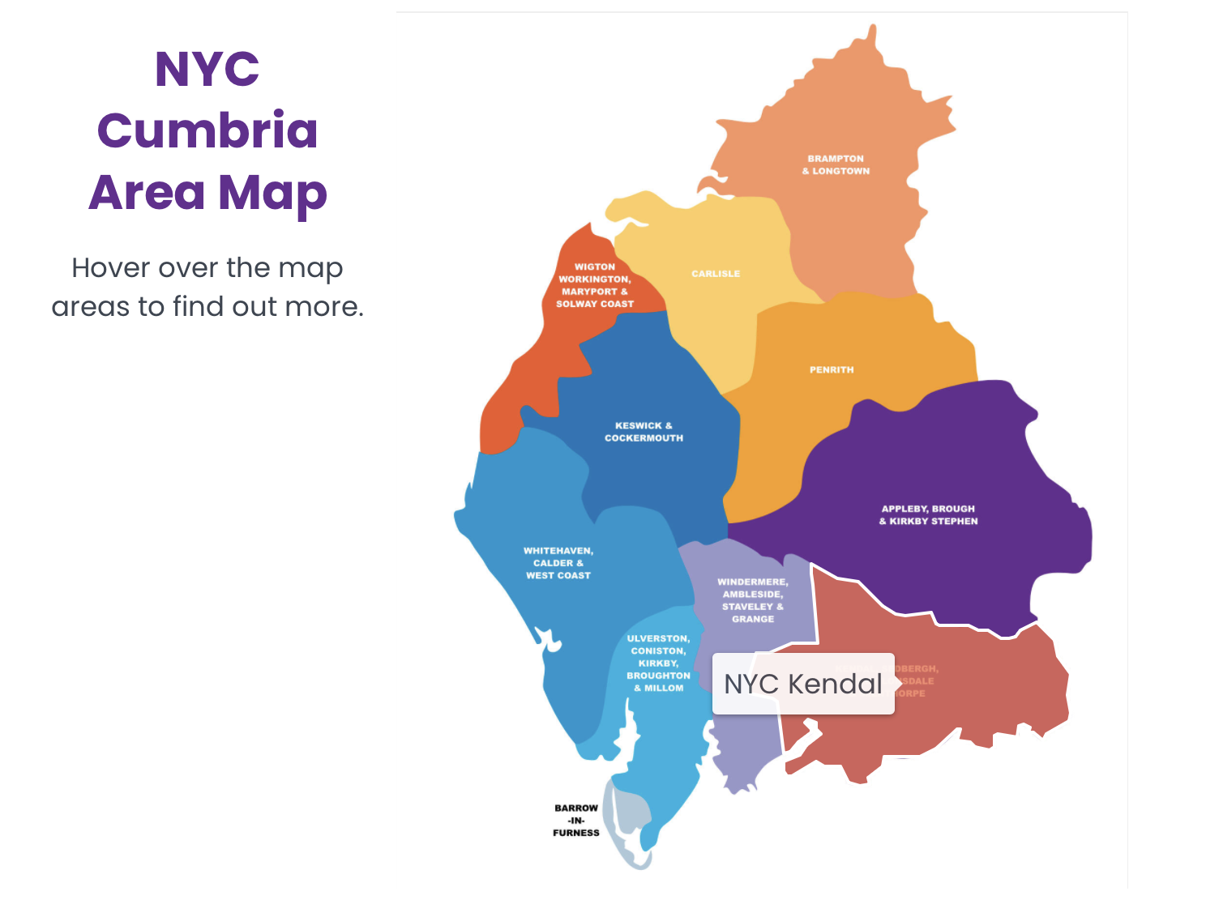
Job Description

JOB TITLE: Trainee NYC Leader
REPORTS TO: Local Line Manager and Growing Younger Enabler for Youth. With day-to-day support offered by an NYC Mentor
DEPARTMENT: TBC
PURPOSE OF ROLE:

- To grow and develop Network Youth Church within the Diocese of Carlisle for young people aged 11-18.

- To create opportunities for young people to explore and experience the Christian faith whilst growing and developing personally, socially, spiritually and emotionally.

- To support and develop Christian Youth Ministry in line with the Growing Younger Strategy and wider God for All strategy.

- To establish new and exciting, relevant forms of church that are brave and creative whilst being sensitive to time honoured church in-line with the wider God for All strategy.

KEY ACCOUNTABILITIES:
- To develop the growth of youth church across the Deanery using the NYC / New Worshipping Communities model as appropriate with particular attention to the key areas in which secondary schools are located.

- To work with an NYC Mentor to develop a strategy for engagement with young people outside of church contexts in a particular area within the deanery.

- To provide and develop an environment in which young people can explore Christianity and be nurtured in the Christian faith.

- Work with the existing youth work across the Mission Communities to creatively form youth cells and develop church as God leads.

- To work within the Diocese of Carlisle’s Safeguarding Policy to ensure the safety of the members, volunteers and staff of Network Youth Church.

- To pray for the young people of Cumbria, particularly the deanery in which you work.

- To help to develop the talents and gifts of young people and volunteers, supporting them to grow their leadership skills and service in NYC.

- To work with the NYC Mentor to identify, develop and equip volunteer leadership for roles within the Network Youth Church.

- To develop knowledge and experience in youth culture, youth church and youth mission and attend events both locally and nationally that will help to build your knowledge and understanding of these.

- To meet regularly with the NYC mentor and attend the deanery NYC steering group and the wider NYC team meetings.

- To work with the NYC Mentor to arrange a programme of visiting and shadowing other NYC Leaders, clergy, ecumenical partners, others involved in youth ministry and youth work within the diocese.

- To work with the NYC Mentor to support and deliver work that supports particular groups of young people e.g. transitions work with Year 6s and Young Leaders.

- To help NYC Leaders to develop age compliant and appropriate social media profiles with effective safeguarding ways of working at the centre to connect to new young people and develop online communities that link into onsite groups and churches and teach them how to use them safely.

- To operate within the policies and procedures of Network Youth Church.

- To facilitate opportunities for young people to go on both local and national events and residentials (e.g. Ablaze, 3Generate and summer camps).

NETWORK (Key people with whom the role liaises)
INTERNAL: NYC Mentor, NYC Leaders, Local Line Manager, Growing Younger Enabler for Youth. Children’s and Families Workers and other Lay Leaders, local Clergy, Diocesan Safeguarding Adviser, Archdeacons (local operational managers), Diocese Ministry, Mission and Innovation Department, Employees.
EXTERNAL: Secondary schools in the area, churches, various appropriate external organisations and statutory bodies, including local youth charities and community projects.

Person Specification

Experience
- An occupational requirement exists for the post holder to be a practicing Christian in accordance with the Equality Act 2010.
- Experience of working with young people aged 11-18.
- Experience of contextual youth mission or outreach.
- Experience in leading or assisting with small groups that nurture and disciple young people in the Christian faith.

Knowledge
- Ability to demonstrate an understanding of the world of young people of secondary school age.
- Relevant experience working with young people, and a willingness to undertake training.
- An awareness of the issues affecting young people living in rural communities & small market towns.
- Experience of contextual youth ministry and outreach.
- Able to demonstrate a knowledge of safeguarding/health & safety requirements when working with 11-18 year olds.

Skills and Aptitude
- Able to build and maintain respectful, child-centered relationships with children and young people.
- Able to effectively communicate with children, young people and families in ways which value them.
- Have a proactive commitment to mission embodied in a pioneering spirit.
- Demonstrable resilience which is supported by effective spiritual and wellbeing practices.
- Be willing to work collaboratively with others involved in youth ministry, including NYC Leaders and clergy.
- Be willing to work ecumenically with fellow Christians and other youth agencies.
- Computer literate.
- Able to write and deliver reports on the work as appropriate.
- Ability to reflect on own progress, learning and goals.
- Able to plan a course of action and develop a ministry in a defined area with support from the NYC Mentor and others.
- Attend the agreed Youth Leadership training course and complete the required work in order to qualify as a Youth Worker.
- Be able to work with young people from a diverse range of backgrounds and identities across a diverse area.

Other
- Be committed to Network Youth Church and make it part of your worship practice.
- A willingness to work flexible hours in order to fulfil the requirements of the role, includes evenings & weekends
- The post-holder will be required to complete enhanced DBS checks.
- Holds a full UK driving license and has access to own transport.
- Due to the geography of the area and relational nature of the post ideally the candidate would be willing to live in the Deanery area in which you work.

Terms and Conditions

TERMS AND CONDITIONS

Salary: £26,000

Pension: Church of England Pensions Board Church Workers non-contributory, defined contributions scheme (employer’s contribution is 15% of salary).

Car: mileage paid at 45ppm

Office provision: TBC

Mobile phone: smartphone with remote access to email

Working expenses: fully funded through the deanery

Other benefits: 34 days annual leave including public holidays

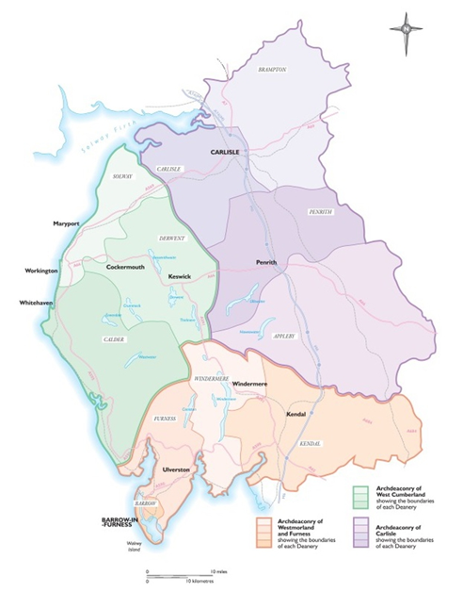
Hours: 35hrs per week with a flexitime and TOIL system in operation. There will be a requirement to work outside normal office hours some of the time.

This post is subject to an occupational requirement that the post holder be a practicing Christian under Part 1 of Schedule 9 of the Equality Act 2010.

Useful Links and Further Information:
Diocese of Carlisle: https://www.carlislediocese.org.uk/
God for All General: www.godforall.org.uk
Network Youth Church: https://www.networkyouthchurch.org.uk/
Northern Young Leaders Project: https://nylp.co.uk/
Ministry Experience Scheme: https://www.churchofengland.org/life-events/vocations/ministry-experience-scheme

