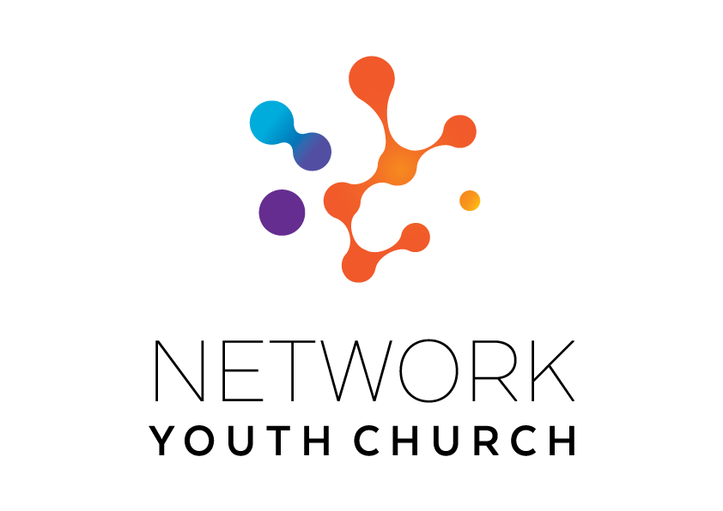

RECRUITMENT INFORMATION

Network Youth
Church Lead –
Barrow Cumbria

In this pack you will find:
Introduction to NYC
About Growing Younger in the Diocese of Carlisle
About the role
Information on the local area
Job Description and Person Specification
Key links for more information
Introduction to Network Youth Church
We are seeking to appoint new leaders for Network Youth Church. Network Youth Church is a new way of doing and being church with young people across Cumbria. We create spaces which are safe and welcoming, but don’t shy away from the big questions of life, working to encourage confidence, participation, understanding and growth. It is a part of the county-wide God for All strategy, which recognises that we need to develop different and new ways of being church, alongside those that already exist. This means that our work is informed by the strengths of the local church, but everything we do is governed by what works best for our young people, and this may mean doing things differently.

We began in response to low numbers of young people engaging with church in Cumbria ten years ago and have since grown into one of the most creative faith-based youth projects in the UK. We take a pioneering and inclusive youth work approach to support the personal, social and spiritual development of young people across the county. NYC is open to all young people.
NYC runs everything from drop-in youth clubs to question spaces, cafe spaces to prayer spaces, schools work to street-based youth work, outdoor activities, days out, and indoor sports. There are activities happening in halls, churches, cafés, classrooms and bus stops. There are large scale events which happen once a year, gathering all the young people from across NYC Cumbria, and there are smaller, more local events where young people from different areas can meet. We also provide opportunities for young people to go on different residentials: both locally and nationally run.

When the NYC is at full strength there are 11 NYC leads each responsible for the development of ministry across a deanery. We employ different approaches in different areas depending on the context and geography and each NYC has a local steering group to help set strategy, develop local connections and support the worker.

Leaders are employed by the diocese and local work expenses are covered by the deanery. A local line manger helps oversee the work in partnership with the Growing Younger Enabler for Youth who oversees the whole of NYC.

About Growing Younger and the Diocese of Carlisle

This is a significant, hope-filled but challenging time for the Church of England in Cumbria.

Alongside our ecumenical partners we have recently renewed our vision and strategy, God for All, as we look to the next decade.

The vision centres around four key values which frame our priorities:

1. Follow Daily:
We will help each other to follow Jesus more closely, seeking to grow as his disciples in all aspects of life, both corporately and as individuals
2. Care Deeply:
We will listen to our local communities and respond in loving service, seeking to transform injustice, challenge oppression and pursue peace & reconciliation.
3. Speak Boldly:
We will share our faith in Jesus Christ in everyday ways, seeking to connect with everyone, especially those currently unrepresented in our churches. We’ll do this in both time-honoured & pioneering ways.
4. Tread Gently:
We will strive to safeguard the integrity of God’s creation, seeking to sustain and renew the life of the earth.

These are the building blocks that help us define our core purpose as Church and our main tasks.

The Diocese of Carlisle covers (more or less) the County of Cumbria and is part of an ecumenical covenanted partnership with three other denominations - the United Reformed Church, the Methodist Church and The Salvation Army. The county is divided into 34 Mission Communities; local ecumenical groupings of parishes and other churches. Mission Communities bring together churches in a geographical location to share ministry and work together in mission and outreach.

We have recently been awarded funding from the national ‘People Capacity Funding’ enabling the recruitment of a Growing Younger Enabler for Youth to join us and help oversee Network Youth Church and the wider work with 10-25yrs.

One of our strategic areas is Growing Younger. As in so many places, our congregations are generally getting older and smaller. In the ten years from 2010 to 2019, numbers worshipping on Sunday in the diocese fell by 27% from 13,100 to 9,500. This decline has happened across all sizes of churches. Church attendance and membership in our less affluent urban areas is particularly low.

NYC has been a key element and over the last 10 years the diocese has invested in Network Youth Church (NYC) as a response to the challenges we are facing. NYC is a way of doing and being church that helps young people discover life in all its fullness, explore the Christian faith, the skills they need to live, learn, work, and interact successfully with other people, and engage with the wider world. Between 2016 and 2022, NYC has grown in core attendance by 33%. There are almost 2000 young people who interact with NYC, and around 800 core (regular) members.

We also have a strategic objective of growing younger in our leadership. Currently just under half of our clergy could potentially retire in the next 10 years, and only 9.4% of our ordained leaders are aged under 40. In 2022, the diocese relaunched its Intern Scheme, the Northern Young Leaders Project. This scheme is part of the Ministry Experience Scheme for the Church of England. We also partner with the Norwegian Mission Society to accept interns from across the globe. Working in placement churches, this year long scheme offers opportunities for young people to grow in leadership and explore their calling to ministry. We are currently recruiting for the 2025 intake.

About the local Area and Barrow role

Located at the most south-westerly point of the Furness Peninsula, Barrow is known for its close-knit community, rich history, and local pride. Whilst a traditional working town, it is surrounded by gorgeous coastal vistas and has easy access to the Lake District. Of course, it is the people who make this area come alive: a mixture of locals who value their deep roots and newcomers who have arrived for work and found a true home.
Barrow is a mission-focused Deanery with a church planting and revitalisation strategy and an emerging priority on ‘Growing Younger’. It features significantly in Carlisle Diocese’ 2025 application for national Diocesan Investment Programme funding, which we hope and pray will increase our capacity for mission.
Within Carlisle Diocese, it is the smallest deanery geographically but the second largest numerically - with a population of 70,000 people, including the town of Barrow and Walney Island. Barrow’s church landscape includes both traditional congregations, chaplaincies, and pioneering missional initiatives. Whilst the town itself is much younger than the impressive 900-year old ruins of our local Furness Abbey, our present churches and Christians now seek to carry the gospel of Jesus Christ forward in our own generations. There is a clear desire to engage young people where they are - and walk with them on a lifetime of following Jesus Christ. We are looking for an intentionally ‘mission minded’ Network Youth Church Leader, who will bring a complimentary missional gift set to work in Barrow at this exciting time.
Network Youth Church (NYC) has been present in Barrow for over 15 years, providing opportunities for young people to explore the Christian faith in creative and relevant ways. However, this post marks a moment to critically reflect on and refine the shape of the ministry going forward. The NYC Leader in Barrow will work collaboratively with the Deanery and local churches, schools, and community groups to shape an approach that is both pioneering and rooted in existing partnerships. This will involve an initial six-month review period where we work together to consider how NYC integrates with local churches and best serves young people in the town. We anticipate this including the following key considerations:
- Recent NYC work in Barrow has focused around the Newbarns estate and St Aidan’s Church, and the new NYC leader will help sustainably transition this work to the emerging Newbarns leadership team.
- The NYC leader will enable churches across the Deanery to develop their offering to young people, discipling, teaching and forming young Christian disciples, recruit & train leaders, model excellent practice, signpost new resources and offer other opportunities for young people to gather for worship & formation from across the town. They will discern further opportunities to disciple local young people and have access to diocesan-wide NYC events such as The Big One, as well as Christian camps & festivals.
- The NYC leader will lead on developing a strategic and comprehensive work in local secondary schools, such as Dowdales, Walney, Chetwynde, Furness Academy and St. Bernards. This could be through lunch clubs, mentoring, RE lessons, Christian Unions, and assemblies. They may also build on existing Deanery relationships with our many primary schools to offer coordinated support for young people in Year 6 as they prepare for their transition to Secondary School.

Job Description

JOB TITLE: Barrow Network Youth Church Lead
REPORTS TO: Local Line Manager and Growing Younger Enabler for Youth
DEPARTMENT: Barrow Deanery
PURPOSE OF ROLE:

- To grow, develop and lead Network Youth Church in Barrow Deanery for young people aged 11-18.

- To create opportunities for young people to explore and experience the Christian faith whilst growing and developing personally, socially, spiritually and emotionally.

- To develop a strategy for missional outreach with ecumenical partners and schools, in line with the Growing Younger Strategy and wider God for All strategy.

- To establish new and exciting, relevant forms of church that are brave and creative whilst being sensitive to time honoured church and in-line with the wider God for All strategy.

KEY ACCOUNTABILITIES:
- To develop the growth of youth church across the area using the NYC / New Worshipping Communities model as appropriate with particular attention to the key areas where secondary schools are located.
- To develop a strategy for engagement with young people outside of church contexts which will include a bespoke approach across the deanery.

- To provide and develop an environment/context in which young people can explore Christianity and be nurtured in the Christian faith.

- Work with the existing youth work and churches across the Mission Communities to creatively form youth cells and develop church as God leads.
- To provide pastoral and safeguarding oversight of the young people including use of social media.
- To pray for the young people of Cumbria, particularly Barrow deanery

- To develop the talents and gifts of young people and volunteers, supporting them to grow their leadership skills and service among the NYC as we partner with churches and charities to train and grow NYC and young leaders.

- To identify, develop and equip volunteer leadership for roles within the Network Youth Church.
- To be an advocate and educator about youth culture, youth church and youth mission with local clergy, church members, church leaders and the wider community.
- To meet at regular intervals (once a term) with the area NYC steering group and the wider NYC team.
- To work collaboratively with NYC, clergy, ecumenical partners, others involved in youth ministry (including Youth Matters Partnership) across the deanery.
- To work with the steering group in the development and delivery of the growing younger strategy and work that connects across the generations, e.g. transitions work with Year 6s and the Children’s and Families workers or 18+ with church youth leaders.

- To develop age compliant and appropriate social media profiles with effective safeguarding ways of working at the centre to connect to new young people and develop online communities that link into onsite groups and churches and teach them how to use them safely.

- Facilitate opportunities for young people to go on both local and national events and residentials (e.g. Ablaze and 3Generate).

- To promote the work of Network Youth Church to Christians in the Deanery, reporting on its work to each Deanery Synod.

- To be part of the Deanery Chapter as a church leader in the Deanery.
NETWORK (Key people with whom the role liaises)
INTERNAL: Children’s and Families Workers and other Lay Leaders, local Clergy NYC Leaders, Safeguarding Adviser, Archdeacons (local operational managers), Diocese Ministry, Mission and Innovation Department, Employees.
EXTERNAL: Links with all the key secondary schools in the area, various appropriate external organisations and statutory bodies, and where appropriate local councillors.
Person Specification

Experience
- An occupational requirement exists for the post holder to be a practising Christian in accordance with the Equality Act 2010.
- A proven track record in work with young people principally of secondary school age.
- Experience of contextual youth mission and outreach
- Experience in leading cell groups to nurture and disciple young people in the faith.
- Able to demonstrate experience in growing young leaders.

Knowledge
- Ability to demonstrate an understanding of the world of young people of secondary school age.
- Hold a recognised qualification in youth work, or relevant experience working with young people, or be willing to undertake training.
- Be aware of issues affecting young people living in rural communities & market towns.
- Have knowledge and experience of contextual youth ministry and outreach and pioneering youth ministry
- Able to demonstrate a knowledge of safeguarding/health & safety requirements when working with 11-18 year olds.

Skills and Aptitude
- Able to build and maintain respectful, child-centred relationships with children and young people.
- Able to effectively communicate with children, young people and families in ways which value them.
- Have a proactive commitment to mission embodied in a pioneering spirit.
- Demonstrable resilience which is supported by effective spiritual and wellbeing practices.
- Able to build and lead a team of volunteers.
- Be willing to work collaboratively with others involved in youth ministry.
- Be willing to work with the clergy of the Mission Communities and attend Chapter meetings.
- Be willing to work ecumenically with fellow Christians and other youth agencies
- Computer literate.
- Able to write and deliver reports to Deanery Synod, Circuit and Mission Communities on the work as appropriate.
- Able to plan a course of action and develop a ministry with support from others.
- Be open to ongoing training.
- Be able to work with young people from a diverse range of backgrounds and identities across a diverse area.

Other
- Be committed to Network Youth Church and make it part of your worship practice.
- A willingness to work flexible hours to fulfil the requirements of the role, includes evenings & weekends.
- The post-holder will be required to complete enhanced DBS checks.
- Awareness of Health and Safety and Safeguarding procedures and practice.
- Holds full UK driving license and has access to own transport.
- Due to the geography of the area and relational nature of the post ideally the candidate would be willing to live in the Barrow Deanery area.

Desirable Criteria

Experience
- Experience of involvement with secondary schools.
- Experience of detached youth work.

Terms and Conditions

Salary: £30,720 (for qualified Youth Leaders, please request the NYC Trainee Leaders pack if you are interested in a training role in NYC).

Pension: Church of England Pensions Board Church Workers non-contributory, defined contributions scheme (employer’s contribution is 15% of salary).

Car: mileage paid at 45ppm

Office provision: TBC

Equipment: A laptop and smartphone with remote access to email

Working expenses: fully funded through the deanery

Other benefits: 34 days annual leave including public holidays

Hours: 35 hrs per week with a flexi-time and TOIL system in operation. There will be a requirement to work outside normal office hours for some of the time.

This post is subject to an occupational requirement that the post holder be a practicing Christian under Part 1 of Schedule 9 of the Equality Act 2010.

Useful Links and Further Information:
Diocese of Carlisle: https://www.carlislediocese.org.uk/
God for All General: www.godforall.org.uk
Network Youth Church: https://www.networkyouthchurch.org.uk/
Northern Young Leaders Project: https://nylp.co.uk/

