

**New Youth Leader roles**

**in the beautiful lake district**

**Exciting opportunities in Cumbria with Network Youth Church**

**Network Youth Church (£29826 plus 15% employers pension Contribution)**

We are seeking creative, enthusiastic, Christian Youth Leaders to join our team to develop Network Youth Church in communities across Cumbria.

Can you

* Build relationships with young people aged 11-25.
* Lead and develop pioneering youth work which grows Christian disciples.
* Establish imaginative new forms of youth church, growing Fresh Expressions of Church with young people.
* Build and support teams at all levels with young leaders, volunteers and across denominations.
* Work with a local steering group to develop a cohesive strategy to engage young people across a diverse area.

If you would like an informal conversation, please contact Richard Passmore 07823415816 or Hannah Burgess 07900519139

[***Check out our recruitment video by clicking this link***](https://www.youtube.com/watch?v=dC_fqi6vYmw)

**Three roles are immediately available in Kendal, Keswick and Ulverston.**

**Another role will be available early next year.**

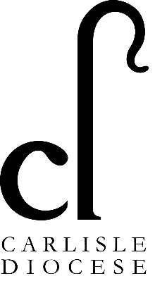

Closing date: 09:00 23rd September 2024.

Interviews: 30th September 2024.

Please return completed applications to:

[HumanResources@carlislediocese.org.uk](mailto:HumanResources@carlislediocese.org.uk)