

Archdeacon’s Executive Assistant

Do you inspire confidence in your colleagues?
Do you take pride in achieving results?
Do you want a new challenge?

The Diocese of Carlisle is looking for an

Archdeacon’s Executive Assistant

who will

- Provide efficient & effective support to the Archdeacon’s
- Diary management for three Archdeacon’s
- Act as first point on contact for enquiries, and provide solutions
- Secretarial duties including minute taking

This is a part-time position, 28 hours per week.
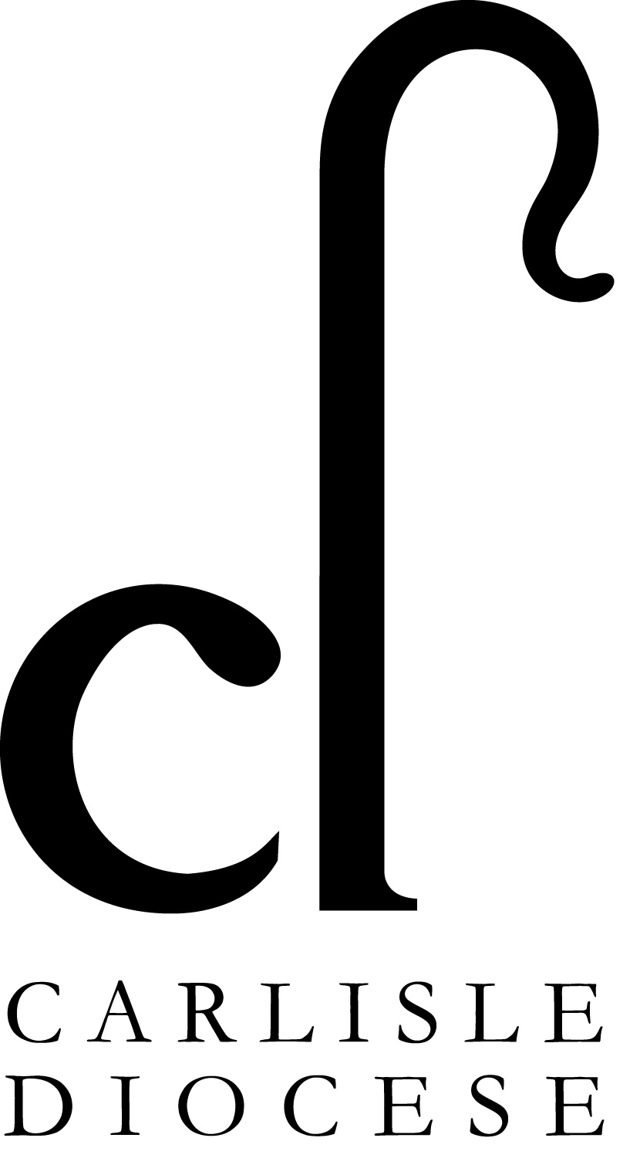
Salary: £29,826 FTE (pro rata) + 15% non-contributory pension

Closing date for applications: 9am Monday 22nd July 2024

Interviews: Thursday 1st August 2024

For the role description & Application form please visit https://www.carlislediocese.org.uk/vacancies/

Please send completed applications forms demonstrating how you meet the essential criteria to humanresources@carlislediocese.org.uk

