Network Youth
Church Lead –
Kendal Cumbria

RECRUITMENT INFORMATION
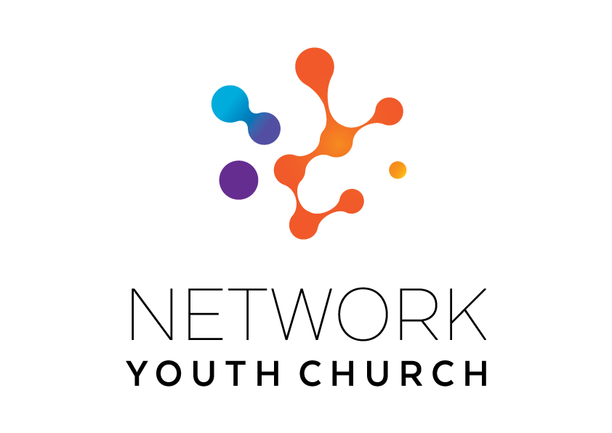
In this pack you will find:
Introduction to NYC
About Growing Younger in the Diocese of Carlisle
About the role
Information on the local area
Job Description and Person Specification
Key links for more information
Introduction to Network Youth Church
Network Youth Church is a new way of doing and being church with young people across Cumbria. We create spaces which are safe and welcoming, but don’t shy away from the big questions of life, working to encourage confidence, participation, understanding and growth. It is a part of the county-wide God for All strategy, which recognises that we need to develop different and new ways of being church, alongside those that already exist. This means that our work is informed by the strengths of the local church, but everything we do is governed by what works best for our young people, and that means doing things differently.

We began in response to low numbers of young people engaging with church in Cumbria ten years ago and have since grown into one of the most creative faith-based youth projects in the UK. We’re one of the largest providers of youth services in Cumbria, welcoming all young people. We take a pioneering and inclusive youth work approach to support the personal, social and spiritual development of young people across the county. NYC is open to all young people, regardless of who they are or what they believe.
NYC runs everything from drop-in youth clubs to question spaces, cafe spaces to prayer spaces, schools work to street-based youth work, outdoor activities, days out, and indoor sports. There are activities happening in halls, churches, cafés, classrooms and bus stops. There are large scale events which happen once a year, gathering all the young people from across NYC Cumbria, and there are smaller, more local events where young people from different areas can meet. We also provide opportunities for young people to go on different residentials: both locally and nationally run.

When the NYC is at full strength there are 11 NYC leads each responsible for the development of ministry across a deanery. We employ different approaches in different areas depending on the context and geography and each NYC has a local steering group to help set strategy, develop local connections and support the worker.

Staff are employed by the diocese and local work expenses are covered by the deanery. A local line manger helps oversee the work in partnership with Growing Younger Enabler for Youth who oversees the whole of NYC.

About Growing Younger and the Diocese of Carlisle

This is a significant, hope-filled but challenging time for the Church of England in Cumbria.

Alongside our ecumenical partners we have recently renewed our vision and strategy, God for All, as we look to the next decade.

The vision centres around four key values which frame our priorities:

1. Follow Daily:
We will help each other to follow Jesus more closely, seeking to grow as his disciples in all aspects of life, both corporately and as individuals
2. Care Deeply:
We will listen to our local communities and respond in loving service, seeking to transform injustice, challenge oppression and pursue peace & reconciliation.
3. Speak Boldly:
We will share our faith in Jesus Christ in everyday ways, seeking to connect with everyone, especially those currently unrepresented in our churches. We’ll do this in both time-honoured & pioneering ways.
4. Tread Gently:
We will strive to safeguard the integrity of God’s creation, seeking to sustain and renew the life of the earth.

These are the building blocks that help us define our core purpose as Church and our main tasks.

The Diocese of Carlisle covers (more or less) the County of Cumbria and is part of an ecumenical covenanted partnership with three other denominations - the United Reformed Church, the Methodist Church and The Salvation Army. The county is divided into 34 mission communities; local ecumenical groupings of parishes and other churches. mission communities bring together churches in a geographical location to share ministry and work together in mission and outreach.

We have recently been awarded funding from the national ‘People Capacity Funding’ enabling the recruitment of a Growing Younger Enabler for Youth to join us and help oversee Network Youth Church and the wider work with 10-25yrs.

One of our strategic areas is Growing Younger. As in so many places, our congregations are generally getting older and smaller. In the ten years from 2010 to 2019, numbers worshipping on Sunday in the diocese fell by 27% from 13,100 to 9,500. This decline has happened across all sizes of churches. Church attendance and membership in our less affluent urban areas is particularly low.

NYC has been a key element and over the last 10 years the diocese has invested in Network Youth Church (NYC) as a response to the challenges we are facing. NYC is a way of doing and being church that helps young people discover life in all its fullness, explore the Christian faith, the skills they need to live, learn, work, and interact successfully with other people, and engage with the wider world. Between 2016 and 2022, NYC has grown in core attendance by 33%. There are almost 2000 young people who interact with NYC, and around 800 core(regular) members.

We also have a strategic objective of growing younger in our leadership. Currently just under half of our clergy could potentially retire in the next 10 years, and only 9.4% of our ordained leaders are aged under 40. In 2022, the diocese relaunched its Intern Scheme, the Northern Young Leaders Project. This scheme is part of the Ministry Experience Scheme for the Church of England. We also partner with the Norwegian Mission Society to accept interns from across the globe. Working in placement churches, this year long scheme offers opportunities for young people to grow in leadership and explore their calling to ministry. In 2023, we had 8 interns on the scheme, some of whom work in NYC and are currently recruiting for the 2024 intake.

About the local area and Kendal role

This is an exciting time for NYC in the area. The deanery covers six mission communities all with varying degrees of engagement with young people. There are several key organisations to collaborate with and several employed lay youth, children’s and families workers, and pioneer ministers across the patch. The churches maintain a key presence in many of the towns and villages and have good connections with local primary and secondary schools.

NYC has not yet been started in the area so we are looking for someone keen to build and grow new youth ministry, with a vision for new forms of church and who will work well with partner agencies such as:
- The South Lakes Youth Matters Partnership who are exploring developing a dedicated youth venue in Kendal
- Kent Estuary Youth – Working across the Milnthorpe area
- The Family Project – Kirby Lonsdale

We will not be expecting the youth worker to be doing everything all at once and key part of the role will be listening to the local community and working out a strategic way forward with the Steering Group. That said we have already identified that it makes sense for the work to start in Kendal as it is the largest conurbation and has the least active youth ministry.

There are six mission communities across the deanery, three mission communities that make up the Kendal town and surrounding areas (Helm, Two Valleys, and Beacon). These three communities work collaboratively in the town centre but spread out from there to include a number of rural areas. There is one mission community for the Sedbergh area (called the Western Dales) another around Kirby Lonsdale and finally a mission community covering the Kent Estuary.

The three mission communities covering Kendal are:

Helm Mission Community which is made up of 7 churches, of 3 denominations, who currently engage with young people in a range of ways; through junior choir, Messy Church, clubs and worship and extensive engagement with local schools. We are keen to find new ways to share the Good News of Jesus with the young people in our communities. It covers much of the lower end of the High Street in Kendal with meeting points like the cinema and Abbots Hall Park. Kendal URC which own the 106 Community Space on the High Street is in this mission community.

Two Valleys Mission Community which includes a representative mix of local contexts: cherished village churches, Café Church, Messy and Forest Church and ministry in village and farming communities, 2 church primary schools forming hubs in village and town, a relatively large market town church with a span of ages, a busy children's and youth work and town & estate housing. The opportunity and challenges of service, discipleship and outreach across these contexts are diverse. We are 6 Parishes west of Kendal along the Lyth and Winster valleys: St Mary’s Crosthwaite, St Anthony’s Cartmel Fell, Holy Trinity Winter, St Paul’s Witherslack, St John’s Helsington and All Saints Underbarrow, St Catherines’ Crook, and St Thomas’s Kendal, which also seeks to work collaboratively in mission with town churches across Kendal.

Beacon Mission Community. The Beacon Team is made up of 6 parishes of various sizes and includes 3 Church of England primary schools and Queen Katherine Secondary school. There is currently an Open the Book team who visit the schools regularly and the Priest in charge conducts weekly Collective Worship too. There is a hope to develop a team Messy Church type activity and plenty of potential for other initiatives in time either with neighbouring mission communities or alone.

Then the three mission communities covering the rest of the deanery are:

The Western Dales Mission Community which is based in Sedbergh, Dent, and the surrounding dales (about 30 minutes east of Kendal). Ecumenism is important to our churches, which are Anglican, Methodist, and URC. We all regularly worship together and are praying for church growth. We are actively seeking to engage with younger people, with regular family services, Messy Church, Teatime Church, and our Ignite Youth Group.

The Kirby Lonsdale Mission Community is made up from the Rainbow Parish which works closely with the local Methodist Church to jointly fund the Family Project, the focus of which is to connect with and enable local families with young people up to age 13 to explore faith through pioneering and Fresh Expression forms of worship and church. Having seen significant discipleship and growth, we are ready and excited to empower our young people aged 13+ to continue their personal exploration of the Christian Faith by involvement with Network Youth Church. We have QES and QEStudio High Schools at Kirkby Lonsdale, both drawing their students from a huge geographical area and doubling Kirkby Lonsdale's population thereby offering huge potential for creating a youth work hub with those who attend.

The Kent Estuary Mission Community which consists of 7 Anglican and Methodist churches, with four full time clergy, covering Beetham up to Levens. One of the great pieces of work which is thriving in the area is the Kent Estuary Youth Project (KEY). KEY is now a stand-alone charity, which was started by the churches in the mission community. Their aim is to enable young people to unlock their potential with a programme which enables creative learning and opportunities. They have established youth groups in Arnside, Storth, Milnthorpe and Levens. Additionally, in recent months, as a mission community we have committed to worshipping together once a quarter and have started a lunch time drop in club at the local secondary school, Dallam, in partnership with NISCU.

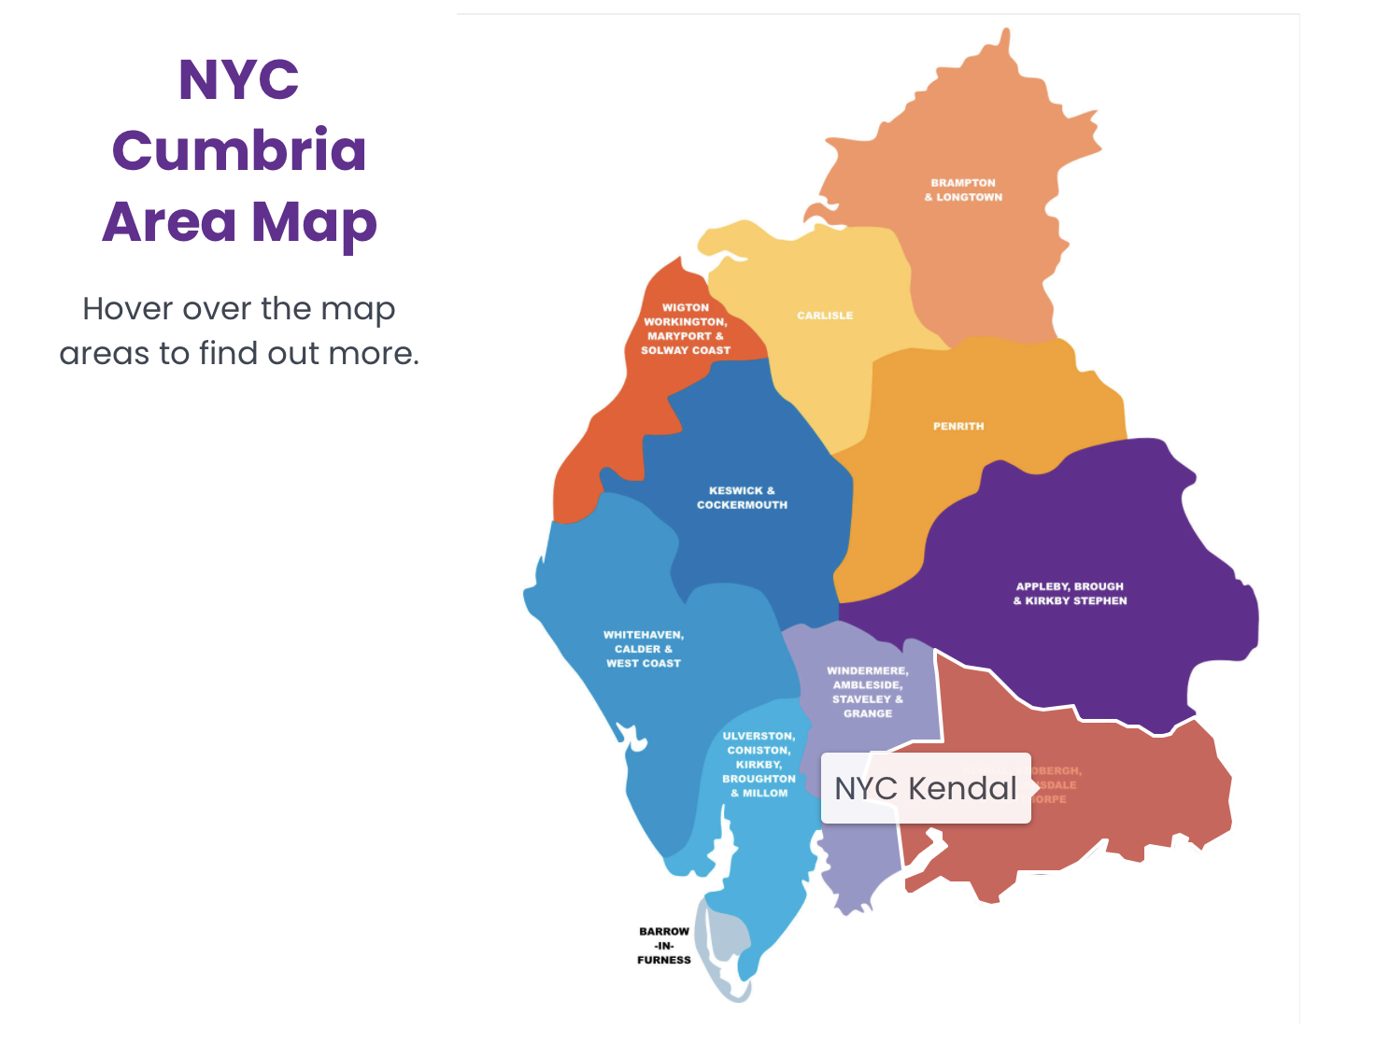

Job Description

JOB TITLE: Kendal Network Youth Church Lead
REPORTS TO: Local Line Manger and Growing Younger Enabler for Youth
DEPARTMENT : Kendal Deanery (including the mission communities of: Beacon, Helm, Kent Estuary, Kirkby Lonsdale, Two Valleys and Western Dales)
PURPOSE OF ROLE :

- To enhance and grow the personal, social, spiritual and emotional development of young people in the Kendal Deanery through Network Youth Church, focused on young people aged 11- 18 who are in school years 6-13.
- To develop youth Fresh Expressions that model “faithful improvisation” drawing on the best of tradition, culture and the bible, so that the work developed is sympathetic and informed about the strengths of time honoured church in rural areas, and connects across new and time honoured expressions of church.

KEY ACCOUNTABILITIES :
- To develop the growth of youth church in the mission communities of Kendal deanery using the NYC / Fresh Expressions model as appropriate

- To spend three months listening to assess what is already happening including working out relationships with schools, and NISCU and key partners in Kendal.

- To develop a strategy for engagement with young people outside of church contexts which may include a phased approach across the wider area.

- To provide and develop an environment/context in which young people can explore Christianity and be nurtured in the Christian faith.

- Work with the existing youth work across the mission communities (e.g. KEY, Kendal detached youth work, Family Project) to creatively form youth cells and develop church as God leads.

- To pray for the young people of Cumbria, particularly Kendal deanery.

- To provide pastoral and safeguarding oversight of the young people including use of social media

- To develop the talents and gifts of young people and volunteers, and support them to grow their leadership skills and service among the NYC as we partner with churches and charities to train and grow NYC and young leaders.

- To be an advocate and educator about youth culture, youth church and youth mission with local clergy, church members, church leaders and the wider community.

- To meet at regular intervals with the area NYC steering group and the wider NYC team.

- To work collaboratively with NYC, clergy, ecumenical partners, others involved in youth ministry and youth work (including Youth Matters Partnership)

- To work with the Steering Group to identify and secure funding for project work through the deanery and other sources.

- To develop age compliant and appropriate social media profiles with effective safeguarding ways of working at the centre to connect to new young people and develop online communities that link into onsite groups and churches and teach them how to use them safely.

- Facilitate opportunities for young people to go on both local and national events and residentials (e.g. Ablaze and 3Generate)

NETWORK (Key people with whom the role liaises)
INTERNAL : KEY, Kendal detached project, and The Family Project, Children’s and Families Workers and other Lay Leaders, local Clergy NYC Leaders, Safeguarding Adviser, Archdeacons (local operational managers), Diocese Ministry, Mission and Innovation Department, Employees
EXTERNAL : 106 URC, Links with all the key secondary schools in the area, various appropriate external organisations and statutory bodies, and where appropriate local councillors.

Person Specification

Experience
- An occupational requirement exists for the post holder to be a practicing Christian in accordance with the Equality Act 2010.
- A proven track record in work with young people principally of secondary school age
- Experience of contextual youth mission and outreach
- Experience in leading cell groups to nurture and disciple young people in the faith
- Able to demonstrate experience in growing young leaders

Knowledge
- Ability to demonstrate an understanding of the world of young people of secondary school age
- Hold a recognised qualification in youth work, Christian Youth ministry or mission
- Be aware of issues affecting young people living in rural communities & market towns
- Have knowledge and experience of contextual youth ministry and outreach and pioneering youth ministry
- Able to demonstrate a knowledge of safeguarding/health & safety requirements when working with 11 to 18 year olds

Skills and Aptitude
- Able to build and maintain respectful, child centred relationships with children and young people
- Able to effectively communicate with children, young people and families in ways which value them.
- Have a proactive commitment to mission embodied in a pioneering spirit.
- Demonstrable resilience which is supported by effective spiritual and wellbeing practices
- Able to build and lead a team of volunteers
- Be willing to work collaboratively with others involved in youth ministry
- Be willing to work with the clergy of the mission communities and attend Chapter meetings
- Be willing to work ecumenically with fellow Christians and other youth agencies
- Computer literate
- Able to write and deliver reports to Deanery Synod, Circuit and mission communities on the work as appropriate
- Able to plan a course of action and develop a ministry with support from others
- Be open to ongoing training
- Be able to work with young people from a diverse range of backgrounds and identities across a diverse area

Other
- As this post is about growing a Fresh Expression of Church we would hope the candidate would be willing to make NYC their main church and attend other churches in the Deanery as appropriate for the work.
- A willingness to work flexible hours in order to fulfil the requirements of the role, includes evenings & weekends
- The post-holder will be required to complete enhanced DBS checks
- Awareness of Health and Safety and Safeguarding procedures and practice
- Holds full UK driving license and has access to own transport
- Due to the geography of the area and relational nature of the post ideally the candidate would be willing to live in the Kendal Deanery area.

Desirable Criteria

Experience
- Experience of involvement with secondary schools
- Experience of detached youth work

Terms and Conditions

TERMS AND CONDITIONS

Salary: £29,826

Pension: Church of England Pensions Board Church Workers non-contributory, defined contributions scheme (employer’s contribution is 15% of salary).

Car: mileage paid at 45ppm

Office provision: TBC

Mobile phone: smartphone with remote access to email

Working expenses: fully funded through the deanery

Other benefits: 34 days annual including public holidays

Hours: 35 hrs per week with a flexi-time and TOIL system in operation. There will be a requirement to work outside normal office hours for some of the time.

This post is subject to an occupational requirement that the post holder be a practicing Christian under Part 1 of Schedule 9 of the Equality Act 2010.

Useful Links and Further Information:
Diocese of Carlisle: https://www.carlislediocese.org.uk/
God for All General: www.godforall.org.uk
Network Youth Church: https://www.networkyouthchurch.org.uk/
Northern Young Leaders Project: https://nylp.co.uk/
Ministry Experience Scheme: https://www.churchofengland.org/life-events/vocations/ministry-experience-scheme

