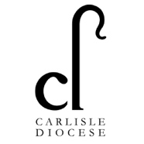
Full-time Mission Community Leader and
Priest-in-Charge - Living Waters Benefice*
(Allonby, Aspatria, Crosscanonby, Dearham, Gilcrux and Hayton)

Wanted:
Someone who is…
- an enabler of the ministry of all Christians
- inspiring and energetic with a conspicuous joy and deep faith
- a team worker and collaborator
- approachable and relational, with a good sense of humour
- down to earth and forward looking
- a good listener

Reward:
A fantastic group of parishes in beautiful North Cumbria, offering excellent mission opportunities, real community, and a lot of fun.

For an informal conversation, please contact Ven. Stewart Fyfe, Archdeacon of West Cumberland: 07552 428772.

For a profile and application form, please visit
www.carlislediocese.org.uk/vacancies
Closing date: 4th June 2024
Interviews: 3rd July 2024

*Pastoral reorganisation is planned to unite two Benefices and the successful applicant would initially be appointed as Priest in Charge of Allonby, Crosscanonby and Dearham and Priest in Charge of Aspatria with Hayton and Gilcrux.

