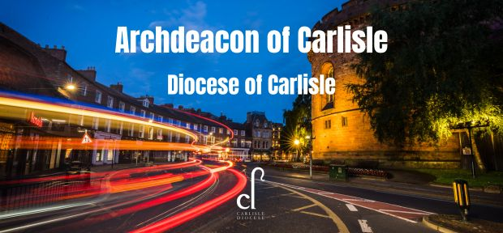

The Acting Bishop of Carlisle is looking to appoint a prayerful, faithful, resourceful and imaginative priest as Archdeacon of Carlisle.

At the beating heart of the Diocese of Carlisle is a love for Jesus Christ and a passion to spread the Good News, as together we seek God’s kingdom across this unique region. Our mission and ministry play out in a county of contrasts: the celebrated beauty of the Lakes sits alongside more gritty urban settings. This is a place where roots go deep and tradition is precious, but where we’re also willing to pioneer new pathways.

**Might God be calling you to join us?**

The Acting Bishop of Carlisle is seeking an Archdeacon who will:

* Contribute to the leadership of the diocese by
  + sharing closely with the Bishop in the pastoral care of clergy, lay leaders and churches,
  + working collaboratively with other members of the Diocesan team.
* Implement the ecumenical God for All vision in the Archdeaconry of Carlisle by
  + encouraging and equipping local leaders and local churches across our mixed ecology of church,
  + establishing new initiatives, mission communities, church plants and pioneering ministry,
  + using all the statutory functions of an Archdeacon to progress the strategy.

The Archdeacon of Carlisle will need to be:

* a prayerful and pastoral person of deep and hope-filled faith,
* a person with imagination and resilience,
* able to work with legal processes and handle difficult situations,
* able to work well with people from all backgrounds, church traditions and denominations,
* passionate about mission and helping people grow as disciples of Christ.

Background information and application papers are available from [Diocese of Carlisle - Vacancies (carlislediocese.org.uk)](https://www.carlislediocese.org.uk/vacancies/). We encourage a broad range of applicants, including those who would potentially increase the diversity of the Bishop's Leadership Team. Applicants should have been a priest with at least six years’ ordained experience. Applicants are strongly encouraged to arrange a telephone conversation with the Acting Bishop of Carlisle as part of their discernment. Please telephone the Bishop’s Office on 017687 73430 to arrange an appointment.

Applications should be sent to [Liz.Howson@carlislediocese.org.uk](mailto:Liz.Howson@carlislediocese.org.uk)

Closing date for applications: 15th February 2024

Interviews: 15th March 2024