

Administrator

The Diocese of Carlisle is looking for an

Administrator

who will

- Provide efficient & effective admin support to the Diocese
- Manage and maintain online systems ensuring data is accurate and up to date
- Oversee end to end administration of processes
- Be willing to work between Penrith & Keswick Offices

This is a part-time position, 21 hours per week.
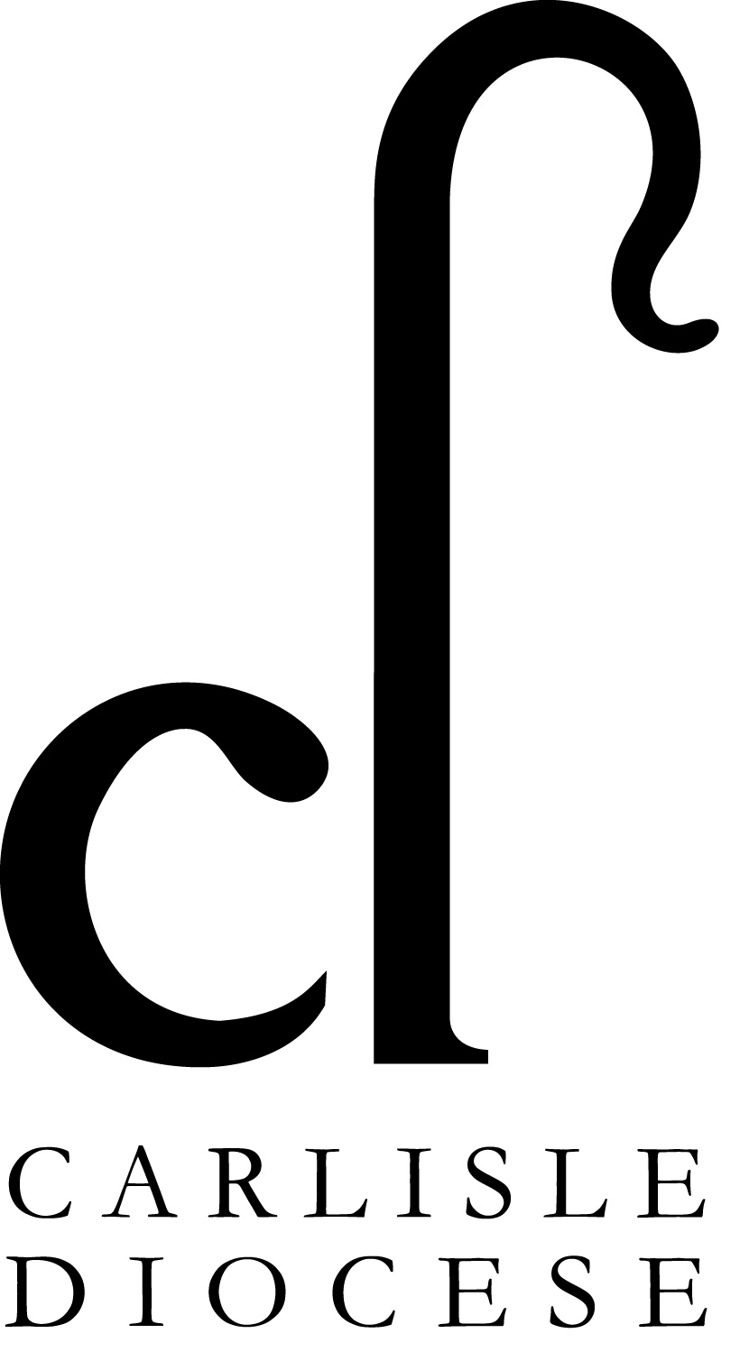
Salary: £21,884.00 pro rata + 15% non-contributory pension
Fixed term until end of August 2024.

Closing date for applications: 9am Monday 11th December 2023

Interviews: Thursday 14th December 2023, Church House, Penrith

For the role description & Application form please visit https://www.carlislediocese.org.uk/vacancies/

