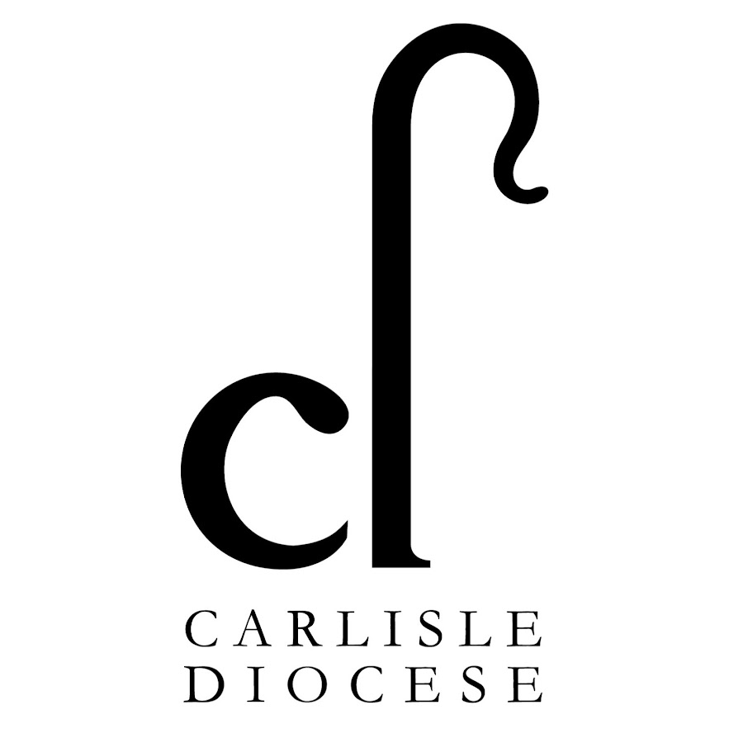

**Full-time Rector**

**Harrington and Distington**

**Wanted**:

Someone who…

* is prayerful and open to the leading of the Holy Spirit
* will make Church joyful and relevant
* is down to earth
* is a natural collaborator and encourager
* can do traditional ministry and innovation
* is willing to be part of two really special local communities

**Reward**: two fantastic parishes on the West Coast of Cumbria, offering excellent mission opportunities, real community, and a lot of fun.

For an informal conversation, please contact Julia Powley 01946 830215 until 3 May. From 3 May contact Ven. Stewart Fyfe, Archdeacon of West Cumberland: 07552 428772.

For a profile and application form, please visit

<https://www.stmarys-harrington-and-holyspirit-distington.co/>

Closing date: **31 May 2022**

Interviews: **30 June 2022**