Chief Operating Officer

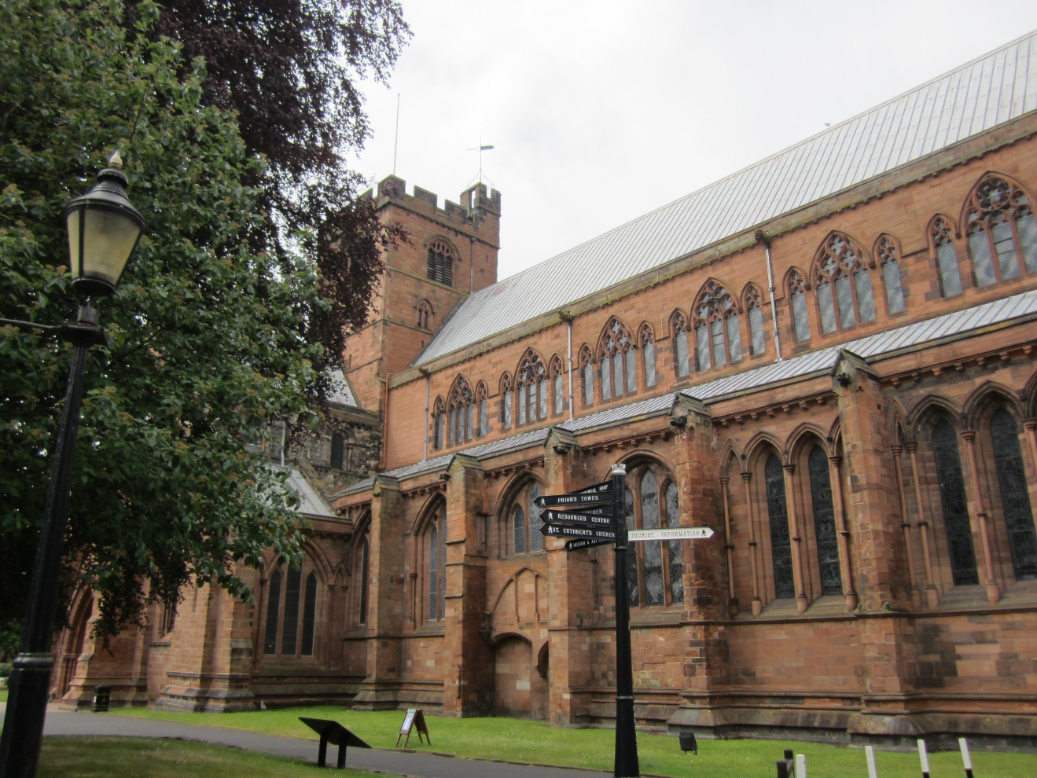

March 2020

The role

The Chief Operating Officer (COO) is the senior non-Chapter employee of the Cathedral. The COO is responsible to the Chapter through the Dean for the operational management of the Cathedral, in support of its mission and in line with the Chapter’s strategy and policies.

The Chief Operating Officer is one of the Chapter’s key appointments. It is a unique role, with responsibilities akin to those of an operations director in a commercial or not-for-profit organisation, or to those of a senior civil servant.

The COO carries wide-ranging responsibilities across the Cathedral’s life. Although not a Chapter member, the COO has a seat and voice at Chapter meetings.

New legislation governing Cathedrals is currently working its way through the Church’s legislative processes and will bring modest alterations to some aspects of the role listed below.

Job Description

The Chief Operating Officer
is responsible to the Chapter through the Dean who is the COO’s line manager. The COO assists the Chapter in building up the Cathedral community, which includes employees, volunteers and worshippers, as it serves the city of Carlisle, the county of Cumbria and its visitors.

Key responsibilities and accountabilities

Commercial activity
- manages the Cathedral’s commercial activity and ensures ethical trading performance;
- line manages Cathedral staff with day to day operational responsibility for catering, retail and hospitality;
- monitors and reports progress against Chapter’s business plan.

Our Property
- manages the Cathedral precinct investment properties, major building projects and
the maintenance of the Cathedral’s built heritage.

Finance, Investments and Fund Raising
- manages developments to achieve financial sustainability, the production of the budget, annual report and audited accounts and optimises the efficient use of resources
- oversees the professional management of the Cathedral’s investment portfolio with the Chapter Treasurer;
- promotes effective fund raising activity in liaison with the Dean and the Chair of the Carlisle Cathedral Development Trust.

Communications and Media
- manages the Chapter’s communications and publicity;
- represents the Cathedral to external bodies and agencies as appropriate.

Safeguarding
- actively supports and encourages the Cathedral’s strong safeguarding culture.
- works closely with the Chapter Safeguarding Lead who manages safer recruitment.

Governance
- ensures that the Chapter meets its statutory and constitutional obligations;
- manages Chapter’s HR, health and safety, data protection, sustainability policies and compliance.

The Chief Operating Officer line manages the Head Verger’s non–liturgical duties, the Head of Visitor Services, the Events Manager, the Café Manager and the Works Team.

The key bodies with which the Chief Operating Officer will work are the Chapter, the Finance Committee, the Surveyor to the Fabric and the Fabric Advisory Committee, the Cathedral Council and such other sub-committees and working groups as are appointed by the Chapter.

Person Specification

The Chief Operating Officer will

- demonstrate successful management of a complex organisation of comparable size;
- have extensive and proven people management skills with a proven record of developing and motivating a diverse team to work together to drive strategic, commercial and operational initiatives;
- have significant understanding of financial management systems;
- be able to understand the vision of the Chapter and the culture of a Cathedral community and to plan accordingly;
- be committed to work with the Christian values and ethos that inform the life and work of the Cathedral;
- have a good understanding of the charity sector, including the management of volunteers;
- have excellent presentation and communication skills;
- have a degree level qualification or equivalent.

The COO will lead by example with integrity, energy, drive, resilience and good humour.

Chapter’s strategic vision

The Chapter’s vision is to bring the love of God to city, county and nation through worship, witness, hospitality and welcome. Faithful worship, active discipleship, outward-looking mission, life-long learning, service to the community, and joyful celebration are important, and in each of these aspects of the Cathedral’s life the Chapter continues to draw inspiration from its Augustinian heritage.

Building on the Cathedral’s long spiritual heritage and strength, Chapter aims to promote loving community where justice is seen to matter, common humanity is owned, people can find support, nurture and blessing and in which lives can be transformed and renewed. Worship is the beating heart of the Cathedral from which both activity and service to our communities flow. Careful pastoral engagement by the clergy, day chaplains and pastoral teams reflects Christ’s great love for all people, and Chapter places a very high value on the safeguarding of children and those who are vulnerable.

Chapter is driving towards sustainability. Its businesses, café/events/shop, are overseen by the directors of the Cathedral’s trading arm (Carlisle Cathedral Enterprises Ltd.) and the Business Working Group oversees performance against Chapter’s Business Plan. Chapter’s programme of activity shapes the ways in which the Cathedral engages with visitors, schools and communities to promote public engagement with our history, faith and collections. The Chapter aims to make a significant contribution to the City’s cultural and heritage economies.

A team of more than 100 volunteers supports very many aspects of the Cathedral’s day-to-day operation.

The Chapter is engaged with several projects to deliver its vision.

The Fratry - Bringing Untold Stories to Life for Everyone
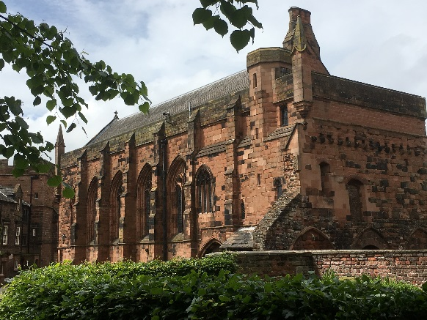
A £3.5 million National Lottery Heritage Fund partner project (which won a £2 million NLHF grant in 2018) will bring the Fratry building, the former monastic dining hall and Undercroft, into daily, accessible use in May 2020. A beautiful contemporary building, built where the west cloister range once stood, will offer excellent hospitality. The Undercroft will house a new learning space and the magnificent Upper Hall will have new interpretation and offer a multi-purpose space seating 120. The Chapter has re-shaped roles and employed new staff to deliver these outcomes and a new Events business. (During the active fund-raising period of the Fratry project, a parallel “Riandu” project to build a school for deaf children in Kenya has received 10% of congregational pledged giving.)

West Walls
The Carlisle Cathedral Development Trust has recently bought the former Carlisle Diocesan Office and Resource Centre buildings (the latter now let to St George’s URC) and a staged project is under way to develop the car parking, short-term letting of office space, and the eventual re-location of the Cathedral office.

Music
The Chapter gives strong financial support to the Cathedral’s music department to maintain the Cathedral’s English choral tradition. Sunday worship is supported by the Cathedral’s Boys’ and Girls’ Choir who sing with the 6 Lay Clerks. The Cathedral Consort of teenage singers sing once a week and on occasional Sundays. Choristers are recruited during Year 3 from local primary schools. Choral Evensong is sung each weeknight except Saturdays. The voluntary adult Carliol Choir sings on some Sundays outside the Cathedral Choir term.

Music is overseen by the Dean. Operationally, it is under the direction of the Director of Music supported by the Assistant Organist and Organ Scholar. There is a strong school outreach programme. Development of endowment funding for music has been identified as an important medium-term aim.

Terms of appointment

Contract Permanent

Salary circa £40,000 - £45,000

Location Cathedral Office, 7 The Abbey, Carlisle. CA3 8TZ

Annual Holiday 26 days plus 8 public holidays, the dates to be agreed with the Dean, and to take account of the needs of the Cathedral. At the discretion of the employing body, additional time off may be granted between Christmas and New Year.

Hours 35 hours per week Monday – Friday. The seniority of this post brings with it the need for considerable flexibility including working such additional hours as are necessary for efficient performance of the role, and occasional weekend and evening work.

Pension The COO will be automatically enrolled into the Church Workers’ Pension Scheme. The Chapter contributes 7% of annual income and the employee a minimum of 5% (April 2019). Additional Voluntary Contributions may be made.

Additional Requirements This position line manages safely recruited staff and has significant contact with and some oversight of those made vulnerable by age or circumstance. A satisfactory enhanced certificate from the Disclosure and Barring Service will be required before employment commences together with successful completion of Church of England safeguarding training at C0 and C1 levels. Further training to advised levels will be required to be completed within 6 months of commencement.

Offer of employment Dependent upon the receipt of three satisfactory references, (present employer/professional person with knowledge of performance/ unconnected with employment), and successful safer recruitment as above.

Review The post is subject to a six month probationary period during which employment may be terminated by either party after 1 months’ written notice. After the probationary period, 3 months’ notice is required. The post is subject to formal and informal review.

Other General terms and conditions of employment as set out in the Employee Handbook, issued to all staff on appointment apply. A copy may be inspected at interview upon request. In the Cathedral Statutes and Constitution, the COO post is presently referred to as the Bursar & Chapter Clerk.

How to apply
Preliminary informal conversations are invited via email or telephone with the Dean, The Very Revd. Mark Boyling (01228 523335, dean@carlislecathedral.org.uk), or the Canon Warden, The Revd. Canon Jan Kearton, (01228 521857, canonwarden@carlislecathedral.org.uk).

Application is by the supplied forms only with electronic submission. CVs are not accepted and should not be included. Applications should be sent to: Ali.Ng@carlislediocese.org.uk

Please attach the following to your submission:
- a completed equal opportunities monitoring sheet. Applications from all groups are warmly welcomed;
- A covering note of not more than 750 words summarizing your proven ability in relation to the person and job specifications.

The deadline for receipt of applications is 12 noon on April 8th 2020

All candidates will be informed by email of the results of the shortlisting process on April 11th 2020.

At the time of writing, Monday April 20th 2020 has been reserved for interviews. Candidates should ensure that they are available on this date. Decisions about how and where these interviews will be held will be made nearer the date in line with advice received from HM Government during the Coronavirus outbreak.

The following documents are attached
Application form
Privacy Notice
Recruitment Monitoring form
Additional Information pages

APPLICATION FORM

Please complete all pages in full Confidential

Post Applied for:

PERSONAL DETAILS
Title: (Mr, Mrs, Miss, Ms, etc.)

Surname:

Forenames:

Address:

Post code:

Telephone: Mobile:

E-mail address:

National Insurance Number:

Employment (current/most recent)
Name and Address of current/most recent Employer:

Telephone:

Post held:
From: To:
Salary:
Notice period required:
Reason for leaving:

Please give details of your main duties and responsibilities:

Employment Experience: please give details of your previous employment (most recent first)

Name of Employer | Position held | To/From | Reason for leaving

Education and Training:
Please give details of secondary education, further/higher education and
Qualifications gained.

School/College/University | From | To | Subjects/Examination results

Other qualifications and relevant training:

Membership of Professional Bodies etc:

Hobbies/Interests:

ADDITIONAL INFORMATION TO SUPPORT YOUR APPLICATION
Please give details of your relevant skills, knowledge and experience (see job description and person specification)

REFEREES
Please give the name of three referees, not related, who are able to provide us with information
to support your application. One should be your most recent employer, one from a professional person who is not the current employer but has associated knowledge of your performance and one from outside the context of employment.

Please note: employment will only be commenced on receipt of the references.

Name:  Position:  Relationship:  Address:  Tel No:  E-mail:  May we contact prior to interview  Yes/No | Name:  Position  Relationship:  Address:  Tel No:  E-mail  May we contact prior to interview  Yes/No
Name:

Position

Relationship:

Address:

Tel No:

E-mail

May we contact prior to interview
Yes/No

Rehabilitation of Offenders Act:

Do you have any convictions, cautions, reprimands or final warnings that are
not “protected” as defined by the Rehabilitation of Offenders Act 1974
(Exceptions) Order 1975 (as amended in 2013) by SI 2013 1198’
http://www.legislation.gov.uk/uksi/2013/1198/pdfs/uksi 20131198 en.pdf
Please give details:

Should you require any special arrangements for your interview eg. special equipment or access arrangements, please give details below. We will contact you prior to any interview to discuss this further.

Other details:

Are you, to your knowledge, related to any member of staff or any member of Carlisle Cathedral.
If yes, please give details:

Please state where you saw the job advertisement (website/newspaper/other)

DECLARATION

- I understand that an offer of appointment will be subject to satisfactory references and successful safer recruitment (including an enhanced DBS check).
- I understand that providing false or misleading information will disqualify me from any appointment or if appointed will render me liable to dismissal without notice.
- I declare that the information I have given is, to the best of my knowledge, true and complete.

I agree that the information provided is to the best of my knowledge correct and complete.

Signature: Date:

Please return your completed application by the closing date to:

ali.ng@carlislediocese.org.uk

Applicant and Candidate Privacy Policy
Chapter of Carlisle Cathedral and Carlisle Cathedral Enterprises Ltd (together ‘the Cathedral’ or ‘we’) are committed to respecting the privacy of their job applicants and we have a duty to protect the personal data of job applicants. Personal data is information that can identify a person, such as name, address, telephone number and email address.
Types of information we collect
This policy covers the information you share with us and/or which may be acquired during the application or recruitment process including:
The organisation collects a range of information about you. This includes:
- your name, address and contact details, including email address and telephone number;
- details of your qualifications, skills, experience and employment history;
- information about your current level of remuneration, including benefit entitlements;
- whether or not you have a disability for which the organisation needs to make reasonable adjustments during the recruitment process;
- information about your entitlement to work in the UK; and
- equal opportunities monitoring information, including information about your ethnic origin, sexual orientation, health and religion or belief.
The organisation collects this information in a variety of ways. For example, data might be contained in application forms, CVs or resumes, obtained from your passport or other identity documents, or collected through interviews or other forms of assessment, including online tests.
The organisation will seek information from third parties only once a job offer to you has been made and will inform you that it is doing so.
Data will be stored in a range of different places, including on your application record, in HR management systems and on other IT systems including email.
How we use information we collect
Your information will be used by the Cathedral for the purposes of carrying out its application and recruitment process which includes:
- Assessing your skills, qualifications and interests against our job opportunities;
- Verifying your information and carrying out reference checks and/or conducting background checks (where applicable) if you are offered a position;
- Communications with you about the recruitment process and/or your application(s), including, in appropriate cases, informing you of other potential job opportunities;
- Making improvements to the Cathedral’s application and/or recruitment process including improving diversity in recruitment practices;
- Complying with applicable laws, regulations, legal processes or enforceable governmental requests.

We will also use your information to protect the rights and property of the Cathedral, our affiliated organisations, applicants, candidates, employees or the public as required or permitted by law.

If you are offered and accept employment with the Cathedral, the information collected during the application and recruitment process will become part of your employment record.
Who has access to data?
Your information may be shared internally for the purposes of the recruitment exercise. This includes members of the HR team, recruiting managers and interviewers involved in the recruitment process. The organisation will not share your data with third parties (although it may do so with our affiliated organisations) unless your application for employment is successful and it makes you an offer of employment. The organisation will then share your data with former employers to obtain references for you, employment background check providers to obtain necessary background checks and the Disclosure and Barring Service to obtain necessary criminal records checks. It is your responsibility to obtain consent from referees before providing their personal information to the Cathedral.
The organisation will not transfer your data outside the European Economic Area.
How does the organisation protect data?
The organisation takes the security of your data seriously. It has internal policies and controls in place to ensure that your data is not lost, accidentally destroyed, misused or disclosed, and is not accessed except by our employees in the proper performance of their duties.
For how long does the organisation keep data ?
If your application for employment is unsuccessful, the organisation will hold your data on file for six months after the end of the relevant recruitment process. If you agree to allow the organisation to keep your personal data on file, the organisations will hold your data on file for a further six months for consideration for future employment opportunities. At the end of that period or once you withdraw your consent, your data is deleted or destroyed.
If your application for employment is successful, personal data gathered during the recruitment process will be transferred to your personnel file and retained during your employment. The periods for which your data will be held will be provided to you in a new privacy notice.

Your rights
As a data subject, you have a number of rights. You can:
- access and obtain a copy of your data on request;
- require the organisation to change incorrect or incomplete data;
- require the organisation to delete or stop processing your data, for example where the data is no longer necessary for the purposes of processing; and
- object to the processing of your data where the organisation is relying on its legitimate interests as the legal ground for processing.
If you would like to exercise any of these rights, please contact the Cathedral Office.
If you believe that the organisation has not complied with your data protection rights, you can complain to the Information Commissioner.

What if you do not provide personal data?
You are under no statutory or contractual obligation to provide data to the organisation during the recruitment process. However, if you do not provide the information, the organisation may not be able to process your application properly or at all.

Automated decision-making
Recruitment processes are not based solely on automated decision-making.

RECRUITMENT MONITORING FORM
Please complete this monitoring form and send it direct to Mrs Ali Ng, HR Manager, Church House, 19-24 Friargate, Penrith, CA11 7XR or ali.ng@carlislediocese.org.uk The information will not be used as part of the selection process and will enable the Cathedral to monitor the diversity of those applying for the post.
Application for the post of:
1 What is your ethnic group?
A White
White UK |  |  |  |  | Irish
White non UK
White UK
Any other white background
(please give details)
B Mixed
White and black Caribbean |  |  | White and Asian
White and black African
Any other mixed background
(please give details)
C Asian or Asian British
Indian |  |  | Pakistani
Bangladeshi
Any other Asian background
(please give details)
D Black or black British
Black Caribbean |  |  | Black African
Any other black background
E Chinese or other group
Chinese |  |  | Vietnamese
Any other ethnic group (please give details)
2 Gender
Male |  |  |  |  | Female
3 Age Group
16 – 25 |  |  |  |  | 26 – 35
36 – 45 |  |  |  |  | 46 – 55
56 – 65 |  |  |  |  | 66 – 70
Over 70
4 Disability
Do you consider yourself to have a disability or a long term health condition?
Yes |  |  |  |  | No

Additional information
History
Carlisle Cathedral stands at the heart of its city. One of the oldest and best-known buildings in Carlisle, it is a key heritage asset and a landmark within the City’s ‘Historic Quarter’. Excavations on parts of the precinct have revealed the presence of both early settlement and churches on the precinct site.

The Priory of St Mary
In 1122, when Carlisle was already an important commercial and religious centre, Henry I founded a house of Canons Regular, living according to the Rule of Augustine of Hippo. Athlewold, his confessor, became its first prior. The Augustinian priest Canons never sought separation from the world but undertook a wide range of pastoral and educational work. The Order’s openness and the work of its priest Canons is an enduring inspiration for the Cathedral Chapter as they shape the strategic vision and daily life of the Cathedral.

The First Cathedral Foundation
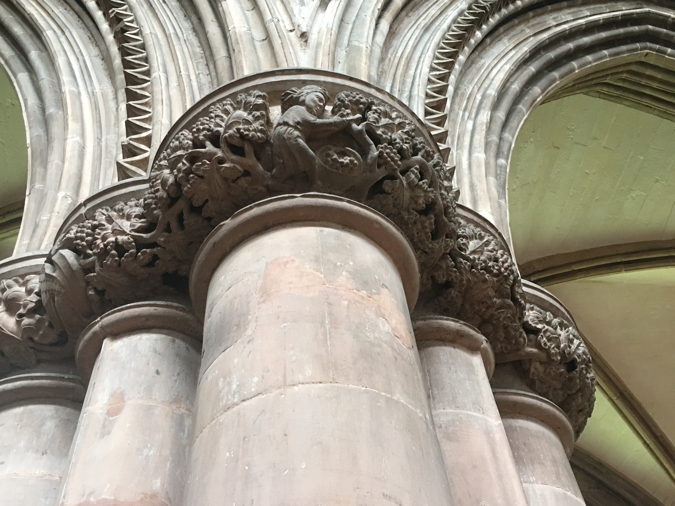
At the founding of Carlisle diocese in 1133 the priory church become its new Cathedral, and Athelwold its bishop. The Norman east end of the Cathedral was demolished in the thirteenth century to make way for the Early English choir, but this was substantially lost in the fire of 19th May, 1292. Later rebuilding was in the decorated style.

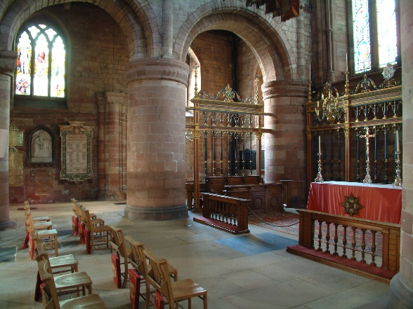
In 1380 during a fierce storm the upper portion of the Cathedral tower collapsed onto the north transept. Rebuilding in the perpendicular style, the bishop of Carlisle endowed the new tower with four bells, one of which survives. The Percy arms mark the governorship of Carlisle by Henry Percy (Hotspur). The present Cathedral building combines work from the Norman, decorated and perpendicular periods.
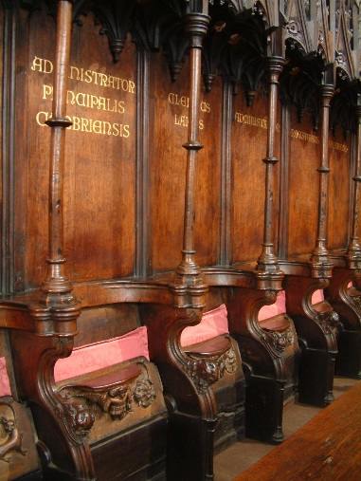
The Second Cathedral Foundation
The great monastery of Carlisle was dissolved on 9th January 1540 and the new foundation, the Cathedral Church of the Holy and Undivided Trinity, came into being on 2nd May 1541. A century of neglect began: the nave and some of the monastic buildings became ruinous and were destroyed between 1639 and 1652. Four sets of medieval paintings survive on screen panels and the Cathedral has a large, well-carved set of misericord stalls dating from 1410.

The Cathedral and its buildings bear the scars of its contested position on the border with Scotland. Around 1650, though they were probably in poor conditions, five bays of the nave, the west end and the west door were destroyed. Cromwell’s troops were billeted in the nave, and it’s said that the nave stone was taken to reinforce Carlisle Castle. Interesting medieval buildings from several stages of the Priory and Cathedral’s evolution are, however, preserved.
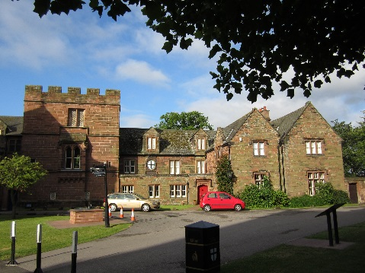
The presbytery ceiling was restored by Ewan Christian and finely painted by Owen Jones in 1856.

The Cathedral Close has a fine Tudor Deanery and Prior’s Tower, and other Queen Anne, Georgian, Victorian and Edwardian housing.

The Cathedral today
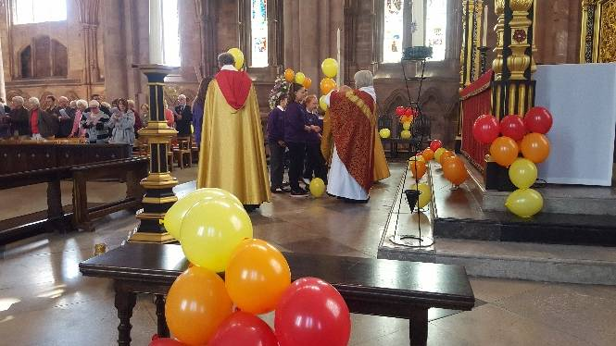
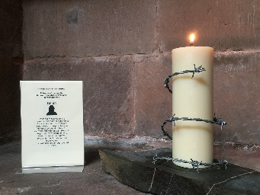
In the Cathedral church, daily prayer and worship has been offered to God for nearly 900 years, and almost 1300 services are offered each year. Worship is a living witness to faith in Jesus Christ. Chapter’s aim is that it should be relevant to the communities within which we are set and whom we serve, and sufficiently powerful and beautiful to enable people to connect with God and reflect on their daily lives. Carlisle Cathedral is the Mother Church of the diocese of Carlisle and the seat of its missionary bishop.

Though regularly filled with visitors or ringing to the sound of organ and choir practice, the Cathedral Church remains a calm and distinct space to those seeking peace and is a focus for those offering private prayer and lighting memorial or petitionary candles. The newly refurbished Welcome Centre offers a warm greeting to visitors.

The Cathedral’s work is carried out by 30 paid staff, supported by more than 100 volunteers. Governance of Cathedrals is described in The Cathedrals Measure (1999) and their care and maintenance in The Care of Cathedrals Measure (2011). Some of the provisions of the 1999 Measure will be revised by a new Cathedrals Measure which is expected to receive final approval at General Synod in July 2020. The Cathedral has its own Statutes and Constitution which will need to be revised to meet the requirements of the new Measure.

The Dean, who takes the lead with liturgy and fabric issues, has oversight of the spiritual life of the Cathedral and its operation, and chairs many of the Cathedral boards, committees and associations. The Dean is supported by two Canons Residentiary: the Canon Warden’s portfolio includes oversight of safeguarding, together with membership of many of the Cathedral boards, committees and associations, and oversight of the arts, culture and learning offer at the Cathedral. The Canon Missioner’s portfolio includes the pastoral care of the congregations, visitors and staff, development and implementation of the Chapter’s intentional mission strategy, oversight of Young Cathedral, Cathedral chaplains, fresh expressions of church, enquirers and new disciples, and ecumenical links in the city.

The Dean and two Canons live in the Cathedral precinct alongside the Chapter’s tenants, the Director of Music and the Head Verger. The Precinct is a local daytime thoroughfare and is treasured by the community as an attractive green space in the heart of the city. The Chapter welcomes those who come to find peace, space and refreshment here during the day.

Life in Carlisle
Carlisle is a small city of 103,500 people (2019/20). Approval has been given to build the Garden Village, and the City Council has ambitions to grow both the City and its employment opportunities further. By car, the Lake District, an area of outstanding natural beauty, and its lakes and fells can be reached in 45 minutes. Allonby beach is 40 minutes away and St Bees beach an hour. Carlisle is a main station on the west coast mainline (London three and a quarter hours) and is 9 miles from the Scottish border. By train, Glasgow and Edinburgh are an hour and half away, as is Newcastle upon Tyne. The Solway coast, a further area of outstanding natural beauty, is also nearby.
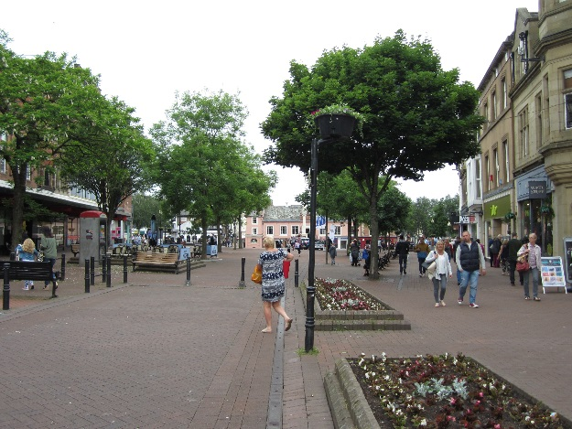
Carlisle has a good range of both local and nationally-recognizable shops. Some are situated around the attractive city-centre pedestrian Green Market, where cafés and coffee shops spill onto the square. Others can be found in the city’s several outer retail and industrial estates. Events ranging from farmers’ and continental markets to live music are regularly offered.

The University of Cumbria now has the power to award research degrees and is building its research base. Plans are under development to expand the university’s existing City campuses to include a location in an iconic building at the heart of the City. University graduations are held in the Cathedral twice a year and the Cathedral is currently developing its extant Memorandum of Understanding with the university into a Memorandum of Cooperation.

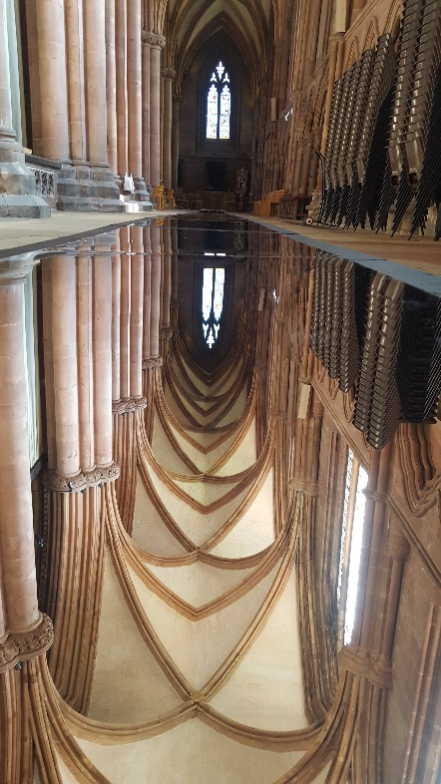
The city has several arts venues such as the Sands Centre, the Old Fire Station, and Tullie House Museum and Art Gallery. The Sands Centre presents a wide range of activities and productions ranging from roller discos to symphony orchestra concerts, ballet and operas. The Old Fire Station is a contemporary exhibition and performing arts space. Productions are streamed from Covent Garden, London theatres and USA and European venues to the city’s Vue Cinema. The Theatre by the Lake in Keswick is 45 minutes’ drive away, and is noted for the quality of its productions and its literary events. The Cathedral is a venue for the city’s Borderlines Book Festival events and also for CArt exhibitions and installations.

Carlisle is an enjoyable place to live. A Rightmove survey of 25,000 participants revealed that Carlisle is England’s most contented city, noting affordability, security, an ability to feel at home and strong community values as significant. Housing is available both in the city centre and in its very attractive outlying villages.

Local employers include BBC Radio Cumbria, Border TV, Pirelli, Nestle, United Biscuits and the Cumberland News Group. Elsewhere in the county farming, tourism and the Sellafield nuclear reprocessing plant dominate the economy.

