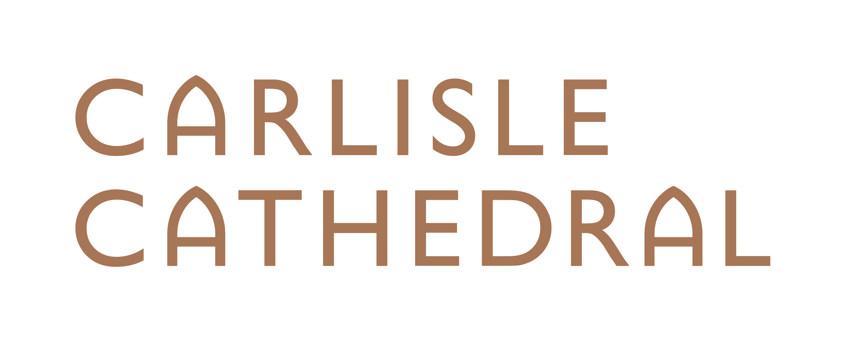

Chief Operating Officer

As a new era unfolds, are you able to make
a significant senior contribution at Carlisle Cathedral?

The Chapter of Carlisle Cathedral wish to appoint
a senior lay officer to help embed recent change and manage many aspects of the daily operation of this medieval Cathedral.

This is a challenging, exciting and rewarding post which offers a unique opportunity to make a lasting difference to the Cathedral’s life and mission.

Salary circa £40,000 - £45,000 p.a.

Applications: Mrs Ali Ng, HR Manager,
Ali.Ng@carlislediocese.org.uk

Closing date: Noon, April 8th 2020.

Interviews: Monday April 20th 2020 has been reserved.

