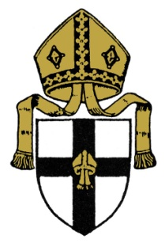
Mitre Housing Association

Recruitment of Board Members

April 2023

The availability of affordable rented housing for local people is a major issue for communities across Cumbria. The shortage of it has a direct impact on families and communities. Mitre Housing Association was set up by the Diocese of Carlisle to take positive action about this.

We are an independent registered housing association, with 154 units under management, an active development programme and the resources to do more. Our focus is on small scale developments in rural areas.

We are committed to high standards both as a landlord and developer. We employ Eden Housing Association as our Managing Agents, giving us access to the professional expertise that we require operationally.

We now want to strengthen our Board in its strategic and governance role.
To help us fulfil our aspirations and drive forward our ambitious strategic plans, we are recruiting additional Board Members who are comfortable with our Christian values. We are looking for people with skills and experience in Finance, Customer Service and Housing Mangement, gained in housing or transferrable from other sectors, preferably at a senior level. We are also keen to ensure that our Board is representative of our tenants and the communities we serve.

Board Members are unpaid, but all reasonable expenses will be paid. The role requires attendance at Board meetings which are typically held four times a year in Penrith, in addition to an Annual General Meeting in early summer.

For further information and an application form see https://www.carlislediocese.org.uk/social-justice/mitre-housing/
or contact: governance@edenha.org.uk or 01768 861402.

Closing date for applications is 5pm on Tuesday 9th May 2023.

