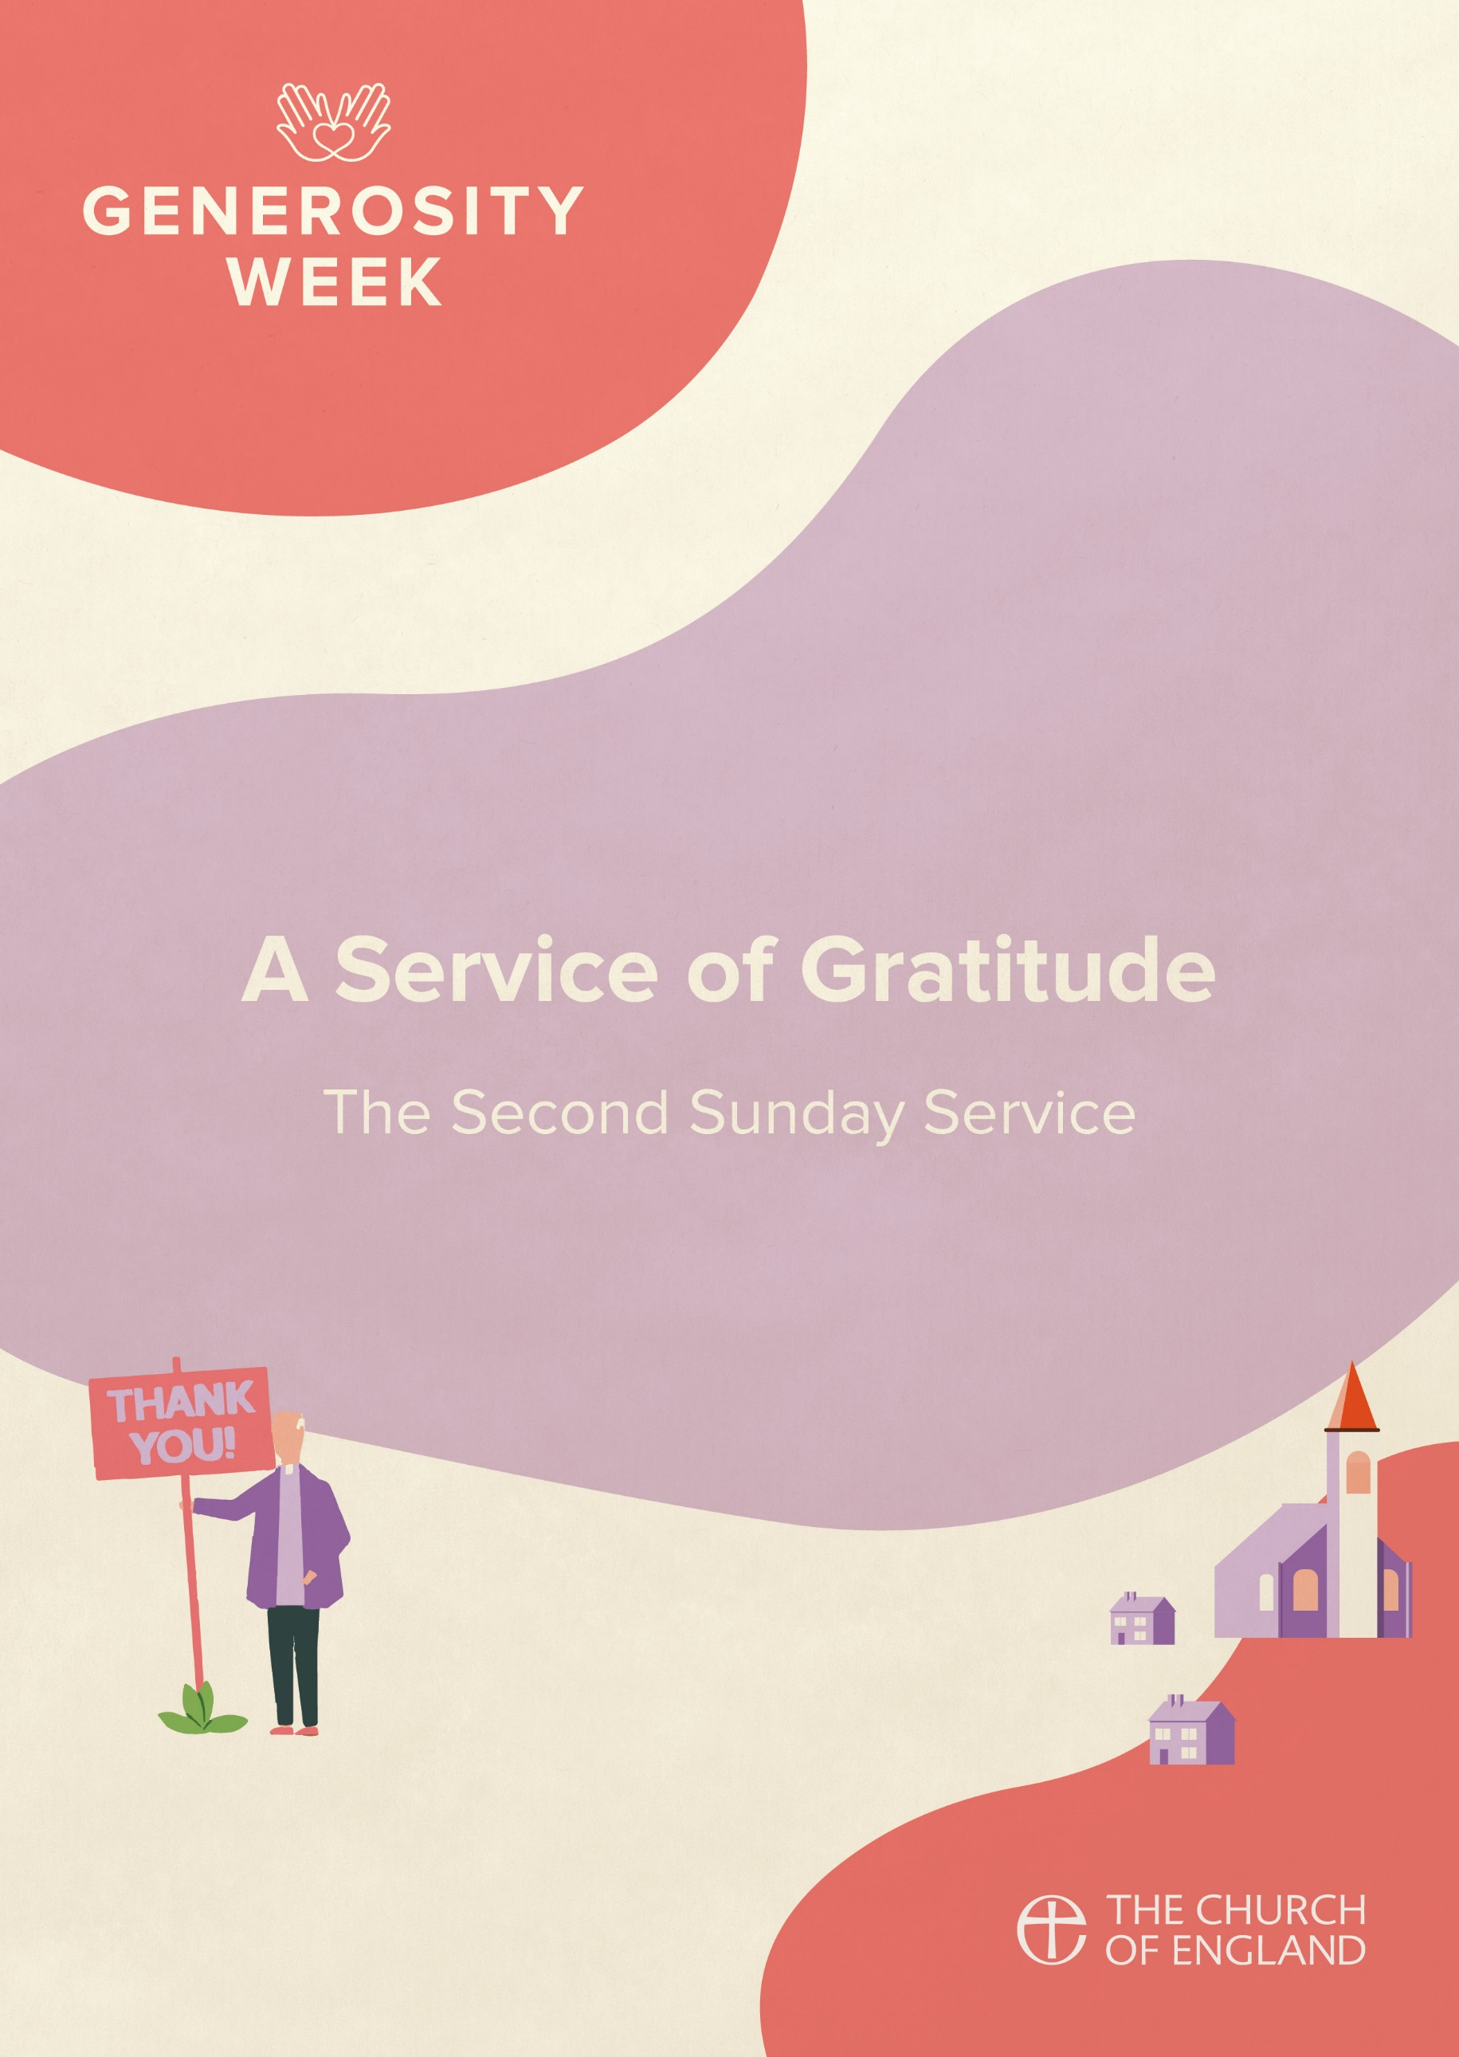

PREPARATION

In preparation for this act of worship, you might wish to pray privately this Prayer of General Thanksgiving.

Accept, O Lord, our thanks and praise for all that you have done for us.
We thank you for the splendour of the whole creation,
for the beauty of this world, for the wonder of life,
and for the mystery of love.

We thank you for the blessing of family and friends,
and for the loving care which surrounds us on every side.

We thank you for setting us at tasks which demand our best efforts,
and for leading us to accomplishments which satisfy and delight us.

We thank you also for those disappointments and failures
that lead us to acknowledge our dependence on you alone.

Above all, we thank you for your Son Jesus Christ;
for the truth of his Word and the example of his life;
for his steadfast obedience, by which he overcame temptation;
for his dying, through which he overcame death;
and for his rising to life again,
in which we are raised to the life of your kingdom.

Grant us the gift of your Spirit,
that we may know him and make him known;
and through him, at all times and in all places,
may give thanks to you in all things. Amen.

Prayer of General Thanksgiving, BCP New York 1979
PREPARATION

In the name of the Father,
and of the Son,
and of the Holy Spirit.
Amen.

Enter the gates of the Lord with thanksgiving,
and enter his courts with praise.
Give thanks to the Lord
and bless his name.
For the Lord is good;
his steadfast love endures forever.
cf. Psalm 100.4-5

Words of welcome or introduction may be said.

Prayers of Penitence

As those who know the generosity of God,
let us confess our sins,
especially the ways in which we take his good gifts for granted.

Creative God, you have gifted us with your creation,
yet we take your good gifts for granted;
Lord, have mercy.
Lord, have mercy.

Gracious God, you bless us each day,
yet we forget to be thankful;
Christ, have mercy.
Christ, have mercy.

Generous God, you offer new life through your Son,
yet we turn away from you;
Lord, have mercy.
Lord, have mercy.

May God who loved the world so much
that he sent his Son to be our Saviour
forgive us our sins
and make us holy to serve him in the world,
through Jesus Christ our Lord.
Amen.

Canticle: A Song of David

Splendour and majesty are yours, O God;
you are exalted as head over all.

1 Blessed are you, God of Israel, for ever and ever,
for yours is the greatness, the power,
the glory, the splendour and the majesty.
2 Everything in heaven and on earth is yours;
yours is the kingdom, O Lord,
and you are exalted as head over all.
3 Riches and honour come from you
and you rule over all.
4 In your hand are power and might;
yours it is to give power and strength to all.
5 And now we give you thanks, our God,
and praise your glorious name.
6 For all things come from you,
and of your own have we given you.
1 Chronicles 29.10b-13,14b

Glory to the Father and to the Son
and to the Holy Spirit;
as it was in the beginning is now
and shall be for ever. Amen.

Splendour and majesty are yours, O God;
you are exalted as head over all.

The Collect

In a time of silence,
let us pray that we may draw closer
to the one who has created all things.

Silence is kept.

God of grace, ever creating and restoring,
you breathe life into all things
and embrace us with an everlasting love;
help us to grow in wonder and awe,
to embody a spirit of gratitude,
and to dream generous dreams;
that, in gathering what we have,
we may graciously offer ourselves
to accomplish what you will,
in Jesus Christ our Lord.
Amen.

THE LITURGY OF THE WORD

The First Reading

As God’s chosen ones, holy and beloved, clothe yourselves with compassion, kindness, humility, meekness, and patience. Bear with one another and, if anyone has a complaint against another, forgive each other; just as the Lord has forgiven you, so you also must forgive. Above all, clothe yourselves with love, which binds everything together in perfect harmony. And let the peace of Christ rule in your hearts, to which indeed you were called in the one body. And be thankful. Let the word of Christ dwell in you richly; teach and admonish one another in all wisdom; and with gratitude in your hearts sing psalms, hymns, and spiritual songs to God. And whatever you do, in word or deed, do everything in the name of the Lord Jesus, giving thanks to God the Father through him.
Colossians 3.12-17

Psalmody: Psalm 136.1-9, 23-end

Give thanks to the Lord, for he is gracious,
for his mercy endures for ever.

2 Give thanks to the God of gods,
for his mercy endures for ever.
3 Give thanks to the Lord of lords,
for his mercy endures for ever;
4 Who alone does great wonders,
for his mercy endures for ever;
5 Who by wisdom made the heavens,
for his mercy endures for ever;
6 Who laid out the earth upon the waters,
for his mercy endures for ever;
7 Who made the great lights,
for his mercy endures for ever;
8 The sun to rule the day,
for his mercy endures for ever;
9 The moon and the stars to govern the night,
for his mercy endures for ever;
23 Who remembered us when we were in trouble,
for his mercy endures for ever;
24 And delivered us from our enemies,
for his mercy endures for ever;
25 Who gives food to all creatures,
for his mercy endures for ever.
26 Give thanks to the God of heaven,
for his mercy endures for ever.

Glory to the Father and to the Son
and to the Holy Spirit;
as it was in the beginning is now
and shall be for ever. Amen.

Give thanks to the Lord, for he is gracious,
for his mercy endures for ever.

Gospel Reading

Hear the Gospel of our Lord Jesus Christ, according to Luke.
Glory to you, O Lord.

On the way to Jerusalem Jesus was going through the region between Samaria and Galilee. As he entered a village, ten lepers approached him. Keeping their distance, they called out, saying, ‘Jesus, Master, have mercy on us!’ When he saw them, he said to them, ‘Go and show yourselves to the priests.’ And as they went, they were made clean. Then one of them, when he saw that he was healed, turned back, praising God with a loud voice. He prostrated himself at Jesus’ feet and thanked him. And he was a Samaritan. Then Jesus asked, ‘Were not ten made clean? But the other nine, where are they? Was none of them found to return and give praise to God except this foreigner?’ Then he said to him, ‘Get up and go on your way; your faith has made you well.’
Luke 17.11-19

This is the Gospel of the Lord.
Praise to you, O Christ.

A sermon may be given.

Affirmation of Faith

Let us affirm our faith in God.

We believe in God the Father,
from whom every family
in heaven and on earth is named.
We believe in God the Son,
who lives in our hearts through faith,
and fills us with his love.
We believe in God the Holy Spirit,
who strengthens us
with power from on high.
We believe in one God;
Father, Son and Holy Spirit.
Amen.
cf Ephesians 3

PRAYERS
A Litany of Thanksgiving

Let us give thanks to God
for his gifts so generous given to us,
and for the blessings we each abundantly receive.

For the beauty of creation,
for the wonder of new life,
for all things seen and unseen.
We give you thanks, O God. Psalm 75.1

For the gift of life that you breathe into us,
for minds to think, hearts to love, and hands to serve.
We give you thanks, O God.

For our families and friends,
for all who we love and who love us,
for your image revealed through those around us.
We give you thanks, O God.

For life of your church,
its vibrancy and diversity,
for the mission in which we all share.
We give you thanks, O God.

For the vocations in which you call us,
for the skills which are nurtured and grow,
for our ministries in all walks of life.
We give you thanks, O God.

For your creativity planted in each person,
for voices to sing our praises to you,
for our capacity to create.
We give you thanks, O God.

For your love which brings us peace even in the darkest of times,
for your strength when we feel weak and vulnerable,
for your hope when all seems lost.
We give you thanks, O God.

For all financial gifts offered to our church,
for blessings offered to be a blessing to others,
for sacrifices made to further mission and enable us to be Christ in the world.
We give you thanks, O God.

For the generosity of this community,
for all who give their time and skills,
for the gifts which are built up and encouraged,
for acts which point beyond themselves and reveal your glory.
We give you thanks, O God.

For you, O God,
for your beauty revealed in all things around us,
for love and life everlasting.
We give you thanks, O God.

For the wisdom of your Spirit,
for gifts given and nurtured,
for sustaining us in prayer.
We give you thanks, O God.

For your Son, Jesus Christ,
for the gift of his perfect sacrifice,
for our hope in him, and the joy of serving his Church.
We give thanks to you, O God.

Intercessions

Intercessions are offered, and may end with;

Source of all life and giver of all that is good,
hear our prayer,
and make us one in heart and mind
to serve you with joy forever.
Amen.

The Offering

An offering is taken, which may be virtual, giving time for people to reflect on gifts given electronically.

God of all creation,
the source of life and giver of all good things;
through your goodness you have blessed us with these gifts.
With them we offer our lives;
that we may be used to serve others,
and give you glory.
We make our prayer
in the name of Jesus Christ, our Lord.
Amen.

THE DISMISSAL

The God of love enrich us in every way,
with hearts overflowing with thanksgiving to God;
and the blessing of God almighty,
the Father, the Son, and the Holy Spirit,
be among you and remain with you always.
Amen.

Go in peace to love and serve the Lord.
In the name of Christ. Amen.

Material in this order of service is taken from Common Worship, copyright © The Archbishops’ Council 2000-2006 and is used here with permission. www.commonworship.com. This order has been compiled by Sammi Tooze. This compilation is copyright © The National Giving Team 2021.

