­­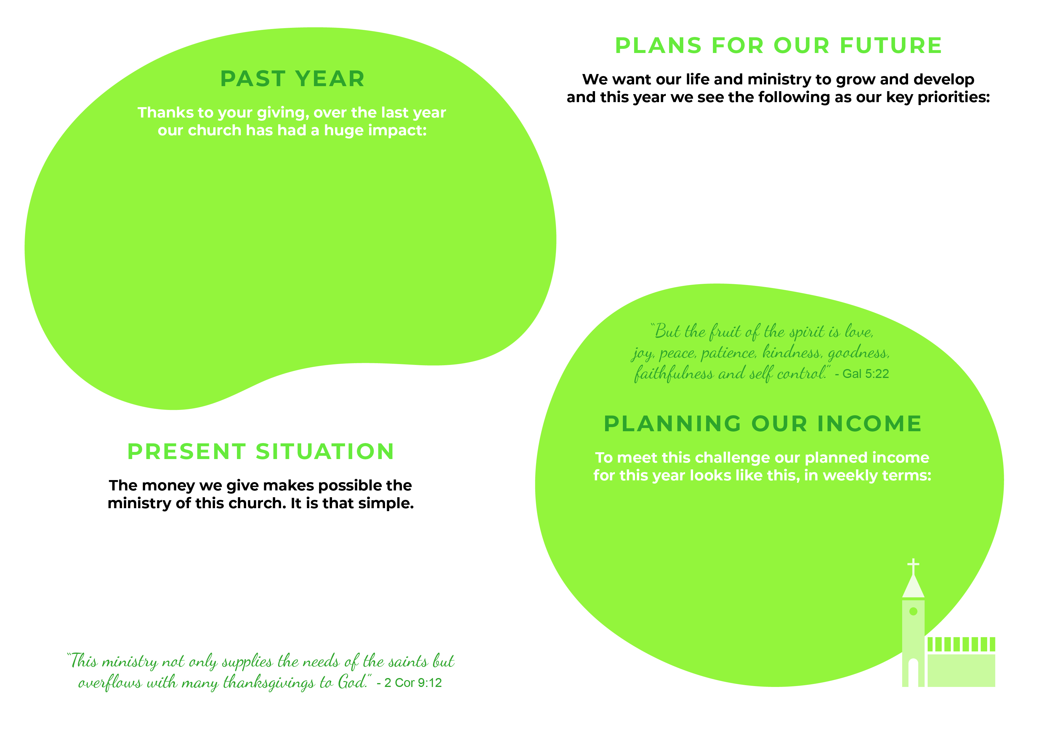

£**xxx** from regular giving, including Gift Aid

£**xxx** from fees, the church hall and our fundraising efforts

£**xxx** from interest and the careful use of some of our reserves

The largest share of this income is from   
the giving of our congregation.

To fund our ministry this year   
we will need an increase in weekly   
giving of £xxx.

This year our church needs £**xxx** per week for the work of   
ministry, worship, service and mission. This breaks down as:

£**xxx** on our share of clergy, housing, training and support costs

£**xxx** on our building, including insurance, heat, light etc.

£**xxx** on worship and ministry costs to and in the community,   
including our church hall








And, of course, we must maintain our beautiful church building, our services and worship, pay our bills and support our mission and ministries. In fact, all those things that make up the life of **Name of church.**

Thank you for your partnership in the gospel, the commitment of your time, your skills and abilities and, of course, your generous giving to **Name of church.**