

**Diocese of Carlisle Board of Education**

**Heads Huddle Notes**

**Tuesday 15th December**

**Reflection:**

**The Year of the Lord’s Favour – Isaiah 61**

**1** “The Spirit of the Sovereign LORD is on me, because the LORD has anointed me to proclaim good news to the poor. He has sent me to **bind up the broken hearted**, to **proclaim freedom for the captives** and **release from darkness for the prisoners**,

**2** to proclaim the year of the LORD’s favour and the day of vengeance of our God, to **comfort all who mourn**,

**3** and **provide for those who grieve** in Zion— to bestow on them **a crown of** **beauty instead of ashes**, **the oil of joy instead of mourning**, and a **garment of praise instead of a spirit of despair**. They will be called **oaks of righteousness, a planting of the LORD** for the display of his splendour.

**4** They will **rebuild** the ancient ruins and **restore** the places long devastated; they will **renew** the ruined cities that have been devastated for generations.

**5** Strangers will shepherd your flocks; foreigners will work your fields and vineyards.

**6** And you will be called priests of the LORD, you will be named **ministers of our God**.”

[Michael W. Smith - Surrounded (Fight My Battles) - YouTube](https://www.youtube.com/watch?v=YBl84oZxnJ4)

*‘For the spirit of heaviness, put on the garment of praise’*

**Celebrating:**

Today we reflected on the **‘Gift of Normal’** schools have worked so hard to give our children and young people since the pandemic began. For all the adaptations that have been necessary and the external pressures exerted by the pandemic, *inside* schools staff and leaders have succeeded in keeping routine, structure and stability in spite of it all.

There have been really hard weeks, but being with children and young people and doing things for them has enabled a focus on ‘the why’ and gifted courage to continue. We talked of the importance of remembering that we continue to live in the midst of a global emergency, and that we need to continue to be kind to ourselves as well as others.

We also noticed that people have been more ‘present to the now’ during the last few months. This has enabled new ways of seeing and being, and fresh approaches to be taken. A feeling of ‘we’re all learning together’ (for example with the ‘how to’ of online meetings and learning), regardless of age or qualifications, has been refresh. Modelling life-long- learning, openness to the new and vulnerability has strengthened relationships between children, young people and those who teach and support them.

We gave thanks for those who have taken time to notice and offer some words of encouragement – for example parents who have taken a few minutes to write in to thank staff for their support.

We celebrated the completion of a greater-than-expected number of projects during this term and the rich variety of Advent and Christmas happenings in our schools that are bringing joy and hope: from Christmas jumper month (yes, month!) to the nativity blooper of Mary falling backwards off a haybale, to the enthusaism of classes for taking part in outdoor Christmas reflections from Mountain Pilgrims, which you can find here: [www.mountainpilgrims.org.uk/schools/](http://www.mountainpilgrims.org.uk/schools/)

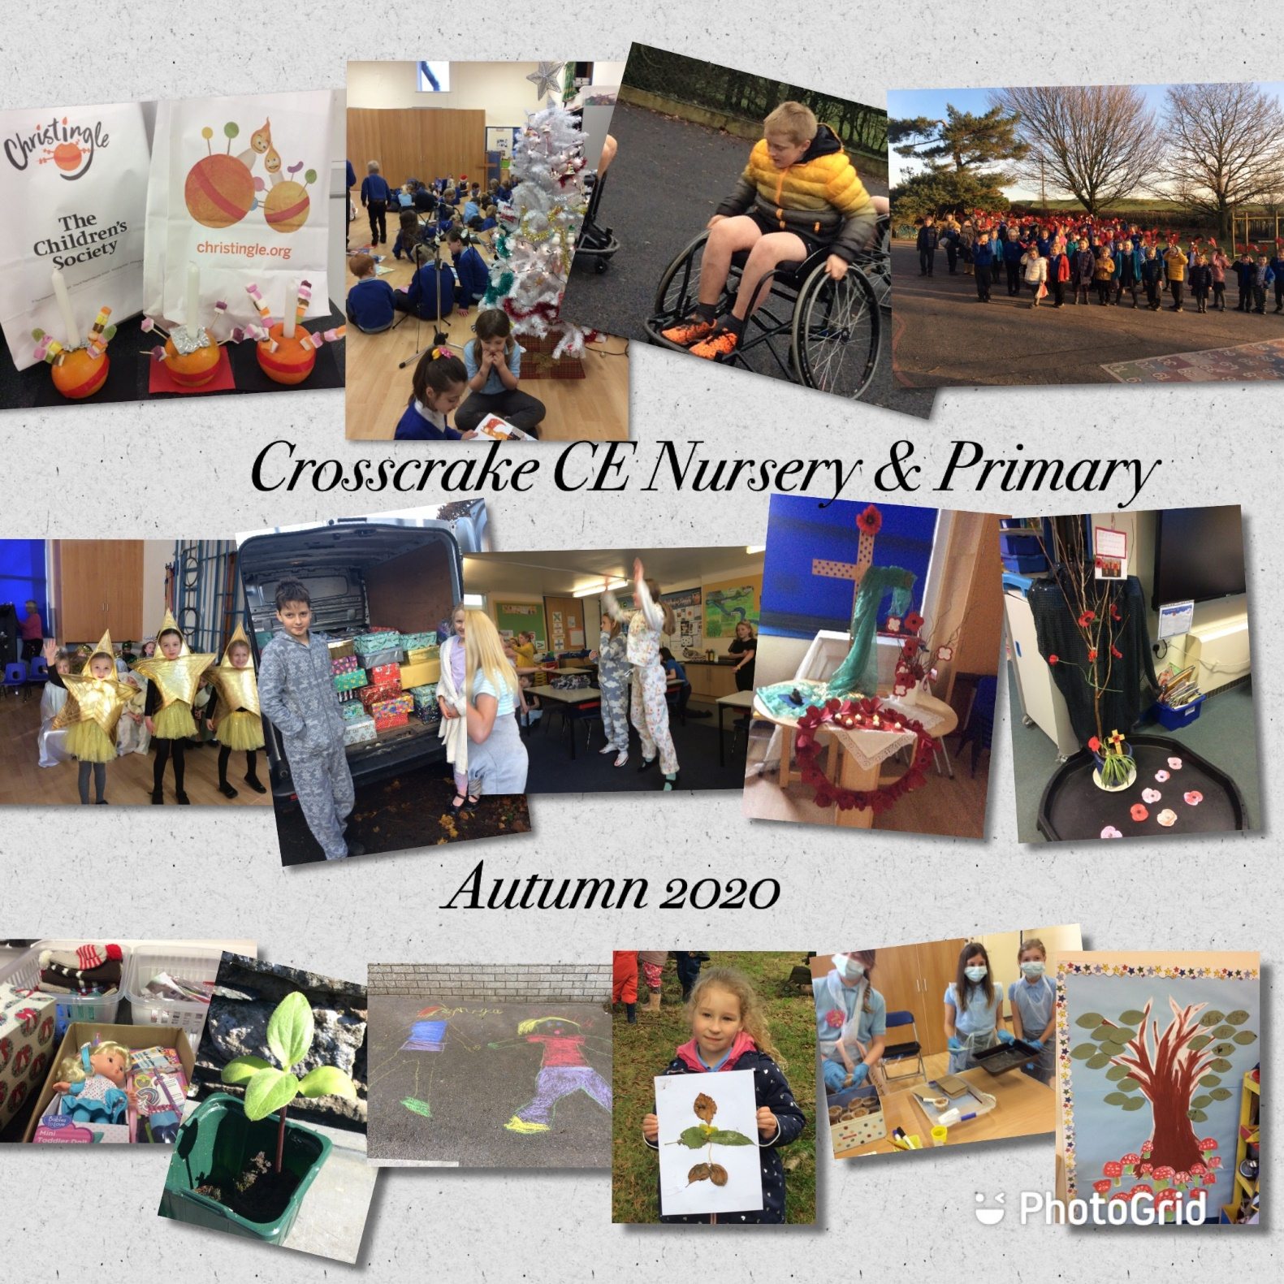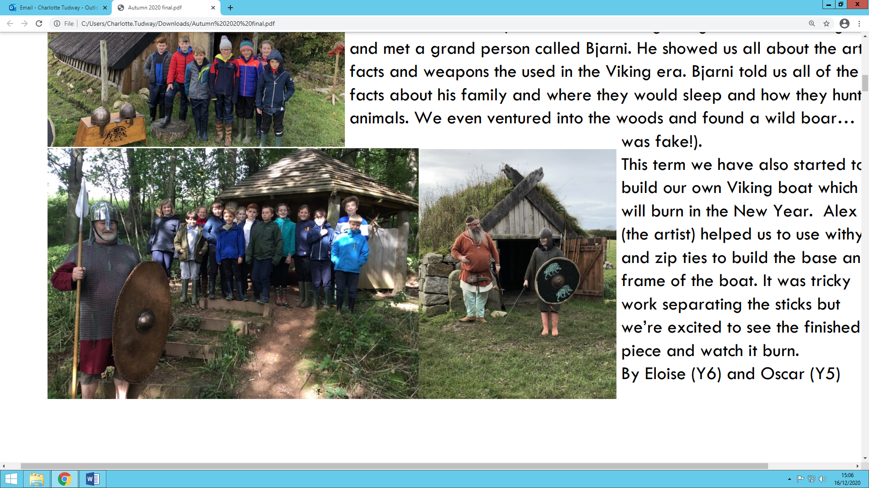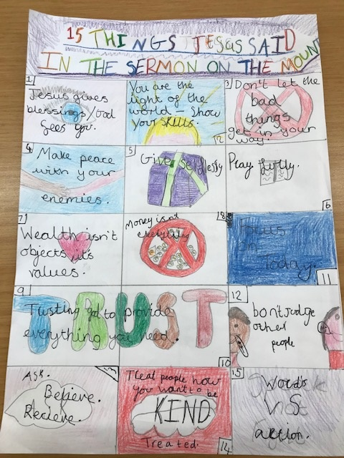**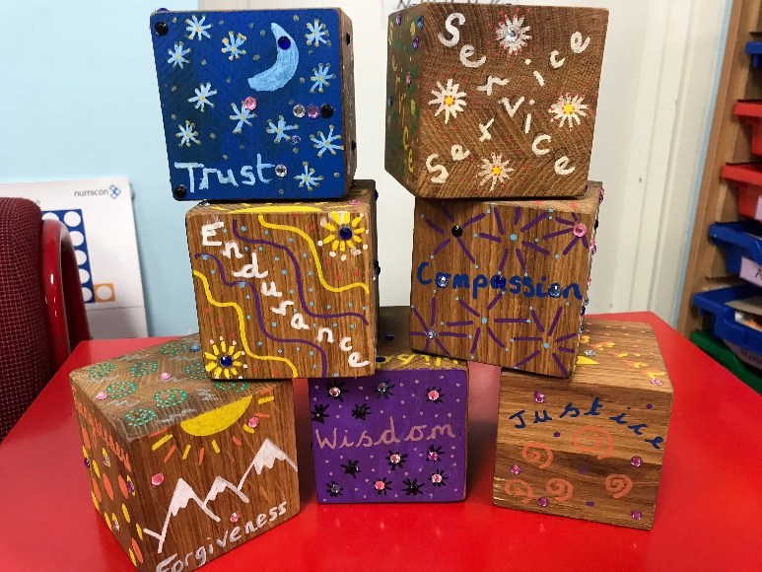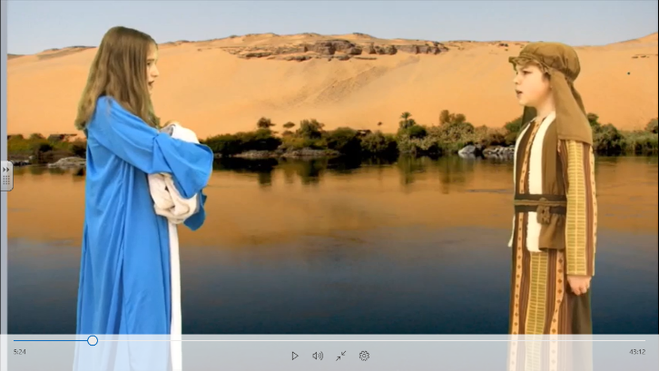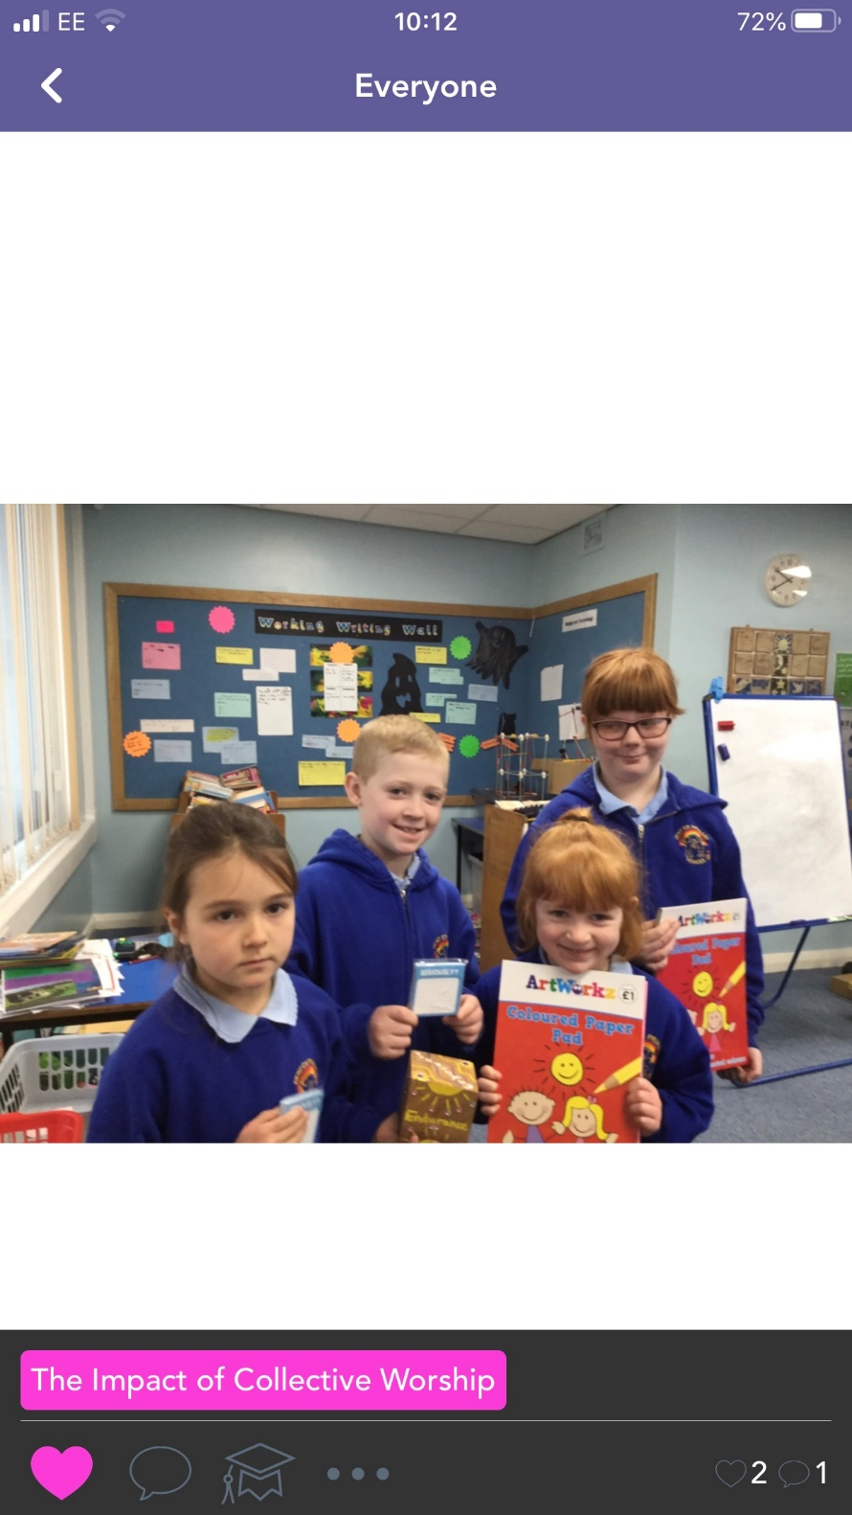Celebrating photos:**

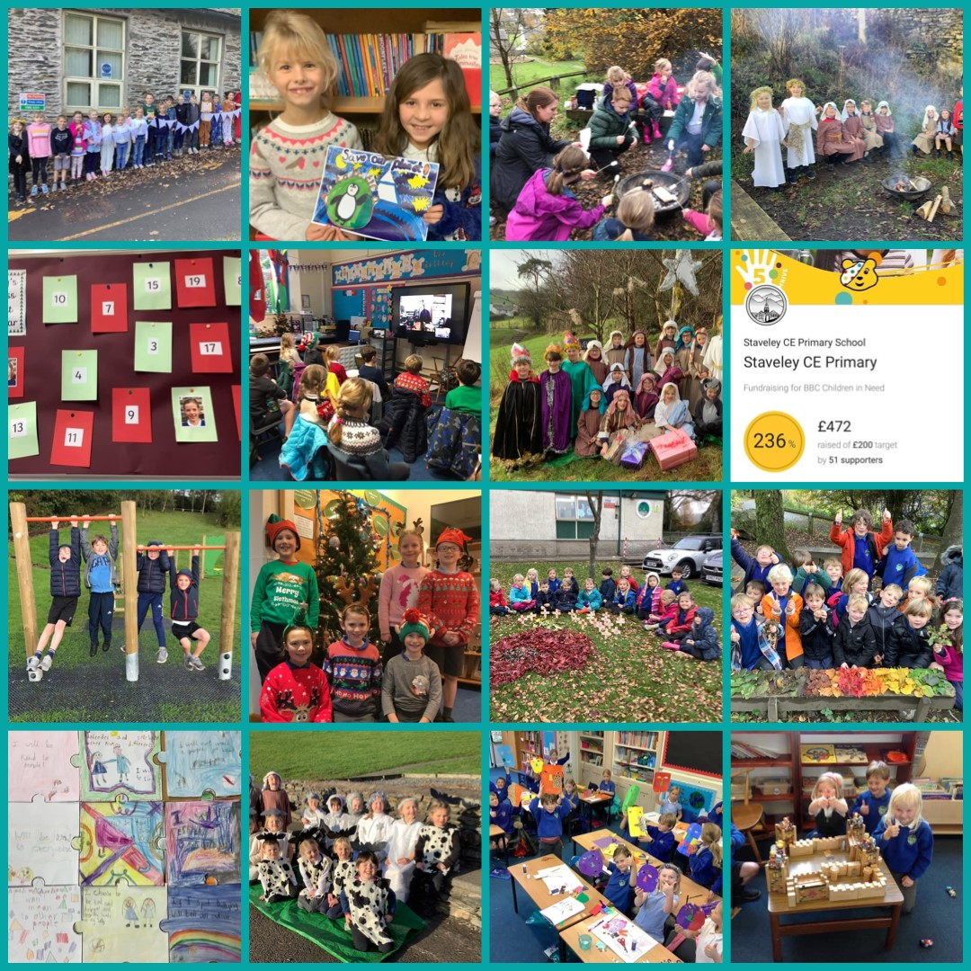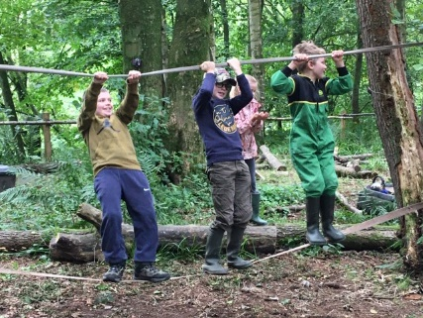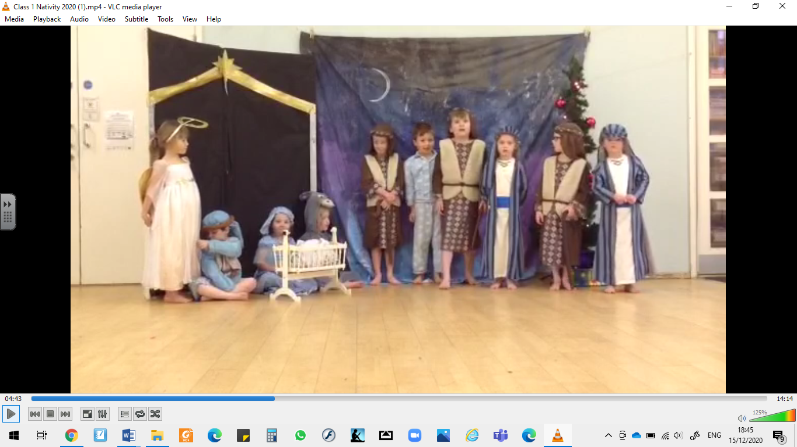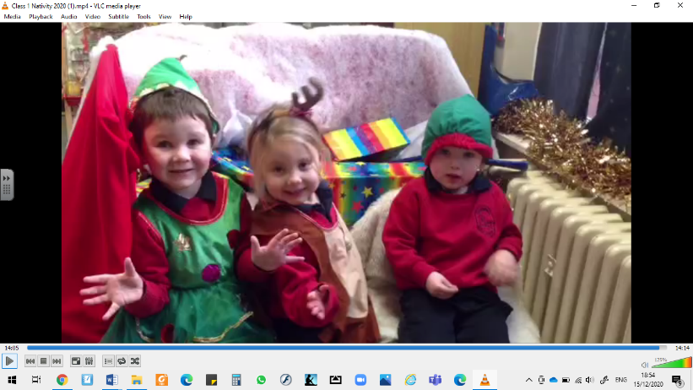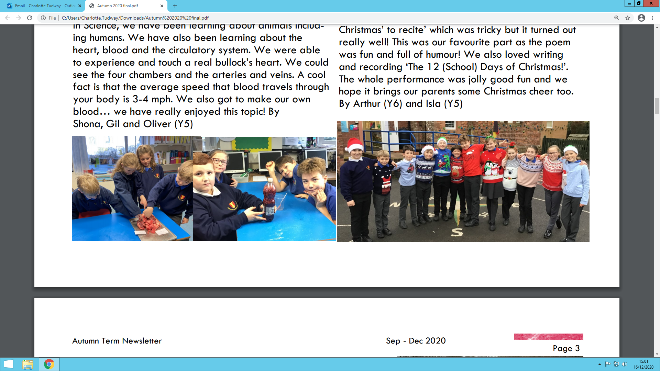



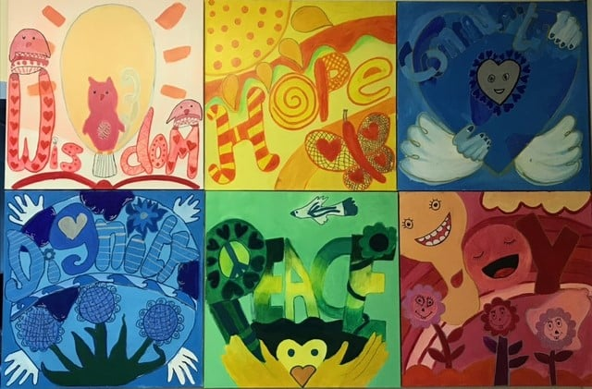

**Nativity Videos:**

**Grasmere**

[**https://www.google.com/search?q=grasmere+nativity&oq=grasmere+nat&aqs=chrome.0.0i324i457j0j69i57j46i175i199j0i22i30l3j69i60.5551j0j7&sourceid=chrome&ie=UTF-8**](https://www.google.com/search?q=grasmere+nativity&oq=grasmere+nat&aqs=chrome.0.0i324i457j0j69i57j46i175i199j0i22i30l3j69i60.5551j0j7&sourceid=chrome&ie=UTF-8)

**St Matthews**

[**https://www.stmatthews.cumbria.sch.uk/ks1-christmas-nativity/**](https://www.stmatthews.cumbria.sch.uk/ks1-christmas-nativity/)

**Looking forward to the New Year…**

**Conference planning:**

We are beginning to get excited about looking forwards to a hope filled 2021, which can include an inspiring conference to encourage us remind us of why we serve in education . We are currently putting together what we hope will be an uplifting, thought provoking and helpful day. We would be grateful for any thoughts or views you may have including, in particular, whether you would prefer a face-to-face or an online gathering. We appreciate that both have their pros and cons.





***“No, in all these things we are more than conquerors through him who loved us.38For I am convinced that neither death nor life, neither angels nor demons, neither the present nor the future, nor any powers, 39neither height nor depth, nor anything else in******all******creation****,* ***will be able to separate******us******from******the******love******of God that is in Christ******Jesus******our LORD.”***

**Romans 8:37-38**

**Spring term - Huddles to continue**

**on Tuesdays at 3.45pm**

**Please join us when you can.**

[**https://us02web.zoom.us/j/85053449378?pwd=dDBUa3NKdXozVHJoeWxnUUNab2FKQT09**](https://us02web.zoom.us/j/85053449378?pwd=dDBUa3NKdXozVHJoeWxnUUNab2FKQT09)

Huddles will continue to be guided by your needs and feedback. We will balance ‘agenda-less’ Huddles with some that have more focus for CPD – for example requests so far have included a focus on identified SIAMS strands and how schools may best evidence these.

We recognise some colleagues aren’t able to join us for Huddles and we will continue to send out notes after each session.

**Events Programme 2021**

Our events programme for Spring and Summer terms is now available and attached.

To book a place of any of our courses, training sessions or events or for more information, please email [**education@carlislediocese.org.uk**](mailto:education@carlislediocese.org.uk)(apart from Teaching Islam with Confidence which you can book directly with the Course Leader via the attached flyer).

Lots of our events are provided free of charge as part of our Core support.

If you have purchased the Enhanced Package in our Partnership Agreement, don’t forget to make use of your **free training places** at our Enhanced events.

We look forward to welcoming you to our sessions in 2021.

