Diocese of Carlisle Board of Education
Heads Huddle Notes

Tuesday 10th November

Reflection:

When you’ve seen the tiger with your own eyes, you run differently.

Feedback from Headteachers: themes of the week

It was really interesting to unpack with one school this afternoon the process they went through in having to close a bubble over a weekend. We discussed how ‘plans’ and ‘risk assessments’ are just that – plans and assessments and not everything goes according to the plan or assessment in practice.

We discussed the importance of good communication: to reassure colleagues who may feel anxious about whether they have been in contact with the infected staff member; and to get communication right with parents – telling them enough that they understand the reasons why you have taken the steps you have taken (however difficult they might make life for families) without telling them so much that you unduly worry them or break confidences.

We agreed that there is still a perception that “remote learning” should be online and live by many families – connotation with the word remote perhaps?

Remember, you know your school best. Stick to what you know will be successful for your pupils and their families. Document your rationale/decision-making and make sure your governors understand and support your approach.

Information sharing from the Diocese:

https://content.scriptureunion.org.uk/resource/in-search-of-christmas
Sustaining Hope in School Leadership (Grove publication)
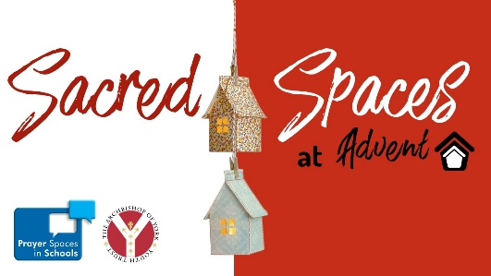

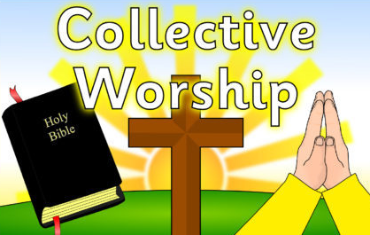
Training Session:

Delivering Collective Worship and RE in schools
Training session for your volunteers: governors, church teams, clergy to help them to support you. We will be joined by some volunteers and Diocesan employees who already work with schools to share their top tips and things they wished someone had told them when they started out. Do encourage your volunteers to join us.

Thursday 26th November, 6.30pm – 8pm
Email education@carlislediocese.org.uk to book your place

