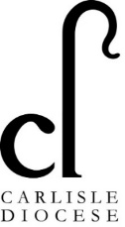

Diocese of Carlisle Board of Education
Heads Huddle Notes

Tuesday 8th September: COVID friendly collective worship

Welcome back!

Thought for the week: hang on to the “why” when things are difficult.

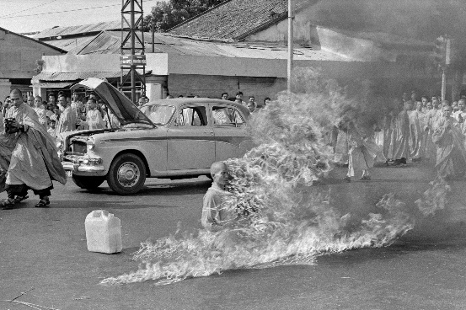

https://en.wikipedia.org/wiki/Th%C3%ADch_Qu%E1%BA%A3ng_%C4%90%E1%BB%A9c

Huddle format: following feedback from huddles in the Summer term, Huddles will now take place weekly at 3.45pm every Tuesday. There will be a weekly focus so that colleagues can decide whether the theme is something that would be useful to them and prioritise joining or not – we know how busy you are. The themes are set out in the courses schedule (attached).

Feedback from Headteachers:

Lunchtimes: were a real pressure point during the first week back. Many revisions needed to plans to make it manageable. Time taken to get all pupils fed is huge. There is a concern about staff getting adequate breaks and about the feel of lunchtimes changing from a happy sociable family meal feel to being rushed and pressurised.

Confusion over testing: Several schools reported NHS 111 telling parents to have pupils tested for COVID even though they were not displaying COVID symptoms but were unwell in other ways. This has made it difficult for those who actually need access to testing to make an appointment close to home.

Comms: we are all feeling that the number of emails and constant revisions to guidance and suggestions is overwhelming, hard to stay on top of and unsettling because of the potential to miss something important.

Collective worship: several schools discussed how much more important than ever collective worship is to give pupils reflection and stillness. However, it can be very time consuming and we discussed ways to make it easier. If anyone has any good resources to share, please do get in touch and we will make them available across the Diocese.

Funding: is a huge issue for all schools, especially small ones. The additional cost of cleaning (personnel and products); insurance not paying for supply staff; and needing additional teaching to help with recovery and gap filling is all taking its toll. We discussed how, whilst is shouldn’t be necessary, PTA fund and sponsored activities can help cover some extra costs.

Wellbeing: Headteachers are already covering classes. There are concerns around school closures because of lack of staffing (in small school only a few absences could close the school). There is concern around Headteacher wellbeing – teaching commitments, cleaning commitments, additional paperwork burdens plus the day job of running the school.

Information sharing from the Diocese

SIAMS:
Dates and timings: National guidance is awaited but is unlikely to be available until well into October. SIAMS inspections (under s.48) will remain suspended until inspections by Ofsted (under s.5) resume as the two are linked. We do not yet have an official restart date but know that it will not be before January 2021. There is inevitably a huge backlog of inspections outstanding and we await information about scheduling to enable us to space out the inspections so that we are not under pressure to inspect a disproportionate number of schools every 5 years from the anniversary of the lockdown. We will keep you updated as soon as the position is confirmed to us.

Collecting evidence during COVID: some schools were concerned that because their usual pattern of worship is not occurring and their physical links with the local churches they work with have ceased that this might count against them in their next inspection. This will be an issue for everyone and inspectors will be aware that things could not continue as usual. A huge amount of the work currently being undertaken around mental health and wellbeing, recovery, hope, forgiveness, repairing relationships, and closing the gap between the most vulnerable or disadvantaged pupils and their peers feeds directly into the SIAMS schedule. You are doing it naturally – remember to get the credit for it! Keep a note of everything you are doing and have put in place. Record what you are managing to do for worship and do ask your church teams if they would be prepared to record a bible story or worship time resource for you.

If you have any concerns about SIAMS evidencing, don’t hesitate to get in touch with Charlotte.

Collective worship: a resource pack is attached with some ideas. We welcome feedback and any further suggestions.

Listening training coming up with NISCU: to complement the difficult job of responding to pupils’ experiences, we are collaborating with Northern Inter-schools Christian Union to run a listening workshop for school staff. There are two separate opportunities. Dates and times are on the courses schedule.

