EVERYBODY WELCOME ONLINE -
HOW TO GROW THE ONLINE CHURCH
WELCOME!!
Welcome to the first edition of ‘Everybody Welcome Online – how to grow the online church’. We are the authors of the church training course ‘Everybody Welcome’ (Church House Publishing) which helps churches invite, welcome and integrate newcomers, and so to grow. Currently much of this course is redundant. We have a new challenge – how to contact, welcome, minister to and integrate the large numbers of people who seem to be accessing online church. Having our buildings closed down was a nasty shock. But those of us who have moved on line have stumbled into a vast new mission and ministry world. How can we best navigate our way into and around it, and how can we share God’s love and call with those who are reaching out to us in fear and hope from their phones and homes?
We have spent a frantic week contacting a large number of church ministers and others to find out what is going on, to begin to sift out good practice, to condense some wisdom, and to lift our eyes for the bigger picture of what God seems to be doing. These notes are the result.
If you find the notes helpful or inspiring then please copy them to as many of your contacts as possible. They are a free offering from two retired church growth specialists who have come out of retirement inspired by the once in a lifetime mission opportunity the lockdown is offering the churches. We would like these notes to go viral as churches and denominations should not struggle on their own but gain strength from each other. You can also find them on our webpage: www.VEW.com
We’ll update this from time to time as we learn more – from you! So please email us your stories, wisdom, corrections and ideas at allarewelcome2020@gmail.com so that we can share them around.
We baby boomers are, of course, trying to learn foreign languages in order to communicate. We’d love to partner with one or two young native speakers – could that be you??!!
Ven Bob Jackson & Revd George Fisher
CONTENTS
Prologue – historical perspectives page 2
A wonderful discovery page 4
How are local churches responding to lockdown? page 5
Are online congregations really bigger? page 6
Interpreting ‘views’ figures page 9
Who are the people accessing online church? page 10
Why are they accessing online church? page 12
Doing online church well during lockdown page 13
When the lockdown period is over page 26
What we have asked your help with page 29
PROLOGUE – HISTORICAL PERSPECTIVES!
A POINT IN HISTORY – Cutting edge communication
In the period of the Early Church the spread of the Gospel was enabled by the cutting edge technology of the day – the Roman road. In the providence of God this network of communication had been put into place just in time to enable Christians to travel the empire in speed and relative safety, spreading the news wherever they went. If Jesus had been born just a few years earlier this rapid spread would simply not have been possible. The Early Church did not make use of their cutting edge technology entirely willingly. It took official steps to close them down to drive out the first Christians from their comfort zone, meeting with each other in the temple courts. Persecution propelled them in fear of their lives along the Roman roads to share the risen Christ with a pre-Christian world.
In the period of the Lockdown Church the spread of the Gospel is being enabled by the cutting edge technology of the day – the internet. In the providence of God this network of communication has been put in place just in time to enable Christians electronically to travel the world in speed and relative safety. If the lockdown had happened just a few years earlier this rapid transition to an on-line church reaching the homes of the nation would simply not have been possible. The Lockdown Church is not making use of our cutting edge technology entirely willingly. It has taken official steps to close us down to drive us out of our comfort zone, meeting together in our church buildings. We have been propelled in fear of our lives along the internet highway to share the risen Christ with a post-Christian world.
Most of St Paul’s roads had actually been there a few years before he walked them, but the early church also made use of the brand new codex technology – an innovative use of scrap notebooks to make sacred texts portable and shareable. Yes, St Paul had pressed the ‘share’ button long before Silicon Valley.
When persecution lifted, the Early Church did not abandon the Roman roads, public city spaces and codex sharing, reverting to a secret sect. When lockdown lifts, we must not abandon the public spaces of the internet highway and share buttons to hide away again in Sunday secrecy. We have been sent out like St Paul to welcome the world to the kingdom of Christ through sharing the technology of the day. What an opportunity!

A POINT IN HISTORY – we’ve been propelled into the contemporary world
Last month we were the Odeon, today we are Netflix. Years ago cinemas were in trouble. The giant Odeon would show a film at 7.30 each night for a week or two. There was no choice of time, venue or film. If you wanted to see a film you had to turn up at 7.20, buy your popcorn and watch ‘The Bridge on the River Kwai’.
A few churches were ahead of the game but typically, until last month, we were the 10.30 showing at St Odeon’s. In the post-austerity world the Odeon was okay. But then along came consumer choice, individualism and crowded, complex lifestyles. The big take it or leave it screens started dying. But then arose multiplex. Now you could turn up at almost any time to suit you and choose your own film out of a range of offerings. There was a lot more than popcorn on offer and the surroundings were as comfortable as your own home. Multiplex thrived. After Multiplex came films on the BBC, then TV film channels, and now Netflix where you can watch whatever you want whenever you want it on whatever device you have in the actual comfort of your own home or wherever else you happen to be.
Inadvertently, by going on line for other reasons, church has moved from Odeon to Netflix all in a couple of weeks. Our livestreaming efforts remain on the Facebook page for ages to embarrass us because we are neither as slick nor as photogenic as film stars. We haven’t even yet learnt how to delete our embarrassments. But people can now choose their own time to take part in the church service, which church and service to access, and their own sofa rather than contracting back pain on a church pew. No wonder it’s more popular. It would seem from the steady rise of the ‘views’ figures over subsequent days that plenty of people are indeed choosing their own time to go to virtual church. The Government has shut our ‘Odeons’ down, so in response we have stumbled into ‘Homespun Netflix’ and it’s looking promising.

A WONDERFUL DISCOVERY

Most churches going online have discovered that far more people are accessing their services than ever came to the building. What seemed initially to be a devastating blow to churches may actually be transforming them to a new level.

God is a redeemer! Who knew?!

HOW ARE LOCAL CHURCHES RESPONDING TO LOCKDOWN?
Closing the churches took us largely by surprise. The alacrity of our response has been remarkable. Most churches have found ways of maintaining community connections. Clergy have spent time on the phone, pastoring their congregations. Some have posted material on their website. Many have started using Zoom for church meetings & home groups, and some smaller churches are using Zoom for worship. Many others are using the YouTube and Facebook platforms. The Church of England, like other denominations, has traditionally counted the size of the church by physical attendance at church services. By this measure the C of E has ceased to exist. But church communities haven’t even shrunk. We have found that many are already growing. Churches are going about our business in new ways. We are more adaptable than we thought, and more needed by our communities than we thought.
One archdeacon in the north of England wrote:
“Our clergy have been unbelievably wonderful is setting up at short notice their various acts of virtual worship. They are using Facebook, Zoom, Google Meet and YouTube for both live worship and pre-recorded stuff. This ranges from individual vicars doing things online to groups of churches and deaneries.”
Many churches and clergy who have taken to the public spaces of the internet to sustain their congregation find to their surprise that lots of other people appear to be joining in as well. Astonishing numbers of ‘views’ appear on our Facebook feeds and new or dimly remembered names appear in our comments boxes, like-lists and friends requests. Others are pre-recording their services as this is less stressful and more open to added elements, then releasing them at the normal Sunday morning time. However, they are then finding that many people access the service later, at a time to suit them.
Clergy live-streaming daily prayers or the daily office are finding far more people joining them that they used to. Others are finding daily devotional posts being much appreciated.
Although we are focussing on worship-events here, these connect with all other aspects of church life. For example, one church in the Forest of Dean has been online fundraising and supporting the local foodbank they helped set up. Many locals did not realise it was a church initiative, but they do now.
All this is happening without any official plan or direction – this is a grass roots movement. And that leads us to suspect it is a movement of the Holy Spirit.
However, denominational and diocesan leaders have not been inactive either. The Bishop of Carlisle live-streamed a Good Friday message to which, by Easter Monday, 938 people had engaged by commenting, sharing or reacting. The Archbishop of Canterbury’s Easter Sunday live-stream on Facebook has received over two million views.
So what is going on? Are we really reaching so many more people? And, if so, what should we do about it? How do we welcome our new virtual friends? And what does this discovery mean for church life after lockdown?
Addressing these questions well may seem daunting. Some of you will shudder at all the techno stuff and new skills we suggest are needed, especially if the last few weeks have left you exhausted. But you don’t have to do all of it! Or indeed more than a bit of it this week! It is amazing what a difference even simple changes can make. So read this prayerfully and ask God how you should respond within your and your churches’ capabilities. Yes you should be stretched but no you should not be broken.
And while we may see the mission opportunities, many of us are also grieving for what we have lost. We fear for some of our congregation. Will the less well-established lose touch and never been seen again? Will the older people be afraid of catching the virus after lock-down and stay away? A friend of mine from church is now on the palliative care route in his nursing home bereft of his family, friends and rector. Many clergy are conducting desperate funerals without congregations. Our hearts may be breaking.
And some of us get stressed out by the tech and with the ordeal of performing to camera. We may also suddenly have our children at home all day and be worrying about an elderly relative. So our attempt to help you with online mission is not a clarion call to over-activism, it’s a resource to help you use your time effectively and to gather a team to share the load.
So the upbeat tone of our writing may surprise you. Our optimism is founded on God being a redeemer. He takes what is truly dreadful and makes good to come out of it. As God is the redeemer of the whole world, so we sense the measure of redemption God is giving us through the new connections and opportunities emergency online church is starting to bring alongside all the tragedy. We see a new stream of church life and joy ahead to set alongside the stream of suffering and we want you to be encouraged.

ARE ON-LINE CONGREGATIONS REALLY BIGGER?
We suspect they are. A lot bigger. This is what is so exciting.
But defining and logging ‘attendance’ at an online event is not easy!
Here are some of the comments and stories we have received from a range of different churches:
- Have had a huge number of hits, many more than in church on a Sunday. Connecting with people who would not come to a regular service. Comments such as, ‘I’m not religious but that’s fantastic’, and ‘see you on Sunday’ (from non-church folk).
- Our online services on our YouTube channel, through Facebook, through our website, have doubled/ nearly tripled Sunday morning numbers, about 200+ viewing for us. We will be looking at doing Live Sunday services in the future, and will get some internet into the Church building.
- Services have been really interesting – 250 people watching live, 1400 people watching a significant amount of the service in a week. 2500 people having a quick peek!
- Rediscover Church in Exeter has been broadcasting its morning service on line for some time. The online part of the congregation tends to be around 100-150 people, and this includes some people who have never been to a church before. The church reasoned that many people today live their lives on the internet so that an online service is natural to them. But entering a church building is somewhat scary. The church has ‘online pastors’ to welcome online viewers and make them feel connected. They find that 80% of their newcomers had been watching on line before they came in person. The online offering is not simply an alternative to personal attendance – it is the route in to personal attendance for, until the lockdown came, it increased the number of newcomers through the door fivefold. (with thanks to ‘Christianity Today’ April 2020)
- Here at Beacon Lough Baptist Church in Gateshead we have only 39 members but we started livestreaming our services six months ago and got about 200 views each week, rising to 300 the Sunday before lockdown. Now we pre-record our services on Facebook. The minister films his part with a video camera and drops a memory stick in my letterbox. Other people taking part (musicians, person with a four minute testimony) do the same and I do the links and put it together. It lasts about 45 minutes. I then upload it on to Facebook and YouTube on Saturday evening for it to go live at 10am Sunday. In the run up to Easter we advertised two of our three services to all 8400 Facebook users within 1km of our building. The advert cost us £5. We had 1300 views of each service. The ‘control group’ service we didn’t advertise got the usual 300. We ask all church members to share the online service on their feeds – to like and share to build audience. We are getting a lot of feedback that people who were only loosely connected are watching and appreciating it. When lockdown began I started a Whatsapp group for all 48 houses in our street. Half the neighbours now seem to be accessing the service. Our minister is a Reservist Army Chaplain. When he goes in now the troops all ask him about the service as lots of them seem to watching it. The most important element in the service is sharing stories, testimony. That’s what makes the most impact.
- We were amazed at the number of views we're getting, comments and likes from people I've never met. Our average Sunday attendance is 128. Church membership is approximately twice that, including faithful weekly attendees and those who come less often from the fringe, but are regular nevertheless. However our first Sunday morning live stream reached 647 with 203 engagements. Palm Sunday reached 951 with 259 engagements. I appreciate that some of these will be people dipping in but it’s still significant.
- Here's a post from someone who responded after the first week.
"I love this and the singing. I work at the hospital for NHS and I'm not able to attend church as often as I would like to as I have to work every weekend, unless I book holiday. Therefore I'm overwhelmed I can listen to services on here. I do try to attend evening services whenever I can as this church is where I did Sunday school as a little girl and has been my family church all my life for services also our family funerals and weddings. This is the only church I have ever attended and want to attend therefore I'm so grateful to be able to listen to the services.”
We've already commented that we are going to have to give serious consideration to live streaming our worship once we get back to normal, whatever normal will look like in the future.
- I am writing this at 8.30am on Easter Monday. My own village church had two live-streamed services on the website Facebook page yesterday – a Messy Style at 9am and a more traditional service at 11am. The Messy-style was backed up by videos and posts largely created by the families themselves. Normally between 25 and 30 households totalling around 70 people come to the 9am service. The live-streaming was reportedly followed by 43 devices, probably representing around 100 individuals, being aimed at families. The number of church families taking part looked about average but new people revealed themselves through comments and likes. My best estimate is that the real-time ‘Messy at Home’ congregation was about 40% bigger than normal because of the new people.
However, the videos and live-streaming remain on the website, being viewed. So far Facebook are telling me that there have been 552 views of the livestreaming and about half that number of views of each of the activity videos. These numbers will keep growing – the Palm Sunday Messy-style is now at 920 views. Some of the 552 may just have been a passing glance on a friend’s Facebook feed shared with them. Only a few will have accessed both the live-streaming and the videos then done some activities but ‘a few’ could easily mean another 50 families. Even the casual glances have increased our exposure and may lead to greater contact subsequently.
The 11am service had 73 devices. Being aimed at adults, people will have been watching in their 1s and 2s so the total number of individuals was probably around 110-120. This is roughly what we might have expected in church yet we know from the comments and likes that the total includes quite a few fringe and new people. I got a lovely email from a couple in Canada who watched it. So it is clear that some of our regular congregation were not connected, perhaps because they did not have the facilities at home. Some of our older and non-tech people were therefore unable to take part – a problem that did not affect the families at 9am, all of whom were tech-savvy enough. Currently, though, the 11am service is showing at 628 views and this will keep climbing.
Some neighbouring village churches are not trying virtual services at all because most of their congregations are simply not equipped to receive them at home. Clearly we should not be so dazzled by the big viewing figures that we become blind to those who are missing out completely. We have not found a replacement for meeting-together services, we have found an adjunct. We are not looking at an either-or future but at a both-and world.
- A vicar in Suffolk is live-streaming his daily morning and evening prayer via the church website Facebook page. The number of people joining him has at least quadrupled and he never now says it on his own. A shortened form of daily prayer has been distributed via the parish magazine and a few people are saying it together over the phone. On his daily walk round the village he finds people more ready to talk than they used to be, and some are admitting to tuning in to the church services.
- A vicar in Sheffield podcasts daily Morning Prayer with his wife from their breakfast table with a five minute reflection. Six used to join him for this in church but now the website gets over 100 page views of this a day, some from a neighbouring parish with pastoral difficulties and little happening at the moment.
We’d love to hear your online story – do send us a summary if you have something helpful or encouraging to share with others.

Are online visitors really part of the church?
Maybe some of them are just watching church out of boredom. More likely is some sort of felt need for community or yearning for God. We could have a fine ecclesiological debate about the boundaries of a church community, but most of us are used to them being vague, porous, open to the world. Here we are assuming that online joiners are all potentially journeying to join the church if they have not joined it already. We do not want to judge motives or faith levels but we do want to echo God’s giant cry of welcome to all who stumble towards him. For most people, it is belonging to the church that leads to believing in Jesus that leads to behaving as Christians. Those who find a warm welcome into the community of Jesus will soon meet its head.

INTERPRETING ‘VIEWS’ FIGURES
We suspect that it will be impossible ever to have truly accurate figures for our online participants. It is extremely difficult to interpret the data we receive accurately. Remember that ‘views’ and ‘devices’ can be several people, especially if a family is watching.
Facebook: ‘Views’ include all devices that clicked on the video or recording and stayed there for at least three seconds.
It is however possible to find out a lot of information from Facebook deep down in the ‘Facebook Analytics’ stats. It helps to be a Facebook ‘administrator’ of a church page or site. Click on ‘insights’ then on ‘view more insights’ and you will begin to see all sorts of data including a graph showing the length of time people viewed your event and how many of each type of device was involved. A phone probably represents one person, larger devices could easily be several. Someone (you?) who views more than once will add to the count each time.
If you buy an advert on Facebook (they will advertise this service to you if you are an ‘administrator’) when the advert period is over they will send you, for free, helpful profiles of the people who saw the advert. These include, for example, age profile and gender split.

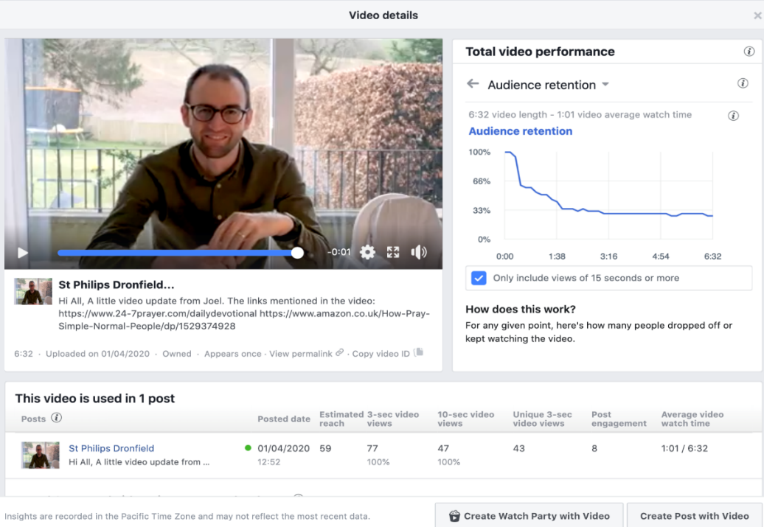

YouTube: On YouTube Analytics you can discover how many viewers were watching you stream throughout your video. You can also find out how many messages were sent by viewers in your live chat.
Views figures clearly include large numbers of transient dippers-in. Be prepared to see a large drop off in the first minute. But that is no reason for dismissing them as worthless. A proportion will always stay the course and even the transient may stay longer next time.
It would be good to work out an average church service view-length profile. Do 10% or 30% or what % on average stay the course for the entire event? What % see at least half? If you discover these statistics or the graph showing them for one of your services could you please send us the results so we can add them to others? That way we can help everyone realistically to interpret what ‘views’ figures for an average event are likely to mean.
Even if only 10% or 30% of views represent serious interaction this will represent for many churches a huge rise in the number of people they are reaching. Many of these people are the equivalent of the new person coming in through the church door or the returnee you haven’t seen for five years. The Holy Spirit will certainly be at work touching their lives with love and grace through our online offerings. The stories and the data we have assembled together even at this early stage of online church tell us that online congregations tend indeed to be significantly bigger than in the building. So let’s consider how best to understand and welcome those who have come to us so readily.
We should also start thinking about what church life could be like when services can be not either in-church (pre lockdown) or on-line (in lockdown) but both at the same time!

WHO ARE THE PEOPLE ACCESSING ON-LINE CHURCH?
When someone has made a comment or pressed the like button on the Facebook platform you can go to their Facebook Profile by clicking on them, and so you find out something about them. Build up a picture by going through each person new to you in turn. Contact as many people as you can to say hello and how nice it was to see them connect with the church, ask how they are and how the church can help them. There may be so many people to follow up that you will need a team from the church to divide up the names between them.
A word about teenagers. So far we have not heard much from church leaders about youth ministry. Some youth ministers are keeping connected with Zoom. But we suspect that online youth worship and ministry might potentially attract lots of new teens. Anyone out there doing this?
We have analysed what we know of virtual newcomers to a few services and can see the following categories:
1. Friends and family of church members
2. Local residents who don't normally come to church, or who used to
3. Housebound with a link to the church
4. Linked by a past event (eg baptism, wedding, funeral)
5. Used to come to the church, or grew up in it, but have moved away
6. Occasional churchgoers who have now become regular
7. Found the church via another (eg denominational or diocesan) link
8. Members of another church that is not live-streaming services
9. No obvious connection but just seem to have joined in
Examples:
- Last Sunday I met a friend from church while out on our walks. She was in tears of joy because both her mother and her grown up daughter had responded to her suggestion, watched our live-streamed service and appreciated it. Neither would have countenanced going to a church building for a service.
- Neighbours of ours who used to come to Messy Church when the children were smaller did the on line service and activities, and posted lovely comments. It was as though they had never been away.
- My friend’s mum is too frail to go to church any more but she now joins our live-streaming every week. Church has re-found her.
- I asked our rector about a name I did not recognise from our live-streamed Messy Church. He told me the man’s baby daughter had been baptised in the church five years ago.
- A young man who had grown up in our church, then married, moved away and lost touch with church joined in our Messy Church yesterday, together, I guess with his wife and their toddler.
- One vicar writes: “People who only ever turn up at Christingle seem to be watching each Sunday, a baptism couple who only attend once in a blue moon have commented that this has made them really miss church, one of our recent wedding couples have been watching and commenting”
- We registered our Messy-style service with a diocesan link and two families joined us through it.
- We actually haven’t identified anyone clearly in this category, we just suspect there may be a few.
- There are just a few completely unfamiliar names who have revealed themselves through comments and likes and we do not know what their story is.
The proportions in each category may well vary between churches. Perhaps large, well known ones will have more in categories 7-9 than other churches. But for most of us it looks like the majority of newcomers are in categories 1-6 with a clear and established link with the church they have chosen. Most will be known to at least some in the church already. This has a number of important implications:
- Simply knowing the names of people joining in may well be enough to enable further contact because the people are known to us anyway - maybe a phone call, a text, a Facebook message or an email can be used.
- The fear that a few large churches with slick on-line operations will scoop the market is largely unfounded. TV churches have existed for years. People are turning to churches they already know, with which they identify, and often that are local to them. To hear the live-streamer say ‘and welcome to John, Elsie’s brother, who has just logged on’, and to get a comments welcome from an old friend, is far more powerful than a flash band and a hip preacher. People are being spatially distant but they do not want to be socially distant. By and large they are turning to their own church or to the nearest one. And they are turning with the full range of motives, needs and personalities, some looking for community, some for peace, some for God. We need the same sensitivity to individuals that we need on the church door.
- The fact that most people joining in do so on the basis of a past link with physical church suggests that on-line church is not that easy to start up from scratch. It is, at the moment, largely dependent on traditional church. If it were easy to start and grow on-line church there would have been lots around for years now. In the long term, on-line church is likely to be an extension to the gathered community not a replacement for it.
- Perhaps the fact that most newcomers may well have been invited by someone is the great new welcoming truth about on-line church. Our ‘Everybody Welcome’ training course spends a lot of time and energy on the problem that it is so difficult to invite people to come to church with us. Some Christians never ever invite anyone to come to church with them, perhaps because of fear of rejection, or the embarrassment of it, or lack of confidence in their own church community’s ability to welcome the stranger. I for one have invited more people to our on-line services in the last week than I have to physical church in the last ten years. So this is the great new discovery:
Inviting someone to access an on-line service is a thousand times easier than inviting them to attend a church building

WHY ARE THEY ACCESSING ONLINE CHURCH?
At the risk of a little repetition, here are some of the reasons churches have come across:
- These are unusual times, and people are looking for support, human contact, re-assurance, faith
- Many people also have more time on their hands
- It is easier to invite people to join online worship
- It seems natural and easy to join online, while scary and unnatural to attend the building
- You can access online church without any commitment or anyone else knowing. You will not leave having been put on the flower rota
- Some are re-connecting with a community they have lost and miss, either through frailty or moving away
- You can access the service at a time to suit yourself – and many are doing so
- One previously non-churchgoer said that online she felt comfortable, fully part of the service and so more welcomed than if she had been in the building unsure of how to behave
- Most people are not looking for high-quality presentation and high-octane performance-religion. They are looking for a familiar and comforting voice and face. It is okay to keep it simple.
- They are being asked, invited, to come to church in undreamed of, unprecedented numbers. It is the simplest thing for a minister to ask all the congregation members who are on Facebook or Instagram or Snapchat to invite their online ‘friends’ to view the forthcoming church online service and send them a link. Even casual conversations over the phone with family and friends, or socially distanced chats on the street with neighbours turn easily to invitation. Many people have up to now had no church of their own not because they don’t want one but because they have never been asked. Now they have been.
This is how one vicar put it:
“My immediate reaction to virtual welcome is that on-line services are accessible, no strings attached, no-one to notice if you ‘get it wrong’ and as such everyone can feel welcome, and able to be a full part of the service. I’m thinking especially of those who don’t normally attend, only come when Grandma is staying, misfits, unsure seekers, and those on the periphery who don’t receive communion. On-line they can really feel part of the service, with all worry about inadequacy, uncertainty gone. Ministering in a small village church, it’s obvious who doesn’t come up for communion, who doesn’t feel entirely part of the ‘set up’, unsure if they belong. I am convinced Christ would have included the outsider, the seeker, the unsure.”
We’d especially love to hear more stories of individuals connecting with online church as these develop everyone’s human understanding of what is drawing people to church, God and faith at this time.

DOING ONLINE CHURCH WELL DURING LOCKDOWN
The lockdown has opened up a mission imperative in an age of uncertainty when people are having their values challenged and being reminded of their mortality. Many are lonely, afraid and bored. Others are over-worked and desperate for support.
How can we respond to this mission opportunity and what is available to help us? This is about choosing and handling platforms, getting the most out of them, and relating well with the people accessing the streams. It includes how to set up online worship, how to lead and present it, and how to follow people up.
You can of course google ‘online church’ or ‘Images of online church’ and a whole world of wonders will explode on to your screen. We don’t aspire to replicate that but to assemble some practical wisdom for ordinary churches, learnt the hard way in the early weeks of lockdown church, and to start a learning community from which we can all benefit.
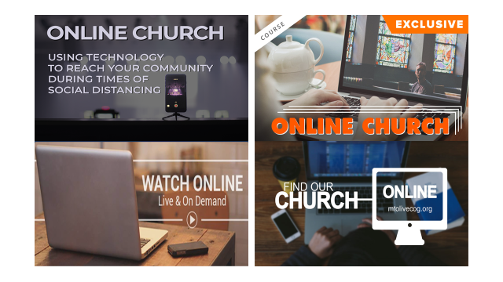
Safeguarding and online safety
Be mindful of the safeguarding implications of moving church services, home groups, personal contact and youth work on line. Normal safeguarding processes should still apply. Your church safeguarding officer should be involved in planning and risk assessments. Those offering pastoral care on line on behalf of the church should have been trained and authorised. Be as alert as usual to potential issues with those joining you on line or on Zoom. The Church of England website provides advice for using video conferencing for youth work and signposts you to ‘Creating safer spaces online’ produced by Youthscape. Anglicans should contact their Diocesan Safeguarding Team with concerns or questions, and other denominations will have similar arrangements.

Platforms
Most churches we have come across are using one of three platforms – Zoom, Facebook and YouTube. They are all free and accessible to most people. For example, you do not have to be on Facebook yourself to access a Website Facebook page, but you won’t be able to use the comments box. The other main choice is whether to pre-record or live-stream.
Other Platforms are Vimeo, Church Online and Instagram as well as various options you can purchase. On Instagram you can post on the news feed, which is permanent, but if you post a ‘story’ it will disappear after 24 hours.
In the early lockdown weeks, people have been grateful for whatever clergy and churches have been able to do, very forgiving of technical hitches and limited formats. In fact, homespun has been better than slick. But, as the weeks roll by, the aim should be to get a little bit better at this each time, raising both the technical and content quality of what goes out. If they can’t hear it properly, the camera wobbles, the same person each week is beginning to run out of ideas, and there is no forward momentum, people will start dropping off. So focus on improving quality and recruit anyone who can help you do this. It will be a team effort not a solo performance. But try not to turn into a tele-evangelist! Stay rooted, human, caring, local.
Zoom
Zoom is being used effectively for a lot of internal church meetings but some also use it for live services. The App is easy to load. The big problem is that you have to be invited and given a code in order to join the meeting, so it feels more like an insiders’ club – everything we are trying to get away from as we open ourselves up to the online world. Entry level Zoom is free but if you want meetings to last over 40 minutes and some other features someone will have to pay. The screen can take up to 100 devices, but it is possible to arrange an extension to go bigger. You may think 100 faces on a TV screen will all be exceedingly small but you can scroll up and down smaller numbers at any one time. There is a danger of talking across each other so the host has to keep firm control, but that is also true of church in person. And you can actually see each other and exchange some conversation.
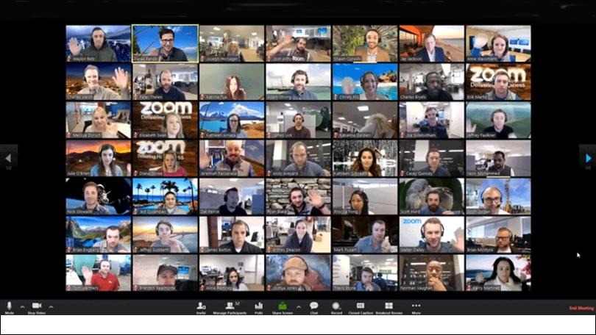
There is a partial route round the ‘secret club’ problem. The Zoom service can be publicised on the church website and people can request a link to participate in services. Clearly there are dangers here in that it is very easy to disrupt a zoom service, and it is not really suited to services where there are children present. Nevertheless a number of smaller and medium sized churches are using Zoom and appreciating it.
Zoom can in fact be recorded then put on YouTube or Facebook for later viewing, though of course the later viewer can’t join the discussion or have their face painted in retrospectively!
When scheduling a regular zoom meeting set it as recurring and choose the option ‘no fixed time’. That way the link remains the same from week to week.
One church publicises the Zoom service on Facebook and the church website and invites people to click and request a link to participate in the service. The vicar then welcomes each person who joins the service taking special care with newcomers. At the end the vicar again goes round all the participants and they report that it feels like quite a community has formed, also inviting people to a virtual ‘tea with the vicar’ for a further chat. To ensure some sort of personal attention, as numbers grow some churches may need to multiply their number of Zoom services. Some of these may then be able to continue after Lockdown.
A vicar in Sheffield puts it like this:
“We are using zoom for on-line worship. The hyperlink to join is made available on our web site. Invitations are sent out through our electronic database. We are finding that people join us who are very much on the fringe of our church, who are rarely seen on a Sunday (Christmas/Easter visitors usually) and we have had some who we don’t know at all.
Joining zoom gives a much greater feel of fellowship than any other live-streaming experience, and this allows the possibility of actually talking to the visitor (admittedly, not easy when you don’t know who they are and everyone can hear the conversation). The numbers will never compete with Facebook connectivity but it may be that one zoom link is worth 50 Facebook ‘glances!”

Facebook and YouTube
These two platforms are the key if you are looking for accessibility and the option for people to post comments, and they are both easy to set up. Some churches are using both so they can reach more people. One key advantage with YouTube is that people can watch it on any Smart TV which means it is much easier to view, especially for a household, and there are fewer problems with volume thereby enabling people to sing along. Another key advantage is that it is easily searchable in all search engines whereas Facebook videos do not pop up in search engines. Many churches publish their services on both, as well as putting them on their website. A detailed comparison can be found at: https://www.epiphan.com/blog/youtube-or-facebook/

If you are putting posts, photos and videos on your website Facebook page you should ideally learn how to delete the old ones, otherwise people will not be able to find the current needles in the Facebook haystack. This apparently is possible but not easy. Go to the Facebook Help Centre for direction. If you crack this one and can explain the click sequence could you let us know?
You can find out quite a lot about people joining a Facebook service if you ask everyone to enter a comment at the start and make responses as the service continues and click on ‘like’ or ‘love’. You can then interact with them and also look at their Facebook profiles.
Having a live host enables repartee and welcome as people log in, and finding a household with lots of people in it can help. Our Easter Sunday Messy-Style service at Eyam was hosted by a family of six, with children doing dramatized readings and accompanying songs on instruments while the youngest ate chocolate eggs throughout. After a half hour pause for activities live-streaming resumed when families reported in what they had been up to.
During Lockdown simple ‘live streaming’ is very limited and can often be only one person giving a talk to camera. Some churches have started this way but are quickly looking for how to enrich the content and format. There is a piece of free software called 'OBS' (Open Broadcast Software) you can download to any computer. This operates with Facebook and allows you to set up a series of 'scenes' for your live-streamed service. Scenes could be still photos or video. You can mix a soundtrack from the church organist with people singing the hymn. https://obsproject.com/forum/resources/how-to-stream-to-facebook-live.391/
Churches who pre-record their services can ‘premier’ them on YouTube or Facebook. This means it is set for a particular time so that you can advertise your service to your congregation and more widely. A step by step beginner’s guide to ‘premiering’ your service for free using Facebook and YouTube is at:https://www.churchofengland.org/more/church-resources/digital-labs/labs-learning-blog/cant-live-stream-your-service-or-event
You can still have elements of interaction in a pre-recorded event through the comments box. The person fronting the recording can also be on line at the publicised real-time point and welcome people through the comments box, and people can respond to each other.
Perhaps the ideal, if you can manage the technology, is to have well prepared and presented video and audio contributions from the church community interspersed by a real-time host into their live-streaming. The best of both worlds.
Churches are exploring what content to use and this partly depends on what expertise and facilities they have. Here are some typical comments we have received from church leaders:
A simple shortened service - not trying to replicate what we do in church, though still containing the heart of it - actually ‘repackaging’ the heart of it is both exciting and creative and more work than it looks! Not worrying about being slick in any way - home-made authenticity seems most powerful.
I’ve been recording and mixing on iMovie. I brought in music from my Musical Director, got readers etc from church via Zoom. This meant that all the services are just like your normal Sunday service. If people then come to the physical church it everyone be what they are used to from the virtual.
Vary the visual content, so that people aren’t looking at the Vicar for the whole of a service, with appropriate pictures, music, members of the community reading lessons, intercessions and so on. Have the words for hymns, responses etc. scrolling along the bottom of the screen. Check for inappropriate material in the background.
The different parts of the service, songs, prayers, bible readings, talk etc are recorded by people who usually do these on a regular Sunday. We find this keeps some continuity for viewers / congregation and for those taking part. Helpful instructions are given such as recording in a quiet space, using something to stand your phone / camera on and most of all smile! I think it should definitely be a team effort, the church is more than 1 or 2, and everyone should be involved where they can. All the services are all age as well rather than the once / twice month that they ran in church so as to engage the children whilst Children’s Church and crèche are not available.
Nurturing insiders as well as newcomers
There is usually a tension in church services between serving the needs of the old hand Christians and the newer seekers and visitors. Of course there is overlap, but it is never easy to help a wide range of people feed and grow together. Sometimes service leaders and preachers need to be clear about who they are mainly trying to communicate with at a given moment. So who are we trying to put a virtual service together for? And what will satisfy them?
It would be quite wrong to be so taken up with communicating with the new people that we ignore the existing church community. They will be looking for echoes of familiarity, re-assurance, community and who can blame them? By all means pick familiar music that will touch their hearts. But what will satisfy them most is the numinous - connecting with the living God, a new truth for a new age from the Scripture, wine outpoured, deep prayer. The core task should be to pray and do our best for the people we know.
But what we find is that this precious core, sharing God at spiritual depth, is also what will attract and feed others. Newcomers should experience the church as it really is. Yes there need to be plenty of packaging-adaptations both to being online and to having a much wider group of people accessing the service. The list of good practices below is geared towards welcoming the newcomer. But that has to be within the context of the character and journey of the existing church community and the way it worships.
Some in your church will be loving all the new action with websites, streaming, emails, zoom meetings, messaging, messenger, WhatsApp groups for ever pinging inconsequential chatter, and all the rest. They will feel excited and energised like some people did in ‘The War’. But others – contemplatives, introverts, technophobes – will get stressed out by it all. The cumulative effect of church media bombardment in lockdown could become very negative for some. So try to stop the church drowning in superfluous communication, leave some people in relative peace, and don’t judge the person who won’t join the Zoom prayer meeting but prefers to pray on their own. You are nurturing people along a marathon not a sprint.
Some good practice suggestions

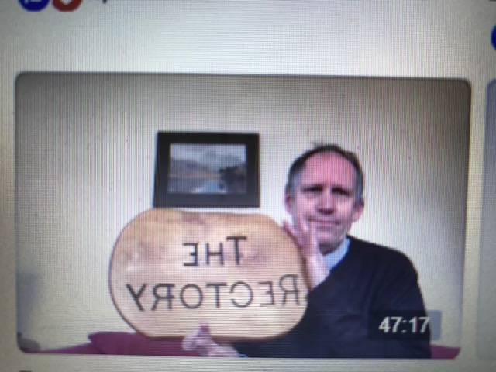
The early weeks of going online have been a hand to mouth existence for many of us. But now is the time to take stock, pull together a planning and operations team, and get organised. Spread the work around and use other people’s skill sets. For example, ask someone methodical to keep a log of whatever statistics your platform throws up, such as the number of devices accessing in real time or the number of views in the following week. This will be the equivalent of your service register and show up the numbers trend and the impact of any advertising. Below is a list of good practice suggestions to check out:
- Don’t look at the centre of your iPad/laptop screen or whatever you are using. The camera lens is shown by the light and it is at the top of the screen. So, if you look at the middle it appears as though your face is turned down towards the ground. Make eye contact with the camera not the screen!
- Involve your whole church community in spreading news of the online service and how to access it by social and traditional media and word of mouth.
- Whichever platform you use, promote your service on other platforms. Try a local Facebook ad but keep the area small so you are not annoying other churches and competing with their adverts.
- You can email out readings and liturgy so that people can join in at home, and also put this on the website and draw peoples’ attention to this at the start of the service.
- At the start and end of every service specifically mention and welcome visitors and newcomers. Tell them they are not interlopers but much valued members of this new community. For a good example of how to welcome onliners look at a service on the website of St Paul’s Dorking. The vicar, Ruth Bushyager, has opened the service the last few weeks with a warm welcome to the new as well as the previous regulars. The welcome includes practical offers of support from the church congregation eg with food parcels, together with an email address and a phone number for people to contact the church during the service. People are manning a laptop for the emails and a phone for the messages to respond as the service proceeds.

Here is some sample wording:
Wording at the start of live-streaming
Welcome everyone. I’d especially like to welcome anyone new or who has not been a regular member of our church in the past. I hope you feel fully part of this on-line worshipping community today and that you find you can meet with God through the service.
Wording at the end of live-streaming
That’s the end of our live-streamed service this week. But I’d just like to say that, if you are new to St George’s, you are especially welcome. We’ll be here at the same time next Sunday. In the meantime I would love to hear from you by email. I’d especially love to know how you came to join our service today and whether we can help you further on your spiritual journey in these unusual times. Just drop a brief email to bobthevic@gmail.com and we will respond to you.
- Make the online service as responsive as possible:
Responsive prayers with the response words on the screen
Invite people to have a Bible with them to follow the Reading & Talk, though you can always put up the words as you read the passage
Use silence
Invite people to write their own prayers in the message box so everyone can see them floating up the screen. Encourage likes etc.
Invite people to contact your team there and then – have a team of welcomers manning an email address or a phone for messages and responding immediately
- Timing: It is rare for people to watch a platform for more than 30-40 minutes. So you may want to shorten your online service and it is absolutely essential to get across your welcome and message immediately you begin – in the first minute. Target the first minute at your online newbies and visitors. Make them feel welcome & valued, that this is for them, they are not gate-crashers. Give them a way of saying hello – eg comments box if on Facebook – immediately. And summarise your message of hope in troubled times.
- Have people on hand to respond to comments which come in, looking out especially for visitors. Personal contact via local people in the congregation is key - when a guest pops up on the Facebook comments stream it may be possible to link them with someone they already know. Envision people to friendship evangelism and delegate to them. Offer a website for people to email. But let people be in charge of their own process. Treat them as individuals and don’t try to corral them down some rigid route you have invented. But have in mind the sort of second steps that are practical in your situation. By all means be ready with an online Zoom Alpha Course.
- It is vital if someone contacts you that you give a first response within 24 hours. You will probably need to get a team up and running for this sort of thing. Don’t try to do everything yourself. Someone should be keeping a log of the names of people who have contacted you online and the type of contact, such as ‘Wrote in the Facebook comments box’. This will help you respond to people appropriately and not forget someone.
- Be sensitive to the presence of a wide range of people when presenting the service and cut out the jargon. One minister wrote: “Our Easter service has already had over 1100 views on YouTube so we know people are watching. That has influenced how we preach and what we preach on – shorter messages and very gospel/Jesus focussed.”
- It may be that the most powerful content at the moment (isn’t it always?) is stories. Get people to tell their story or testimony and include one in an online service. The person will need to script it and practice at home to record on their device. It should be short (2-4 minutes), real and recent and be about an experience of God in their lives.
- At the end encourage people to ‘like’ the service and share it. That is one way it will ripple out through the local community over the coming week.
- Always tell people how they can take a next step if they wish to – otherwise you are implying they are very welcome to watch but you have no further interest in them after that. A next step will almost inevitably mean them revealing themselves to you. That should be their unpressurised decision but it is the key that unlocks everything else.
- Blessing people properly is particularly powerful and needed at the moment. Make it an important element of the service. It may be the last time someone is blessed or prayed with before they go to hospital and die in isolation.
- Explore using Zoom for after-church coffee and invite people to join in. If you are a large church you may need several Zoom rooms. A Zoom organiser might split people up so they have to talk to people other than their immediate friends.
- Look at “Insights” on Facebook and “Analytics” on YouTube to see what is happening during your stream. Zero-in on retention metrics. Don’t get wrapped up in how many people viewed your content, but how long they watched for, and figure out how many people engaged during the service.
- If you are a Church of England church, ‘A Church Near You’ shows which churches are live streaming so make sure you inform them.
- Some churches record a CD of the service for those not able to access the internet and send it out to them. In some cases others in the household who do not normally attend church might join in.
- People read the comments. Encourage church members to have conversations in the comments section about the material and their reactions. Encourage the church to have public conversations about their everyday faith and reactions to content in the comments section. People will and do read that stuff! In fact they are probably more interested in what everyone else is saying – or said – than what the pastor in the video is saying.
- Have people monitor old posts. Stuff still gets viewed after the event. Pick up ‘late’ likes and comments.
- Gathered and Glued. The idea is that the service is planned by a service leader, and different folk are given the task of videoing themselves saying or singing the different parts- these are then gathered and glued together into one video which is put out on You Tube at the regular Sunday morning time.
- You can offer an invitation to something "face-to-face" once normal socialising is permitted. Meeting together still is an important aspect of Church. E.g. "If you enjoyed the online service today, why not try coming to St Bob's when our services resume? We'd love to welcome you in person." Or, when a date for resuming socialising is known you could invite new online worshippers to a gentle social event to meet you and each other.
- Ensure that you have the copyright permission you need if you are using music. Your existing licences may be sufficient but details are at: https://www.rscm.org.uk/live-streaming-of-church-services/. Further details from CCLI can be found at: https://uk.ccli.com/ccli-news/recording-streaming-and-podcasting-your-services/. You cannot broadcast YouTube songs you happen to find as that is breach of copyright and Facebook will put a stop to it. So find ways to make, record and broadcast you own music.
- Other useful links:
ChurchEdit: https://www.churchedit.co.uk/website-tips/church-video/live-streaming-your-services/
Love Black Country: https://loveblackcountry.org.uk/featured/how-to-stream-church-services-online/
This is a really useful link to: “Community in a Crisis - relational sustainable online church” https://www.facebook.com/communityinacrisis/
Premier Media run courses in online church – see their website
Here are four examples of what churches are doing:
  - We're livestreaming Sunday morning on FB - we go live 10 minutes before service starts, and I keep an eye on comments stream and say hi to people on the livestream as they join - including newcomers / folk from distance - I also encourage people to say hi on the comments. At the end we have a few Zoom rooms open after the stream - one for general chat, one for kids, and one for newcomers / people who want to know more – we haven't actually had anyone come to this yet! We're working on a virtual equivalent of our welcome / address capture card.
  - We have been live streaming pre-recorded services on Facebook and YouTube, and have noticed how important the comments section can be for created a sense of interaction. In particular we have tried to make sure those who aren't regular members are noticed and acknowledged. This may be a more general comment "Welcome everybody, and a special welcome to anyone who is joining us for the first time", or if we have some vague connection we might welcome them by name, "Welcome Bob, it's great to 'see' you". We have also tried to make sure we interact with any comments visitors make during the service, even if this is just the "like" button. Before each live-stream begins we decide who is posting as "St Matthew's" and then the rest of the team post as themselves - this helps people to know that they're engaging with a whole community rather than an anonymous organisation.
  - We are live-streaming services, using OBS via Facebook live, so that it is accessible to all. FB saves the streamed service as video, but we also up-load the video to YouTube for extra accessibility. We do not specifically single out newcomers - although we do have them. We welcome everyone, sometimes by name as they join the stream. We post a screen at the beginning with details of all our streamed services as a general invitation, and another at the end with contact info. We end the stream with a short spoken repeat of all that info (service times and contact info), as well as another general invitation to get in touch. Most are returning regularly and commenting via the comments bar on FB. We respond to the comments, thereby engaging individually. We are finding this works well, and feels less segregated than specifically mentioning newcomers - the new community is building organically without divisions; in a sense everyone is new, because the method of meeting is new.
  - I began Zoom Sunday services. These have been well received and I have enjoyed leading them. We have had guests from across the country - London, Henley and Hull to name a few, as well as members of the congregation from across the benefice. The services have been advertised: in parish newsletters, on Facebook and word of mouth. The Zoom services are surprisingly spiritual and ministerially rewarding. Online services and electronic media is not my comfort zone, I have had to learn new things very quickly but I believe it is necessary at this time. I have been pleased with how well it is going. To be honest I have had more compliments on my ministry in the last three weeks of lockdown that I have had in the three years of incumbency. That may be a little sad but it shows that something is working.
Websites
We guess that many churches have just discovered that their website is not really fit for purpose. At the very least you should be able to add and delete content yourselves. If not, take urgent steps to acquire this ability. The website should become far more than a notice board – it should be the portal through which the visitor can beam themselves up to meet you. One church’s Alpha page has a button to press so you can arrange a Zoom meeting with the Alpha organiser. It should be a route to online services, to a facetime chat with the vicar, or whatever routes are appropriate for you.
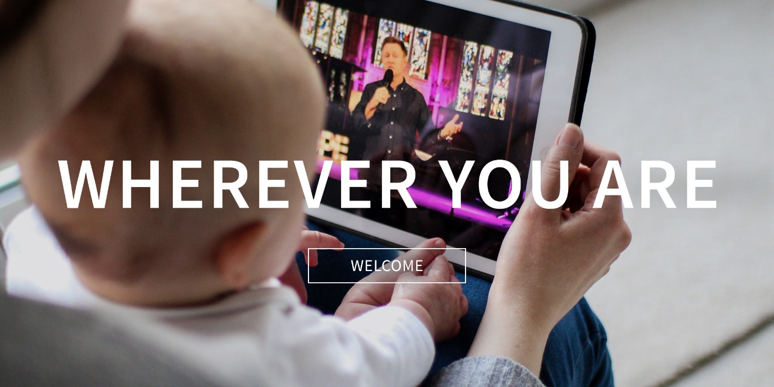

Make sure that up front and central on your website homepage there is a warm welcome to people who are just browsing and who may possibly access an on-line service or some other offering. On line service information should be near the top of the homepage. Here is a sample wording:
Welcome to everyone – a message from our vicar
Our church services haven’t stopped just because the building has closed. We have gone online so it is really easy to find us on Sunday morning at 10. Click the Facebook link below and you are in. You don’t need to be on Facebook yourself.
And if you have been accessing our live-streamed services, or simply looking at our website, welcome! Perhaps you find church on line easier to try out than a physical building, perhaps these extraordinary times have triggered something spiritually inside you, perhaps you would appreciate linking with a Christian community. If, for whatever reason, you would appreciate some human contact with our church, or have a question, then please email me at bobthevic@gmail.com and we will respond to you.
And make it easy for people to find what they are looking for:

Live Video Stream
This is the place to come to watch and engage with live video streams of our services at St Paul's.
All videos will be available on the St Paul's Church YouTube Channel stpaulsdorking.org.uk/youtube
Follow the link to watch a live stream service each week, or to catch up on previous weeks services.
Alternatively, the links below take you directly to our most recent Sunday services:

Easter Holy Week Services
To see all our Easter services watch this playlist.

Does online preclude contemporary styles of worship?
It does seem relatively easy for a vicar to live stream a service, doing everything themselves in the old-fashioned way. Much harder to replicate a service with many people contributing or a families’ worship event like Messy Church or one with inspiring music. However, with ingenuity there is always a way. The music group leader at my son’s church laid down their own instrument track at home then sent it round the other members in turn to film their track. The band was then put together and led singing for the streamed service. Virtual church does not need to be just the vicar doing everything in the old-fashioned way. This is a wonderful opportunity to get tech-savvy families to produce inspiring home-videos and to ask others to host the live-streaming or make contributions on phone videos. In my church it was the children by video who conveyed the Easter story most memorably and attractively. We should build on that when lockdown ends.
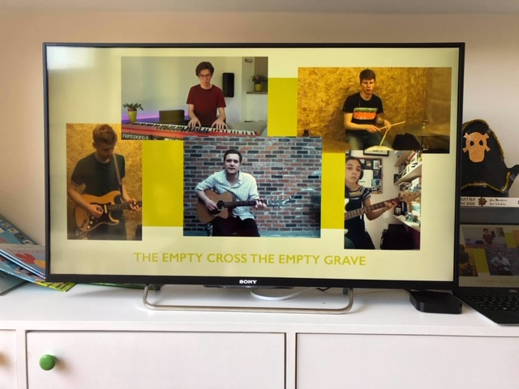

Lucy Moore, the founder of Messy Church, at first thought that most Messy Churches would sit out the lockdown and resume when it was over. However large numbers have been determined to keep going with regular craft suggestions & Bible verses being sent round their families, and pastoral phone calls to see if they are okay. Some, like our own, have kept their events going with a mix of posts, video and live-streaming. A Baptist Church in Doncaster distributed ‘Messy Church in a Bag’ to 400 homes.
Messy Church are adjusting their online resources to fit the new situation. The run up to Easter gave the churches obvious activities and an extra motive. What they can sustain in the period after Easter is yet to be discovered.
CAN YOU HELP US WITH TESTING?
Until there is large scale testing we cannot know key facts about the C19 virus and this hugely handicaps the effort to beat it. Our efforts to grow the online church will be similarly handicapped if we don’t really know what is going on. Many churches may well be reaching numbers of people online, but others won’t be. Where is the balance? The easiest way to shed light on what is going on is comprehensive surveys in small areas. ‘Churches Together in X’ or the ‘Deanery Chapter of Y’ or the ‘Z Circuit’ would ask all churches in their area to fill out a very short questionnaire we will provide and send the results in to us. We will analyse and share the results. When results are in from several areas or groups we will have a pretty good idea of the patterns of response and new insights into which responses seem to be working best.
Just drop us an email and we will supply the questionnaire and all you need to conduct your survey. Then send us the filled-in forms and we will analyse and report.

WHEN THE LOCKDOWN PERIOD IS OVER
Many of the church ministers we have consulted have told us the experience of lockdown will change their church for ever. One free-church minister in West Sussex wrote: “The situation is forcing us to ask questions we have not asked before. It will change how we do church whenever this lockdown is over.” A vicar in Derbyshire said, “I’ve known for some time that we should have been on-line but we did nothing about it. Now I know we have to stay online when this is all over.”
So do not imagine that when the lockdown ends you can ‘return to normal’. The emergency may well have propelled you into mission areas you would have otherwise avoided. It’s forcing us to gaze in through a massive mission-window we hadn’t realised was more than a tiny slit. When people get busy again they might be slightly less inclined to take in a church service. But we hope that, from now on, many churches will always have an on-line presence and that services will always be live-streamed in some way or other. Setting up good on-line welcoming practices should be not a temporary expedient but a permanent mission-advance. There might also be a wave of new people turning up in person when churches re-open because they have so appreciated the online version of church.
Resources
Once Lockdown is over then many churches will hopefully continue to stream their services live and helpful information on this is at: https://www.youtube.com/watch?v=9TKsLQYagYA. This is a 17 mins video on how to physically equip your church building to livestream.
There is also step by step beginner’s guide to going live with your service or event using YouTube, Facebook and Instagram at: https://www.churchofengland.org/more/church-resources/digital-labs/labs-learning-blog/beginners-guide-going-live-your-service-or.
The Church of England also provides webinars on streaming which you can book into: https://www.churchofengland.org/more/church-resources/digital-labs/labs-learning-webinars.
Timing
Livestreaming for lockdown may be needed for longer than many people think, for four reasons:
- When lockdown ends some people are likely to be still too frightened to attend church in person. This may be especially the case for older congregations
- The pandemic may go in waves so lockdowns could possibly be re-imposed for periods several times over the next year or two
- Mrs Merkel announced on April 15 that unlocking in Germany will gradually start in early May with small shops, hairdressers and schools re-opening. However, large public gatherings and religious services will remain banned until August 31st. Germany is ahead of the UK. At the moment our Government refuses to say what our exit strategy is, perhaps because they don’t know. But, if Germany is anything to go by, do not expect your church building to re-open for worship until at least September. Every church should now set up an online presence if it does not wish to suffer the impact of being closed for at least six months. Some churches, after such a hibernation, may never reopen at all.
- Suppose, as unlock approaches, you have 125 people regularly accessing online services, of whom 75 used to come to the building and 50 are new. And suppose your church building is not yet equipped to film and stream the re-opening service. Do you simply tell your new onliners they can come to the building if they wish, otherwise you have no further interest in them? Far better to maintain a stopgap online-only offering until the building is equipped.
So keep learning and honing the skills, don’t imagine they will be redundant for ever in a few weeks’ time. If you have been wavering about whether to do online services because it might soon be over then think again. And start planning for the new era of live-streaming when churches do eventually reopen.
Strategic Options
The main option choices for the long term would appear to be:
- Just try to keep congregations ticking over until we can get back to normal in our buildings. Please don’t think like this!
- Invite on-line contacts to further explore the faith with on-line steps such as an enquirers' course. Well worth a try. Make sure you have an enquirers’ course pencilled in to start when lockdown ends even if you have one during lockdown. There may be all sorts of people, not just online visitors, who have developed a need and desire for this through their lockdown experience. Advertise it during on-line events and on the website and offer to conduct it using Zoom if that is people’s preferred medium. If in the end they opt for face to face then fine, but give them the option.
- Make better contacts with the wider fringe and encourage some to join in the physical gathered community that is 'proper' church. We have both spent years trying to persuade traditional Christians that fresh expressions of church are not half-way houses on route to their own church culture and service. But experience says that online is an excellent stepping-stone to ‘in person’ – so encourage people in that direction. But if it doesn’t work for some people what do you do then?
- Set up a separate on-line congregation alongside the gathered ones. We would like to find out whether this would work but we have our doubts. If permanent online-only church were easily viable we would have lots of them already. Can the intrinsic human need for community and belonging really be fully satisfied for ever in virtual space? When lockdown ends, the instinct to gather may be stronger than ever. Adding a dedicated online service would involve a lot of extra effort compared with simply filming what happens in church anyway.
- Livestream regular services in order to include people who can't or won't be part of a gathered congregation. This is going to be a natural outcome for many churches. Those contacted through the lockdown weeks – plus others - can be offered the chance to view existing services in the church building when they re-start. This may work very well for many people, including those too frail to attend or who live in care homes or those for whom a physical visit to church is a bit too stressful to contemplate. It could be a good substitute for home communion and so be a net time-saver for hard pressed clergy rather than an extra task. But it may work for many younger people as well, including those whose partners would disapprove of a physical visit to church. This is worth doing even if the online participants are simply silent individuals watching a gathered community without being part of it. But leaving it at that will miss most of the benefit.
- Use interactive livestreaming to grow a blended, fluid online- in person church community. We think this is usually the best option. An online pastor will offer welcome and some commentary as people log on and say hello through the comments box. The on-liners could join after church refreshments in a Zoom room. They would be invited to small groups and other dimensions of church life. Some people would come in person one week and be on-line the next. Shift and Sunday workers could catch up on a different day. The average churchgoer pre-lockdown attended the service only one week in two. Having the service available online all week might greatly increase frequency rates and even enable a revival of sequential preaching. Friendship-welcome would be offered to all online and in person newcomers equally. This is not a model of participants and spectators but of a single, complex, fluid, open community.
- Vary the format on different weeks. The 9am ‘Early Church’ for families at Eyam currently meets twice a month. During lockdown it has gone online, attracted extra people and enabled families to do much of the ministry and leadership. When lockdown ends the twice a month in-person services will probably resume without any filming. But in a third week we may well continue the online ‘home’ style that is proving to work well at the moment, blending in person and online in one community by week of the month.
Get prepared!
- Technology and kit. Churches should be preparing the technology for this now as a matter of urgency. We foresee a massive business opportunity for anyone able to offer a one-stop shop to equip churches for live-streaming their events and services. However, there may be such a scramble to get set up when lockdown ends that the waiting list for kit and people to fit it will be horrendously long. Wise churches will research what they need and buy the kit now as a matter of urgency then fit it as soon as they regain access to their buildings. Ideally there should be not a week lost between lockdown ending and livestreaming of a church service beginning.
- Skills and training. A whole new set of technical skills has become needed for the good and growth of the church. Every church should seek out people among its friends, fringe or members who have the skills needed. Gaps should be plugged by finding training opportunities for people to acquire the needed skills. We would love those possessing good level technical knowledge and skills for online church who can share this with others to let us know and we’ll put your contact details up on our site.
- Welcome and relationships. Imagine the scene on the first Sunday your church is allowed to open. Those regulars brave enough to start meeting other people will be overjoyed to see each other again and in many churches there will be much hugging and rejoicing. In others, people may even smile at each other momentarily. However, disconcertingly, there are also a number of strangers who have turned up. These are people who had been accessing the services online during lockdown – and they actually already think of themselves as belonging to the church community even if they haven’t been in the flesh before. But the regulars ignore them in their delight at old friends so the newcomers leave disappointed and disillusioned. If you think this may be a plausible scenario in your church then prepare your congregation for this key event. Make sure some people are appointed to look out for the strangers, to talk to them and integrate them into what is happening. Acknowledge them from the front and get their names and contact details so you know which of your on-liners is there and can continue developing the relationship. And we know the perfect training course for your congregation – Everybody Welcome (Leaders Manual, Members manual and DVD) written by the two of us!
https://www.chpublishing.co.uk/features/everybody-welcome

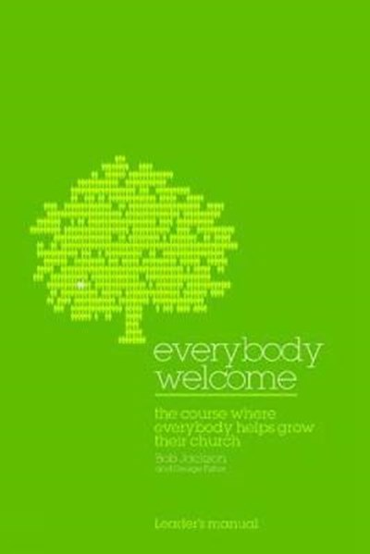

A reminder of what we have asked your help with
If you find the notes helpful or inspiring then please copy them to as many of your contacts as possible.
We baby boomers are, of course, trying to learn foreign languages in order to communicate. We’d love to partner with one or two young native speakers – could that be you??!!
We’d love to hear your online story – do send us a summary if you have something helpful or encouraging to share with others.
A word about teenagers. So far we have not heard much from church leaders about youth ministry. Some youth ministers are keeping connected with Zoom. But we suspect that online youth worship and ministry might potentially attract lots of new teens. Anyone out there doing this?
It would be good to work out an average church service view-length profile. Do 10% or 30% or what % on average stay the course for the entire event? What % see at least half? If you discover these statistics or the graph showing them for one of your services could you please send us the results so we can add them to others? That way we can help everyone realistically to interpret what ‘views’ figures for an average event are likely to mean.
We’d especially love to hear more stories of individuals connecting with online church as these develop everyone’s human understanding of what is drawing people to church, God and faith at this time.
Can you help us with testing? Just drop us an email and we will supply the questionnaire and all you need to conduct your survey of what your churches are doing. Then send us the filled-in forms and we will analyse and report.
We would love those possessing good level technical knowledge and skills for online church who can share this with others to let us know and we’ll put your contact details up on our site.

