Instructions for using Zoom – an online meeting app
- First go online and search for zoom.us
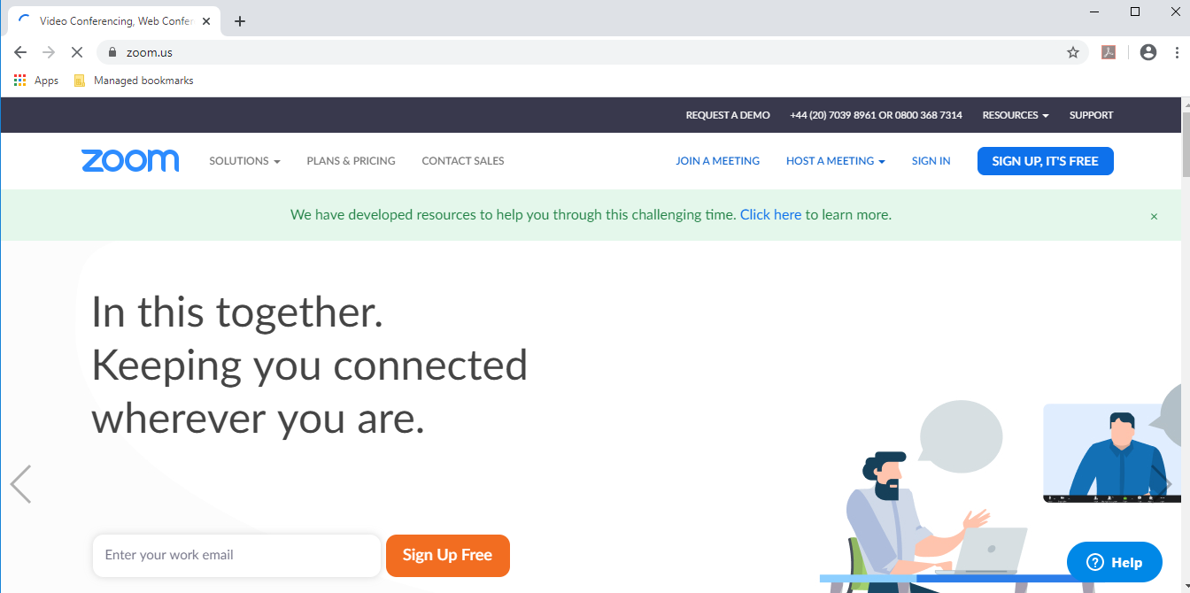

- Next, click on ‘Sign up Free’ or Sign up, it’s Free’. Enter your work email address or you can log in with a google account or your facebook account. Click on ‘Sign Up’
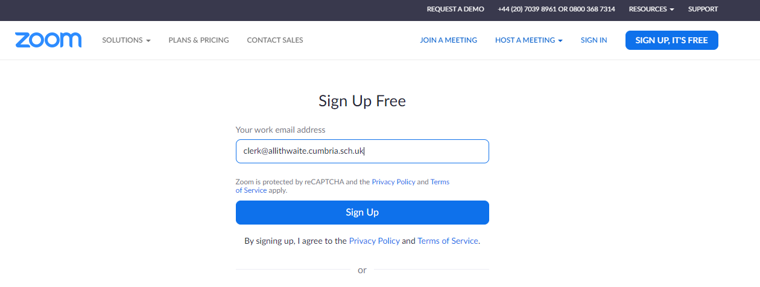

- Now you will see this screen, it’s about getting emails. You can change your preferences by clicking ‘set preferences’ or change them at any time once you’ve signed up completely. Click ‘Confirm’
- You should now get a message saying that an email has been sent. Go to your email account and click on the ‘Activate Account’ button in the email from Zoom.
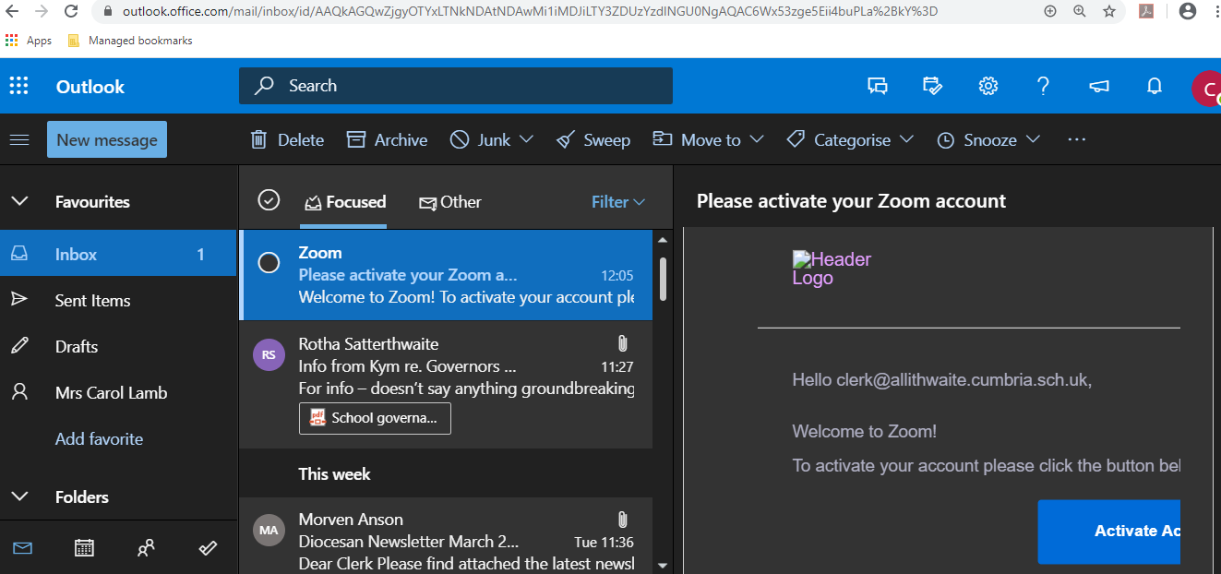

- You should now see this screen. Fill in your name and create a password (8 characters: Letters incl. 1 uppercase and 1 lowercase, numbers, symbols), enter your password again in the ‘confirm password’ box. Click ‘Continue’
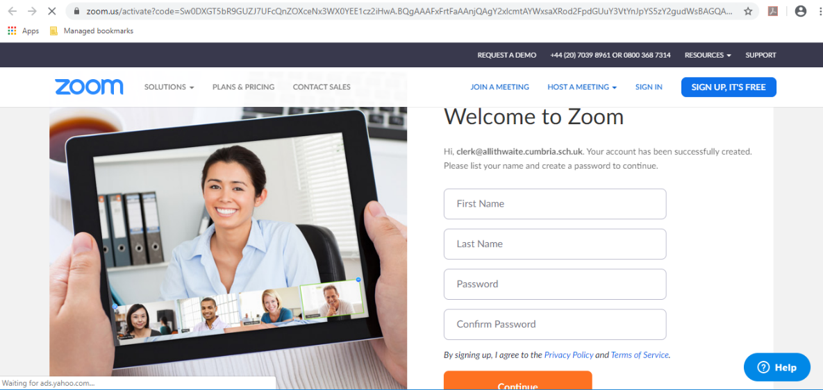
- You now have the option to invite others to zoom. You can skip this step by clicking on ‘Skip this step’.
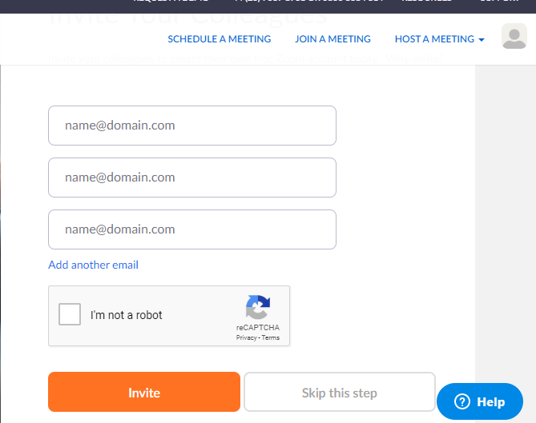

- You should get this message next. Click on ‘Start Meeting Now’
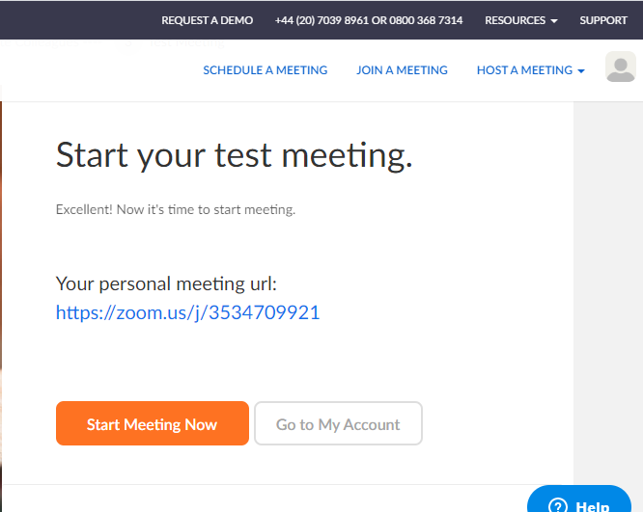
- This screen will now appear. Click on the download as directed.
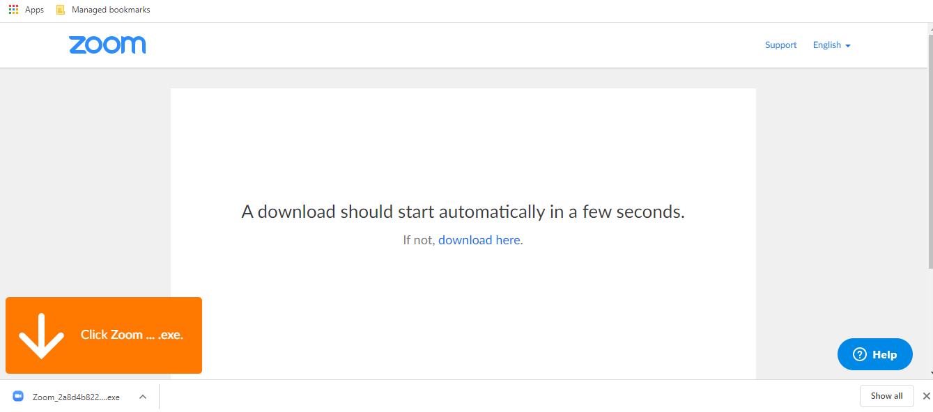
- You can read the Terms and Privacy policy if you like or click ‘I Agree’
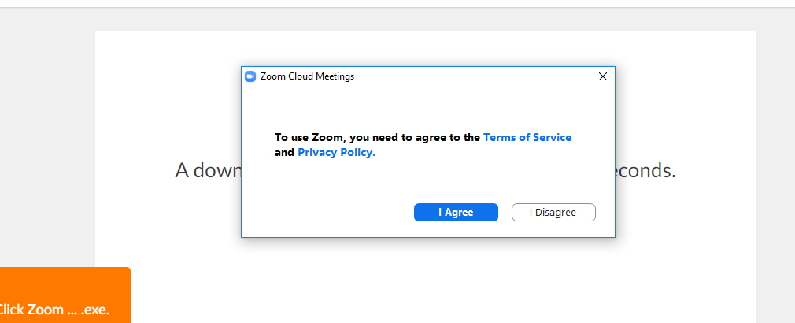
- You will now enter your own ‘Meeting Room’. You will be asked if you want to join with Computer Audio (as below) and then with Computer Video. You can click on Test, follow the instructions to test your equipment. Otherwise click ‘Join with Computer Audio/Computer Video’
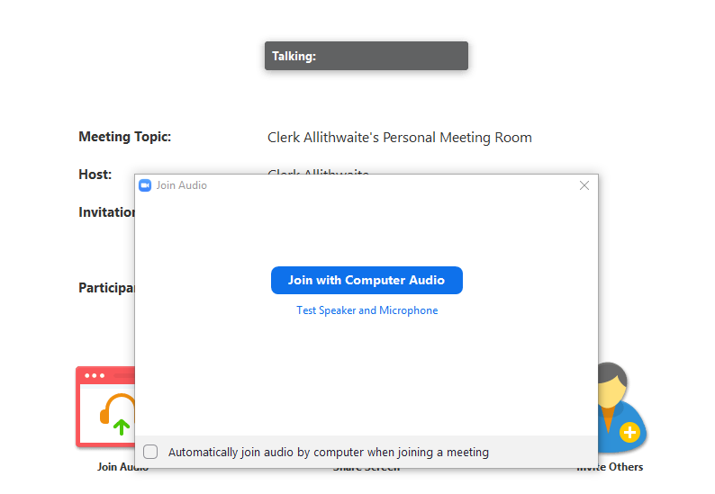
- Once you’ve tested and accepted. You can close this screen (cross in top right corner). Now click on ‘End Meeting for All’
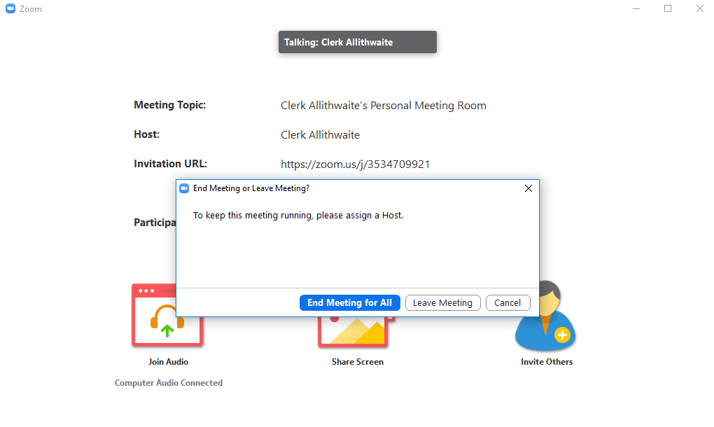

- Well done! You’re basically there! If you use Outlook as your email client then you can download this add-in that lets you schedule meetings direct from Outlook. It’s not necessary though.
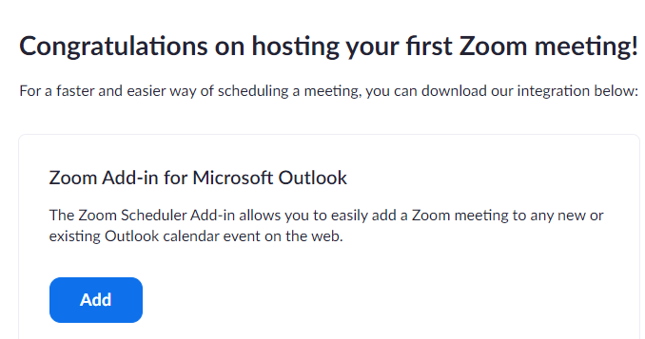
- When someone invites you to a meeting, you’ll receive two numbers. The first is a Meeting ID. Got to Zoom, log-in and click on ‘Join a Meeting’ now enter the Meeting ID where prompted. Click ‘Join’
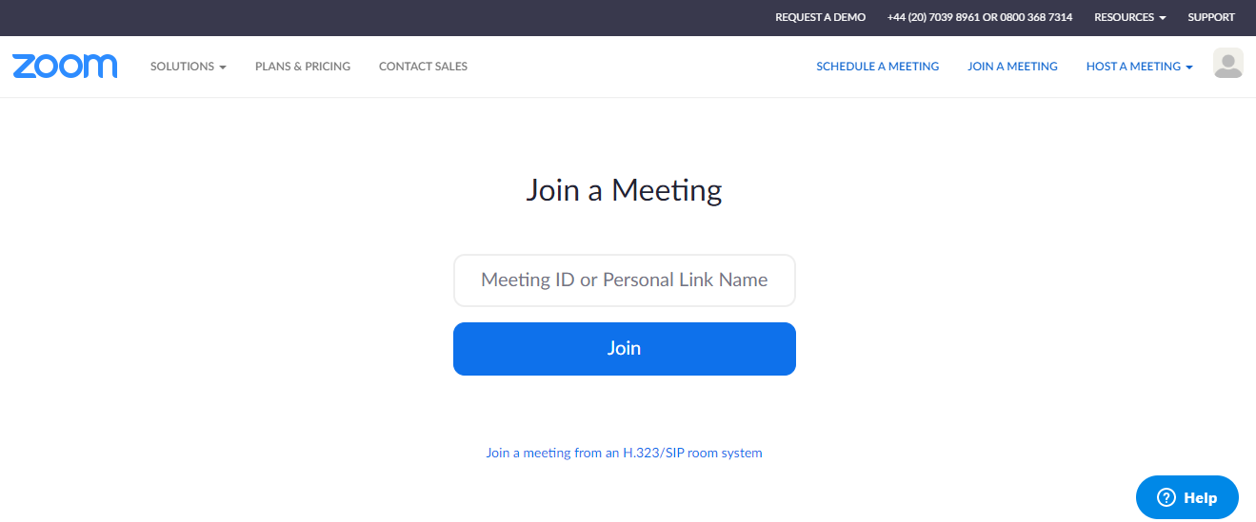

- You’ll then be prompted to enter the password. Once entered you can click ‘Join Meeting’
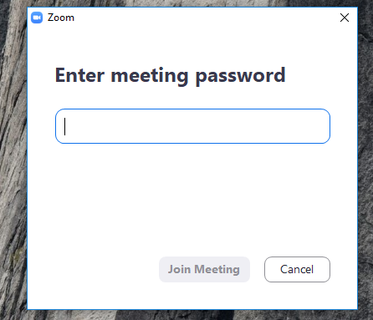
- You’ll get to preview your video and audio again. Click either ‘Join with Video’ or ‘Join without Video’.
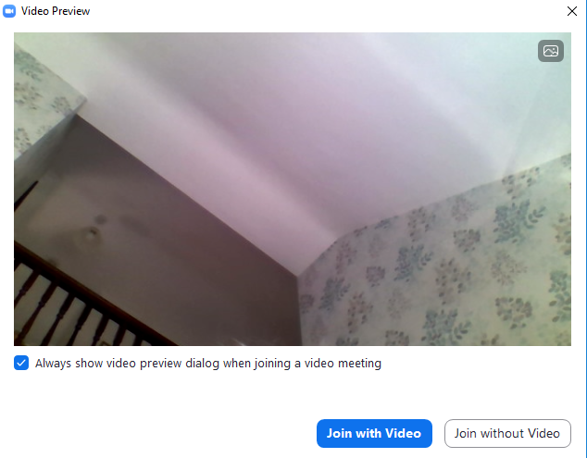

- Congratulations you should now have joined a meeting! You can control who sees/hears you using controls in the bottom left hand corner of the screen. You can ‘mute’ yourself, so others can’t hear you and ‘start/stop’ video.
- To leave/end a meeting click on the red button at the bottom right.
Hope these instructions help!

