Collective Worship Guidance for Schools, Clergy and Governors

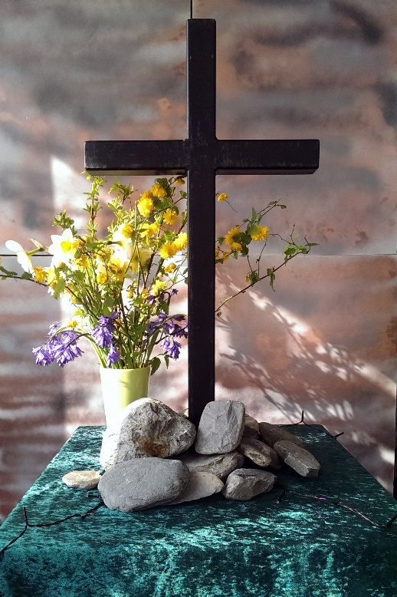

Author | Penny Hollander
Approved by Board of Education | January 2020
Review Date | January 2022
Acknowledgments
We are very grateful to the following schools who have given valuable help in contributing to this guidance document and allowing us to share examples of their practice with other school communities within Carlisle diocese:
The Bishop Harvey Goodwin School
Broughton in Furness CE School
Cartmel CE Primary School
Eaglesfield Paddle CE Academy
Langwathby CE School
Lazonby CE School
Old Hutton CE School
Pennington CE School
Staveley CE School
St Bridget’s CE School, Brigham
St Herbert’s CE Primary and Nursery School, Keswick
St James CE Infants School, Whitehaven
St Mark’s CE School, Natland
St Mary’s CE School, Kirkby Lonsdale

We also thank the following dioceses for their documentation that helped us in compiling this guidance:
Diocese of Canterbury
Diocese of Rochester
Diocese of Guildford
Diocese of York

Contents

- The place of collective worship in a church school 4
- Opportunities in collective worship 4
- What’s in a name collective worship or assembly? 5
- The legal requirements for collective worship in a church school. 5
- Collective worship and RE 6
- The impact of collective worship in school life 6
- Questions to consider in planning collective worship 7
- Structuring collective worship 8
- Classroom worship 9
- Outdoor worship 10
- The role of clergy in leading collective worship in a church school 11
- Observation and Evaluation of collective worship 14
- Reflection areas 17
- Resources 18
- Appendix 1 - The Right of Withdrawal from Collective Worship 20
- Appendix 2 – A Range of Prayers 21
- Appendix 3 – A Model Collective Worship Policy 23
- Appendix 4 – Sample Governor Monitoring Form 27

Collective worship in Church of England Schools

…Worship as the heartbeat of the school
SIAMS schedule 2018

- The place of collective worship in a church school
Collective worship is central to the life of a church school. It is part of the outworking of the school’s Christian vision and is a time for the whole school community to gather, pause and reflect on their own spirituality, values and place in the world.

Offering this in the context of authentic Christian worship is not ‘religious indoctrination’ but a simple chance for children of all faiths and none to develop spirituality and gain perspective in an otherwise crowded day
Nigel Genders Chief Education Officer for the Church of England

- Opportunities in Collective Worship
Collective worship gives opportunities to:
• Engage in an act of community
• Express praise and thanksgiving to God
• Reflect on the character of God and on the teachings of Christ through Biblical texts
• Affirm Christian values and attitudes
• Celebrate special times in the Christian calendar
• Experience and respond to Anglican traditions and practices
• Explore the big questions of life and respond to national events
• Foster respect and deepen spiritual awareness
• Be still and reflect
• Share each other’s joys and challenges
https://www.churchofengland.org/more/education-and-schools/church-schools-and-academies/religious-education-and-collective-worship

The whole school community involves adults in school as well as all pupils unless pupils have been withdrawn by parents/carers or staff have exercised their right of withdrawal from acts of worship. See Appendix 1

- What’s in a name - collective worship or assembly?
It is a legal requirement that all maintained schools, including Voluntary Aided and Voluntary Controlled Schools and Academies conduct a daily act of collective worship. It does not define clearly what ‘collective worship’ means precisely but in church schools and academies it needs to be distinctively Christian in character, reflecting Anglican traditions and practice. God is honoured and worshipped. The term ‘collective’ assumes that the whole school community is gathered, expresses its shared Christian values and the contribution of everyone is celebrated. It is an inclusive time for all members of the school community, regardless of faith background or none. It offers opportunity but is also invitational without compulsion. Although some church schools use the term assembly this can be misleading in that this word simply means ‘gathering’. It can be applied to any situation where the school meets together for different purposes.
Collective worship and assembly are distinct activities. Although they may take place as part of the same gathering, the difference between should be clear (DfE circular 1/94 para 58)
Think about:
- Be explicit about what is worship time and what is not e.g. light a candle at the beginning of collective worship and then extinguish to show that it is the end of worship
- Using a specific greeting/prayer at the beginning and end of collective worship

Corporate worship refers to people of the same beliefs and values meeting together to share their faith e.g. at a Sunday service in church. This is not appropriate in a school setting where there are different faith/no faith stances represented.

- The legal requirements for collective worship in church schools

- Be conducted in accordance with the Trust Deed of the school and Instrument of Government and be consistent with the beliefs and practices of the Church of England
- The Governing Body ensure that all pupils each day engage in a distinctively Christian act of worship
- Arrangements for collective worship in foundation schools (i.e. church schools) of a religious character are the responsibility of the Governing Body, after consultation with the headteacher (DfE Circular 1/94 para 52&53)
- All acts of worship should be based on Biblical teaching
- Unless the right of withdrawal has been exercised all pupils must take part each day in an act of collective worship (DfE circular 1/94 para. 51)

- Collective worship and religious education (RE)
Although what has been experienced in collective worship may be on occasion referred to in RE lessons these two areas of life in a church school are distinct. Collective worship is NOT curriculum time for religious education. RE is an academic subject where children learn about different beliefs and faiths of different believers, whereas collective worship offers opportunity for worship and allows children to engage with their own spirituality and see Christian faith in action. Prayer spaces or reflection areas may be an extension of collective worship where children can be still, reflect on their own spirituality, express their thoughts or questions, sometimes in a prayer of their own. RE displays/working walls are distinct from this and reflect children’s academic learning in the subject.

- The impact of collective worship in school life
In a church school collective worship should be inclusive, invitational and inspiring
SIAMS Schedule 2018

A church school needs to evaluate how:
- All pupils and adults are offered the opportunity, without compulsion, to grow spiritually through experiences of prayer, stillness, worship and reflection
- It enables all pupils and adults to appreciate that Christians worship in different ways e.g using music, silence, story, prayer reflection, the varied liturgical and other traditions of Anglican/Methodist worship, festivals and, where appropriate, the Eucharist
- It helps pupils and adults to appreciate the relevance of faith in today’s world, to encounter the teachings of Jesus and the Bible and to develop their understanding of the Trinitarian nature of God and its language
- It enables pupils as well as adults to engage in the planning, leading and evaluation of collective worship in ways that lead to improving practice. Leaders of worship, including clergy, have access to regular training

Think about:
- What are the different elements that are currently used in our collective worship?
- To what extent do we use different settings, seating arrangements, styles of worship?
- How do we ensure that collective worship builds up children’s understanding of the Trinity?
- To what extent are children involved in planning, leading and evaluating worship?

- Questions to consider in planning collective worship:

- Is it rooted in Biblical teaching and made relevant to life today for pupils and adults?
- If it is whole school collective worship is it appropriate for the whole age range?
- How will you create a welcoming and inviting atmosphere that is conducive to worship?
- Is there a clear beginning to worship?
- What role will the children have?
- How will you involve a range of visitors in leading collective worship? (e.g. NISCU, Jesters for Jesus, Open the Book, Charities)
- How will you give children the opportunity to experience different traditions from the world-wide church?
- What opportunities are there to mark significant national and international events?
- How will you create a time for stillness and reflection?
- What opportunities are created for prayer, either collectively or individually?
- How will you end collective worship?

- Structuring collective worship
Many schools use a structure of collective worship that mirrors Anglican liturgy:
Gathering
Engaging

Responding
Sending
Your text here

The following website gives lots of ideas in using this pattern in school collective worship
https://www.worshipworkshop.org.uk/

From observation of collective worship in a range of schools across the diocese the following table gives an outline of activities used following the GERS pattern:

Gathering | Engaging | Responding | Sending
Creating a worshipful atmosphere by:  Music as children enter the worship space  Projected images to be considered  Worship Table  Lighting a candle (some schools use 3 candles to represent the Trinity)  A greeting and response – see Appendix 2 for examples  A school creed or prayer | Use of bible stories – often linked to the school’s Christian values.  Children engaged in role- play activities, actions and questions  Use of props to add interest  Powerpoint/visual images, video clips used to give stimulus and interest  Singing – often action songs and more contemporary Christian music  A Bible verse that reinforces the theme | Time given for children to reflect on what they have heard  Use of specific questions for children to discuss with talk partners or by themselves and then shared responses  Prayer that may be led by worship leader or children. These may be prayers children have written or spontaneous prayer linked to the theme of worship  The Lord’s Prayer | A sending prayer-see Appendix 2 for examples  The candle/s extinguished to signal the end of worship time  Meditative music as children quietly leave the worship space  Singing a song as they leave, linked to the theme of collective worship that day

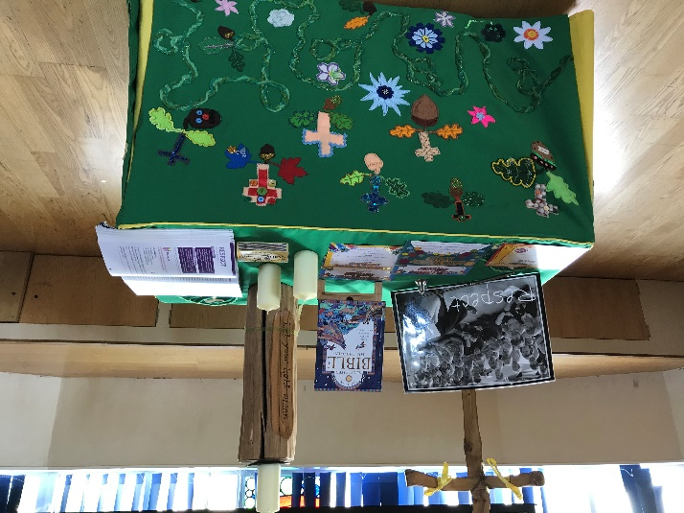

- Classroom worship
Class-based collective worship can provide a more intimate atmosphere and offer more time for individual response. It can be tailored to match the needs, ability and interests of the children in that age group. It is often a good opportunity for children to begin to develop their skills in planning and leading worship.
Think about:
- How can you make the classroom space feel special and different from the lesson before?

- How do you fit class worship into the timetable/school day?

- What resources and displays will support class-based worship?

- What resources/support exist for class teachers in delivering class worship?

- Will you have a class prayer or book of prayers to use?

Advice and guidance can be found at:
http://www.elyeducation.org/main/wp-content/uploads/2016/03/Worshipping-in-Classrooms.pdf
For children in EYFS there is a specific one-year programme that provides children with an introduction to Christian worship and faith. It uses a multi-sensory approach with puppets, simple songs set to well-known nursery rhymes, interactive simple Bible stories. The resources are linked to values.
https://imaginor.co.uk/jack-box-worship

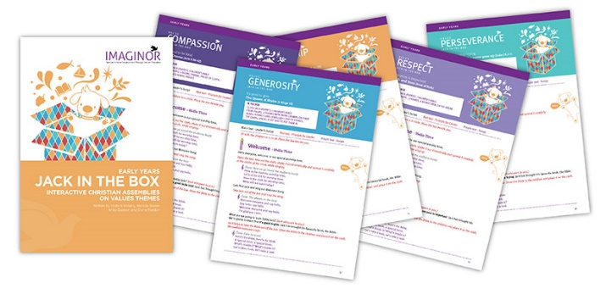

- Outdoor worship

The use of the outdoors for collective worship is a powerful means by which children can learn to appreciate the wonders of God’s creation. Some schools construct their own outdoor spaces/journeys, prayer labyrinths.

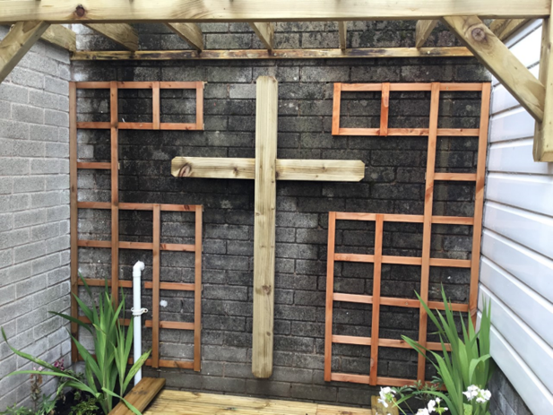

Outdoor Prayer Space at St James’s CE Infant School. Whitehaven
The use of silence in outdoor worship can be particularly powerful and the space can provide a range of activities e.g. the use of the senses to appreciate God’s creation, a time of stillness and peace.
Resources such as Experience Easter Outside provide guidance for outdoor stations to share the Easter story.

https://www.gloucester.anglican.org/2017/experience-easter-resources

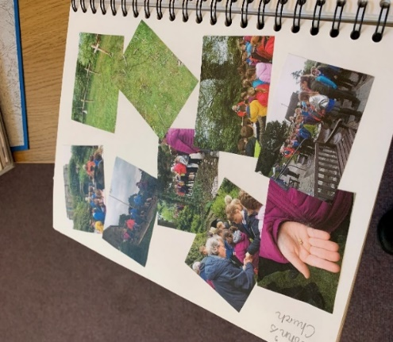
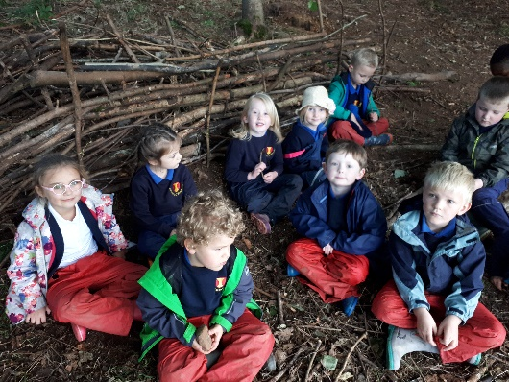
Examples from Levens CE School and Lanercost CE Schools

Carlisle diocese is keen to develop new innovative forms of outdoor worship, part of what is known as Fresh Expressions. This will include the employment of a Pioneer Practitioner Enabler for Outdoors and Education focussing on developing outdoor spirituality through the concept of pilgrimage.
Salisbury diocese have produced a leaflet about how to develop a spiritual garden in school that could be used both for collective worship and quiet reflection.
https://www.salisbury.anglican.org/resources-library/schools1/spirituality/2011%20Spirituality%20in%20Schools-%20Spiritual%20Gardens-%20Information%20Leaflet.pdf
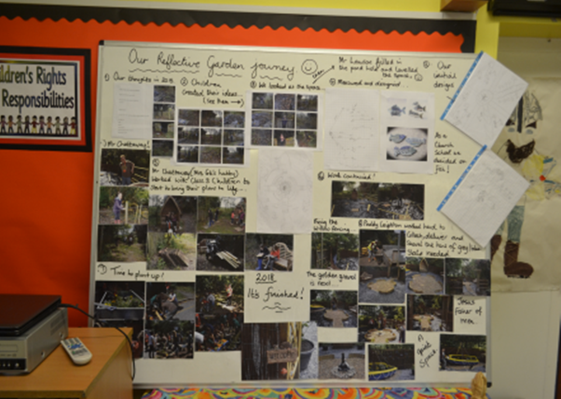
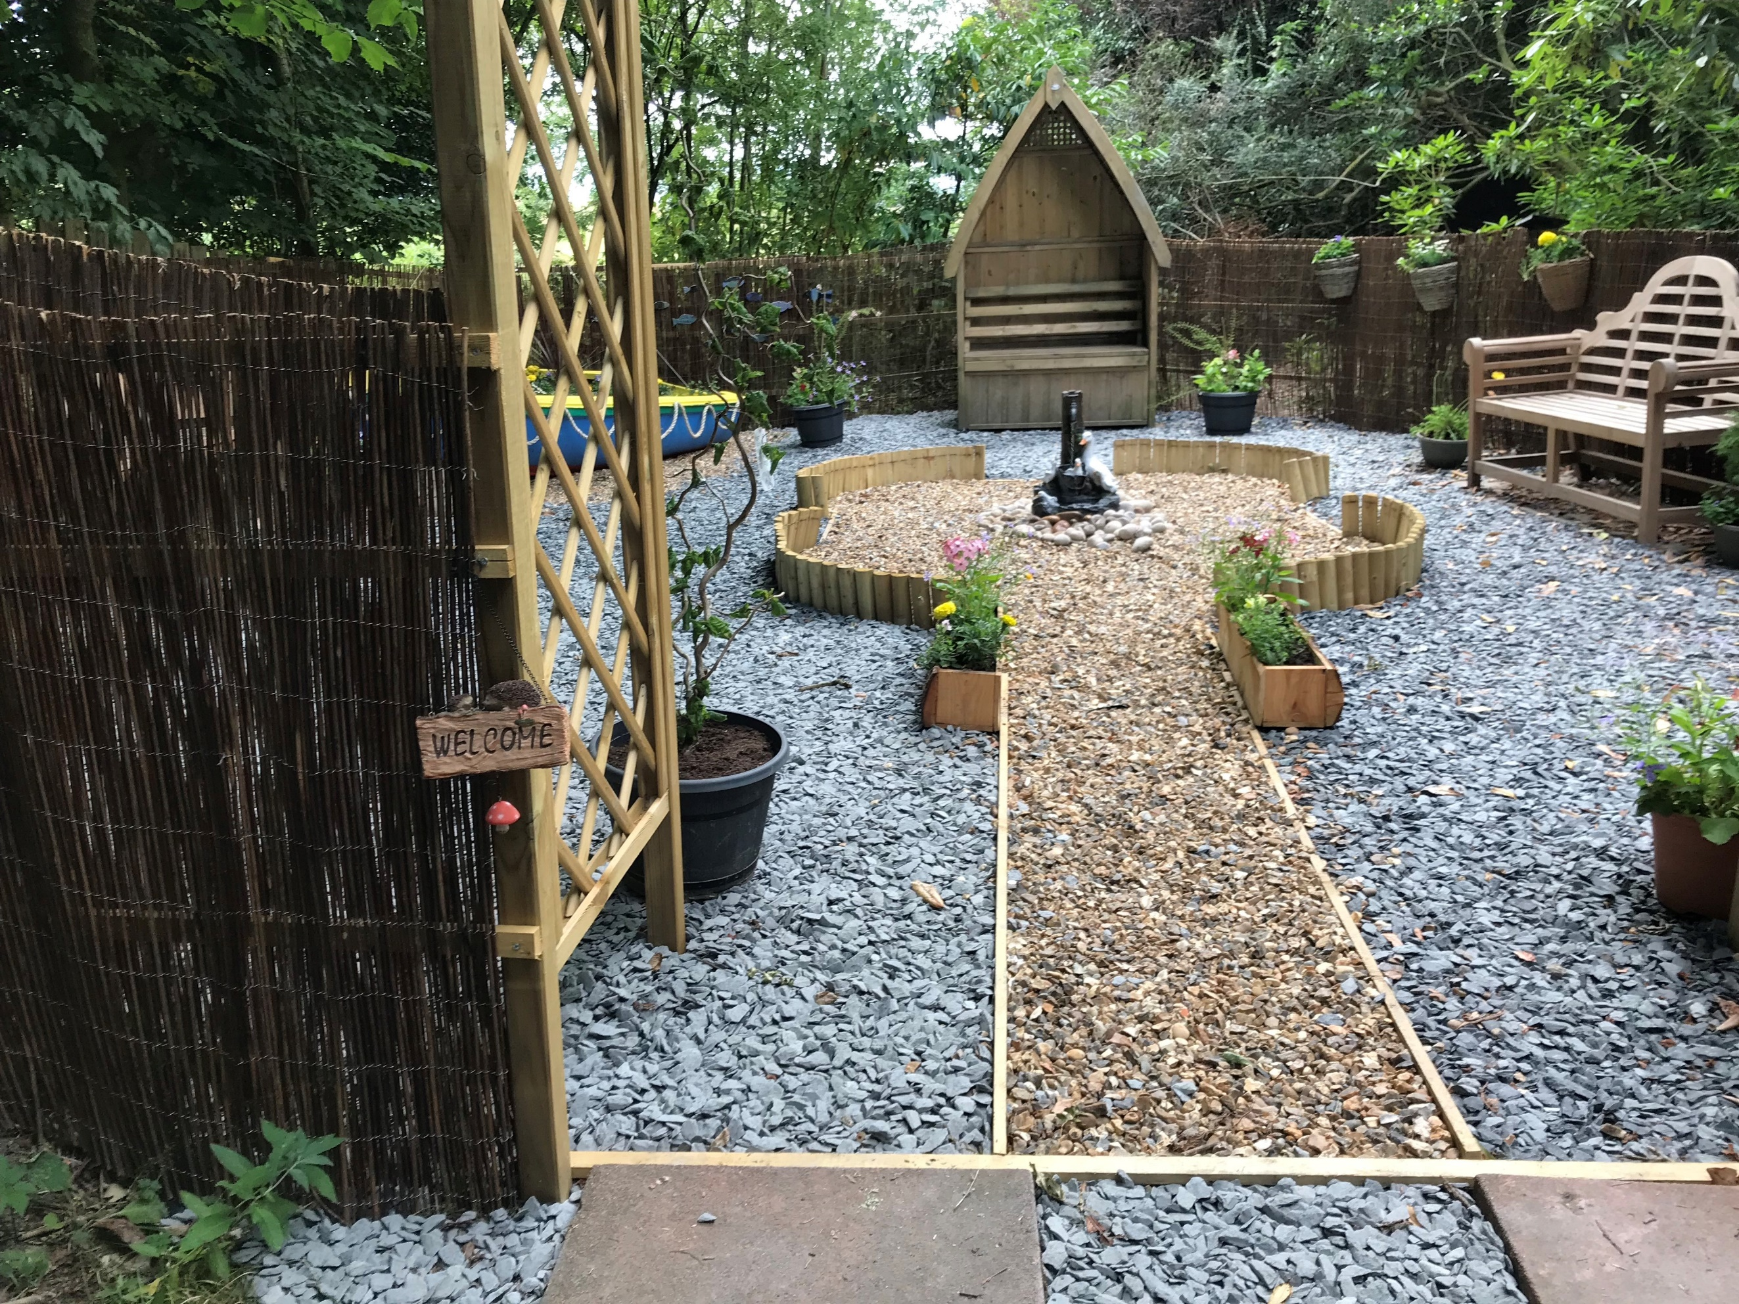

The development of the Spiritual Garden at Broughton in Furness CE School

- The role of clergy in collective worship in a church school

Arrangements for collective worship in a church school are the responsibility of the governors in consultation with the headteacher. However, clergy have a vital role to play as well:

- Making relevant and engaging the rites and practices of the Church of England in the contemporary life of the school

- Through their own personal faith and knowledge inform the worshipping life of the school

- Can contribute to staff development and the planning of worship by exploring different forms of worship e.g Taize, Iona, African worship

- Involve church members and school in joint initiatives such as ‘Experience Christmas’, ‘Experience Easter’ etc. with resources available from
https://www.gloucester.anglican.org/schools/jumping-fish-publications/

Some clergy who feel that they have little experience of working with children and young people find the experience of leading collective worship in school challenging as it is not the same as leading corporate worship in church settings. They may have received little training in leading school collective worship.. The following pointers may help:

  - Theatrical aspects of telling a good story – use of props, children as ‘actors’. Keep it short and to the point - 10 minutes from beginning to end, so focus on one ‘Big Idea’.
  - Use visual stimuli – e.g pictures, powerpoint
  - Use of Christian vocabulary – but be aware that you may need to explain this in clear, straightforward language for the children
  - Try to balance timings, following the usual conventions and habits of the school e.g ways of starting and finishing, verbal cues for prayers, balance of singing/ listening, answering questions
  - Observe an act of collective worship in school before leading it yourself and check how others leading worship speak to the children, keep all children interested and engaged.
  - Ask the children what they think makes good collective worship!

The clergy are in school to work alongside staff, governors, pupil and parents rather than dictating the terms. It is important that clergy consult with the headteacher/worship coordinator in planning collective worship in school. Ideally, staff will be present when clergy are leading worship so that the message is reinforced about this is an important and collective part of the school day and is in partnership with the church.
Mission communities are increasingly important in Cumbria. Different church denominations work together to ensure that the Christian message is clearly heard in every area of the county through the God for All initiative. This can be of great benefit for schools in providing a richness of different Christian traditions, particularly in places where there is either no incumbent or where one vicar serves several parishes. Mission communities should consider how they wish to reach out to schools as part of their action planning and how they resource this work, including supporting collective worship in (all) schools. The Diocesan Board of Education can help mission communities with developing their action plan and training.
There is a good short guide for clergy and other visitors leading collective worship in school:
How to Craft Collective Worship by Tim Elbourne published by Grove Education
(Copies available from the diocesan Education Office)
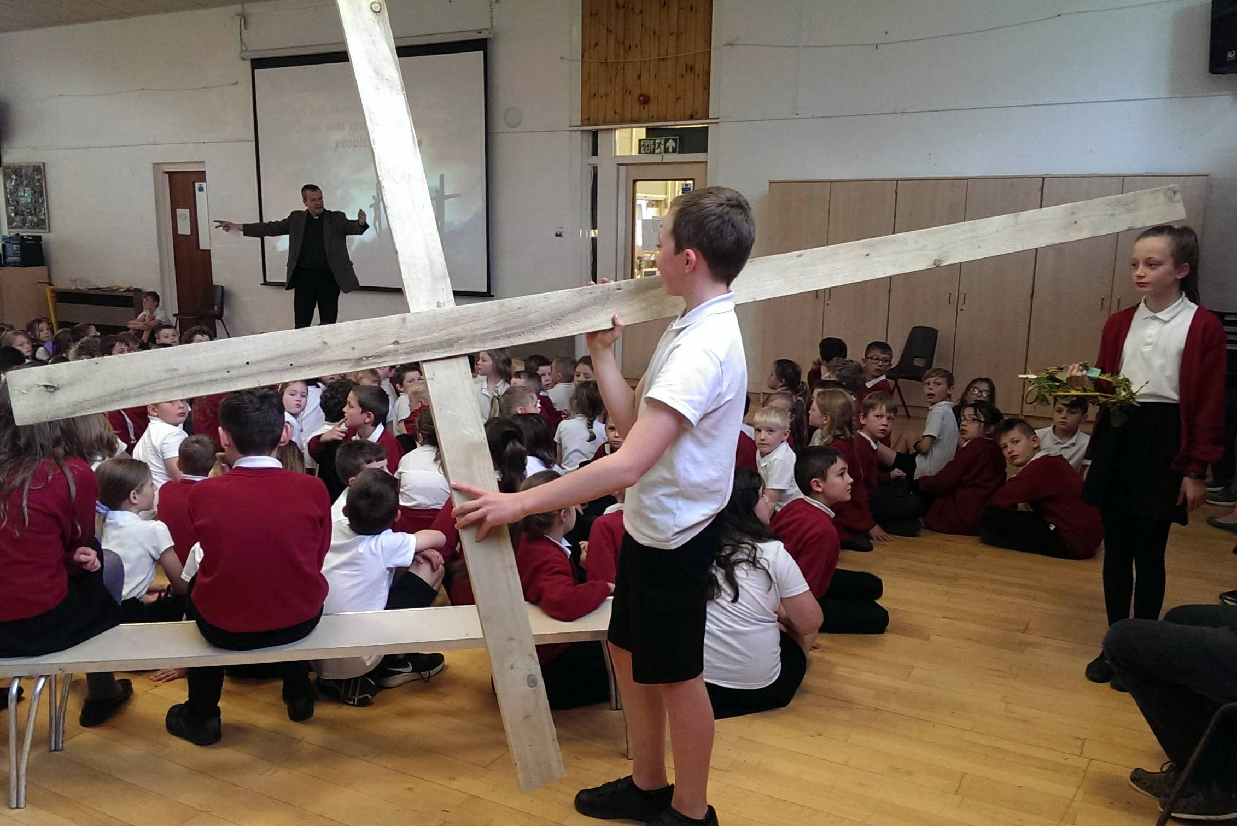
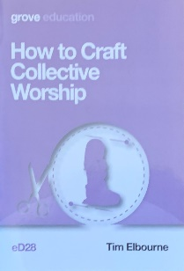

There is also diocesan guidance for schools and visitors leading collective worship in church schools available on the Carlisle diocese website:
https://www.carlislediocese.org.uk/documents/guidance-staff-when-faith-representatives-visit-ce-school/

https://www.carlislediocese.org.uk/documents/guidance-faith-representatives-visiting-schools/
More questions to think about
- How can we engage more with the local mission community and churches about the way they can support the school?

- Are there other clergy/church members in our area that we could ask to lead collective worship in school?

- What opportunities could we include in collective worship to celebrate the world-wide nature of Christian faith e.g. prayers, songs?

- Does our local church have mission partners that we could be involved with as a school?

- Children and young people are often acutely aware of world issues such as caring for the planet, poverty and injustice. How do we incorporate such themes into collective worship, using Christian teaching?

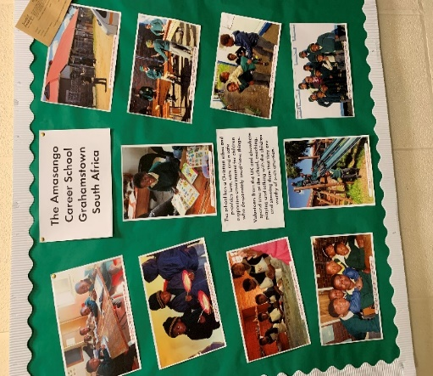

- Observation and evaluation of collective worship
In considering the impact of collective worship in school it is essential that observation and evaluation takes place, in order to inform future planning as well as understanding the difference collective worship makes in school life. Whatever form the self-evaluation takes it should not be too time-consuming.
Likewise, children need to be involved in the evaluation in order to understand the impact that collective worship has on their day to day lives. In some instances, pupils may be asked to reflect on what they have learnt in collective worship. This will help in evaluating children’s understanding of what they have experienced.
It may be as simple as writing their reflections on post its and creating a display of their responses:

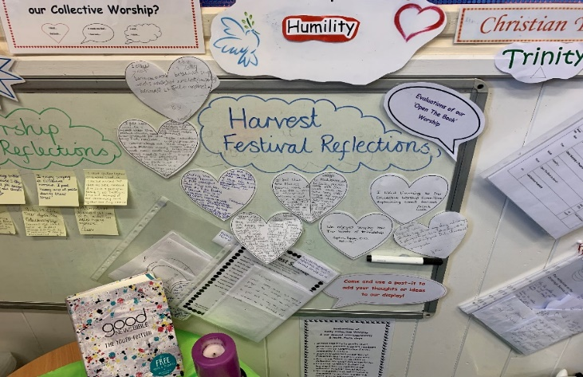

Other schools keep ‘Reflection Books’

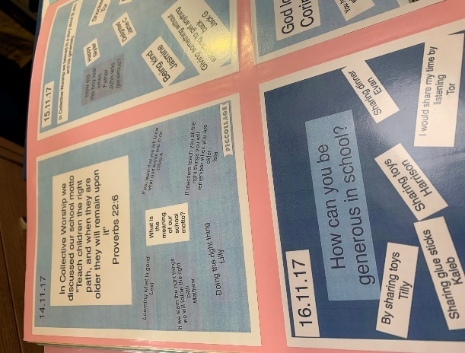

When pupils are planning, leading and evaluating their own worship the following simple structure may be helpful:

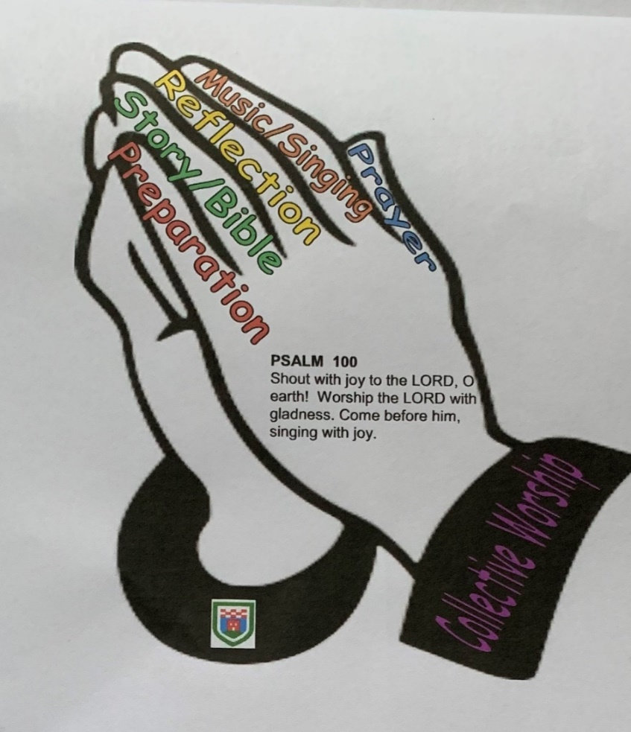
This was devised by Michaela Judd and Esther Ryder from Dalton St Mary’s and provides non -negotiable elements for children need to use when planning and leading worship.

For staff and senior leaders observing collective worship a helpful example is that used by St Mary’s CE School, Kirkby Lonsdale:
Collective worship in Church of England Schools should at its simplest create a time and space where we can come closer to God and God can come closer to us.

 | Criteria | Aspect
Gathering | Music | Is there a real sense of a marking the start of a special time in the day?  Immediate impact, relevant, welcoming, stimulates interest or dull,
 | Welcome
 | Atmosphere
Engaging | Focus | Does the worship leader capture the attention of the children and staff so they become actively engaged in the content.  Is the leader expressive, stimulating?  Is the leader convincing, enthusiastic, warm and creating a rapport?
 | Awe and Wonder
 | Conviction
Responding | Participation | Does the leader allow for a response from the children and adults – whether active or passive, noisy or quiet?
 | Singing
 | Reflection
 | Prayers
Sending | Dismissal | Does the leader send us out with a clear ‘thought for the day’, something that changes behaviour in some way.  Does the leader send the assembled group with a clear summary, reflection on the learning, a reflection on the message.
Content | Distinctly Anglican | Was there a clear Christian/biblical focus?  Did the worship have structure, and Christian focus?  Were all children and staff included?
 | Inclusive
 | Dynamism and Theatricality
 | Open/Closed
 | Age Appropriate

- Reflection Areas
Worship in schools is about facilitating spiritual search, a means to explore faith and above all God’s love for all and his purpose for each individual and the world. Reflection areas can be a good way to express this knowledge and understanding and may include questions and prayer requests. They may be placed in classrooms, central areas inside school…

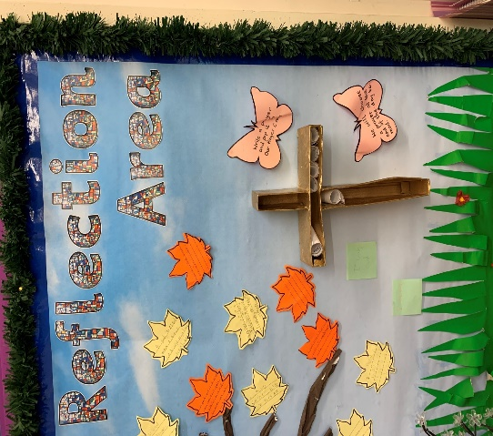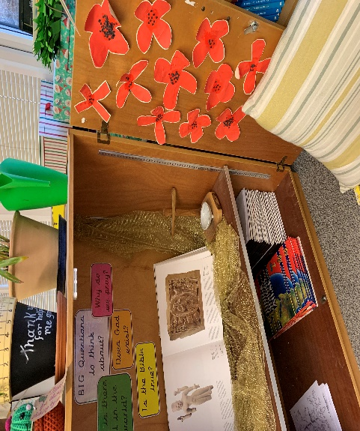

…or outside

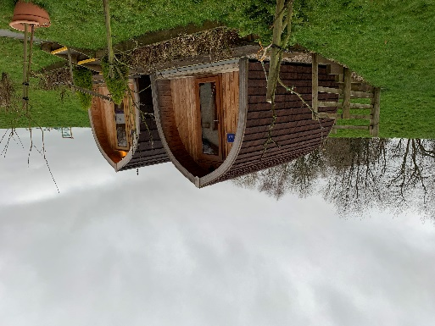

- Resources

In addition to the resources already highlighted in this guidance the following have been found to be useful
Imaginor
Roots and Fruits 1 – Stories in the bible rooted in Christian values
Roots and Fruits 2 – looks at 6 values of Hope, Community, Dignity, Wisdom, Joy and Peace – written with the SIAMS requirements in mind
https://www.imaginor.co.uk/

Flippin Praise
A simple A4 flip-book intended to help children plan acts of worship in relation to a given theme for a day
https://cofesuffolk.org/uploads/FlippinPraiseOrderFormpdf

Open the Book
Over 100 stories to be used in a programme over consecutive years. Each story has a scripted introduction, conclusion, time for reflection and prayer. Volunteer storytellers from local churches use this with schools and bring the Bible to life through drama
https://www.openthebook.net

Prayer spaces in schools
Gives children an opportunity to develop personal reflection and explore prayer in an open, inclusive and safe environment.
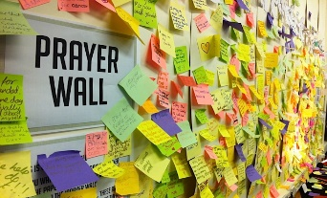
This Photo by Unknown Author is licensed under CC BY-SA-NC
www.prayerspacesinschools.com

Experience Journeys
A series of resources for the main seasons and festivals of the Christian year. There are ideas for interactive stations that can be set up by church members. There are detailed instructions to help school leaders to introduce and reflect on each part of the story. These resources are a good way to strengthen church-school links.
The series contains: Experience Easter, Experience Easter Outside, Experience Pentecost, Experience Harvest, Experience Christmas and Experience Church.
https://www.gloucester.anglican.org/education/jumping-fish-publications/

World-wide Christianity
www.barnabasinschools.org.uk/idea/nativity-sets-around-world
This focusses on a Ugandan and a Filipino Christmas, using nativity sets
www.christianaid.org.uk/schools/school-assemblies
This website has a range of collective worship resources with world-wide themes linked to justice, poverty, peace and harmony

Videos
You Tube has a good range of both songs and video clips about different Bible stories from both the Old and New Testaments
https://www.youtube.com
Alternatively, you can use the following, for a range of stories about the stories Jesus told.
https://www.max7.org

Music
Fischy Music www.fischy.com a good range of songs both for collective worship and PHSE. Also available on You Tube
Out of the Ark www.outoftheark.co.uk has a good range of songs both for collective worship and musical plays

Appendix 1

The Right of Withdrawal from Collective Worship
The Schools Standard and Framework Act 1998 (Section 70 and Schedule 20)

- Parents have a right to withdraw their children from parts or all of collective worship. Parents do not need to give a reason for this.

- A similar right exists for children in the sixth form over the age of 16 years who may exercise this right independently of their parents or carers.

- Where children are withdrawn from worship the school must provide appropriate supervision but currently is not obliged to provide alternative curriculum provision.

- Teachers may also withdraw from collective worship unless their contract is deemed to require attendance of them as part of the requirement to respect the character of the religious foundation of the school.

Appendix 2
Prayers:
A range of traditional prayers that are appropriate for school collective worship include:
The Lord’s Prayer
Our Father in Heaven Hallowed be your name Your kingdom come Your will be done On earth as in heaven Give us today our daily bread And forgive us our sins As we forgive those who sin against us Lead us not into temptation But deliver us from evil For The Kingdom, The Power and The Glory are yours now and forever Amen

From the prayer of Sir Richard of Chichester
Most merciful redeemer
Friend and brother
May I know you more clearly
Love you more dearly
And follow you more dearly
Day by day

The Prayer of St Francis
Lord, make me an instrument of your peace. Where there is hatred – let me sow love Where there is injury – pardon; Where there is doubt – faith; Where there is despair – hope; Where there is darkness – light; Where there is sadness – joy

A prayer attributed to St Patrick
May the strength of God pilot us
May the power of God preserve us
May the wisdom of God instruct us
May the hand of God protect us
May the way of God direct us
May the shield of God defend us
May Christ be with us
Christ before us
Christ before us
The day and evermore

Prayer from the
Iona community
God the Father bless us
God the Son, defend us
God the Spirit, keep us
Now and evermore

Greeting prayer examples at the beginning of worship:
The Lord be with you
And also with you

Father we are here for you
Father we are here
Jesus we are here for you
Jesus we are here
Spirit we are here for you
Spirit we are here

The Lord is here
His Spirit is with us

God is good all the time
All the time God is good

We have gathered in the name of God the Father, Son and Holy Spirit to worship together
(said as the 3 candles are lit)

The peace of God be with you
And also with you

Sending prayer examples:

Blessing suitable for end of year service
May the road rise to meet you
May the wind be always at your back.
May the sun shine warm upon your face.
May the rain fall softly upon your fields.
Until we meet again.
May God hold you in the hollow
of his hand.

A Celtic Blessing
Deep peace of the running wave to you
Deep peace of the flowing air to you
Deep peace of the quiet earth to you
Deep peace of the shining stars to you
Deep peace of the Son of Peace to you

We go into the world to walk in God's light,
to rejoice in God's love
and to reflect God's glory.

Appendix 3

Model Collective Worship Policy

This policy was established, and approved for implementation by the full Governing Body of XXXX CE School
Signed by the Chair of Governors:
Dated:
The name of our Collective Worship Governor is:
This policy is to be next reviewed in:
Our vision for Collective Worship

XXXXX CE School’s Vision Statement
It may include any Bible verses that underpin the vision and/or strapline

Collective worship is central to the life of XXXX CE school. It is part of the outworking of the school’s Christian vision and is a time for the whole school community to gather, pause and reflect their own spirituality, values and place in the world and drawing on the opportunities described by the DfE (circular 1/94).

‘…there is a strong educational case for experience of worship being part of school life, since its omission lessens the possibility of understanding traditions to which worship is essential;’

Church of England Vision for Education 2016

Collective worship is not the same as an assembly, though can take place in the same gathering. A school may hold any number of assemblies each week but must have a daily act of collective worship. Collective worship can be held in class or tutor groups for a shorter period of time.

Aims

Inclusive, Invitational, Inspirational
The aims of collective worship in this school are:

- Collective worship will help educate for wisdom, knowledge and skills, hope and aspiration, dignity and respect as well as developing community and understanding of living well together.
- It aims to be inclusive, invitational and inspirational
- It is central to the life of the school
- It supports pupils and adults in their spiritual growth
- Supports pupils in their understanding of the Trinitarian nature of God in Christian belief
- Introduces pupils to a variety of forms of Christian worship that reflect the rich diversity of experience in Anglican (and other Christian traditions) locally and globally.
- Enables pupils to use the use of silence or stilling, reflection and prayer
- Provides opportunities to explore the ‘Big Questions’ of life and to recognise the responses that have been made to these by people of faith
- Affirms the uniqueness and contribution of every individual in the sight of God

Legal Framework

Since 1944 collective worship has been a legal requirement in maintained schools. The law requires that all registered school age pupils take part in an act of worship each day. In a church school these acts must be distinctively Christian in nature. By inviting the school community to worship, we need to consider the varied backgrounds that the school community come from and therefore collective worship is invitational rather than confessional in nature.

At this school collective worship is conducted in accordance with the Trust Deed and Instrument of Government and is consistent with the beliefs of the Church of England.

Planning, Recording and Evaluation

The content and planning of collective worship should be varied. The themes for each week/half term/term are shared with staff and visiting clergy at the beginning of each term and include ideas for stories from the Bible that support this. However, the pattern is flexible and on occasions, will focus on a response to local or national events.

The school visits the local church for worship, particularly at major festivals in the Christian calendar Harvest, Advent, Christmas, Easter, Ascension, Pentecost (delete as appropriate).
We also use outdoor areas e.g. spiritual garden or reflective space (indicate as appropriate)

Resources

The school uses a variety of resources recommended by Carlisle Diocese that are available to use when planning collective worship. Amongst others, we utilise materials from Carlisle Diocese, The Barnabas Trust, SPCK, Messy Church, Christian Aid and other story/parable-based explorations. including resources from the world-wide church.

Responsibilities

Headteacher (CW lead) – has the delegated responsibility for day to day acts of collective worship:
Identifying and planning themes
Support where required for those leading worship
Identifying training needs
Monitoring and evaluation of collective worship

Foundation Governors – monitor and evaluate the impact of collective worship in our school through governor observations and ensure collective worship is consistent with the trust deed. The governor with collective worship responsibility will report annually to the full governing board and propose any necessary amendments to the School Development Plan, including any need for staff development or training. See Appendix 4.

Leaders of collective worship – plan and deliver acts of worship.

Visitors

We encourage guest leaders of collective worship throughout the year. Some of these may be linked to a specific project or organisation. Please see additional diocesan guidance for religious or faith visitors taking part in collective worship.

https://www.carlislediocese.org.uk/documents/guidance-staff-when-faith-representatives-visit-ce-school/

https://www.carlislediocese.org.uk/documents/guidance-faith-representatives-visiting-schools/

Review

There will be a review every three years of this policy. Its effectiveness will be monitored by the collective worship leader, together with a senior leaders and governors. This will include discussions with other members of staff, observation of teaching and monitoring of children’s work. Evaluation of teaching plans will from part of any review. The outcomes will influence the school development plan.

This guidance takes into account current requirements for collective worship in the new SIAMS schedule from September 2018

Appendix 4
Example questions to ask during monitoring activity for Collective Worship
This is intended to help governors and others to monitor or evaluate the effectiveness of acts of collective worship. The prime concern is to ensure that the governors’ policy on collective worship is being delivered. Monitoring the effectiveness of the worship leader is the headteacher’s responsibility and governors should guard against judging or commenting on this aspect. Governors who are present in worship should participate in the worship fully.
Question | Comments | Action required
Are the children:
- Engaged, interested and responding well
- Actively involved - they took part through drama, roleplaying, readings etc
- Able to take a lead – they made choices that affected the worship
- Enjoying worship
- Moved/made to think
Does the presentation:
- Vary in pace, format and emotional tone – were there lively and quiet times
- Appeal to the senses
- Allow for a variety of learning styles
- Allow for a range of responses
- Include effective use if eye contact, variation in tone and pitch, body language and gesture
- Clearly related to children’s previous learning and experiences
Is the content:
- Relevant to the pupils age interests and ability
- Related to the school curriculum
- Linked to the distinctive Christian Values
- Reflective of Christian traditions and practice
- Inclusive of those of all faiths and none
- Well resourced
Did the leader succeed in:
- Creating an appropriate emotional environment – secure, warm, lively, amusing, challenging or reflective
- Promote spiritual, moral, social and cultural development
- Provide appropriate opportunities for meaningful reflection, not only, but including silence

