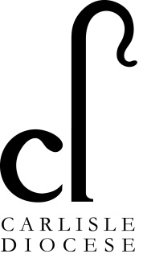
Vulnerable Adults

For the purpose of Church policy and guidance the definition of “vulnerable adult” is contained in the Safeguarding and Clergy Discipline Measure 2016 That defines a ‘‘vulnerable adult’ as a person aged 18 or over whose ability to protect himself or herself from violence, abuse, neglect or exploitation is significantly impaired through physical or mental disability or illness, old age, emotional fragility or distress, or otherwise; and for that purpose, the reference to being impaired is to being temporarily or indefinitely impaired’.
Please note that the Care and Support Statutory Guidance issued under the Care Act 2014 (14.2) by the Department of Health uses the term ‘adults experiencing, or at risk of abuse or neglect’ in order to assess eligibility to statutory social care services.
However, the term ‘vulnerable adult’ is used in the Safeguarding Vulnerable Groups Act 2006 and other legislation in relation to eligibility for criminal record checks and as a result appears in DBS guidance.

