Caring for our Common Home

An Action Plan for Christians in Cumbria

(Prepared by “Cumbria Christians 4 Creation Care”, CC4CC, formerly Churches Together in Cumbria’s Environment Group)

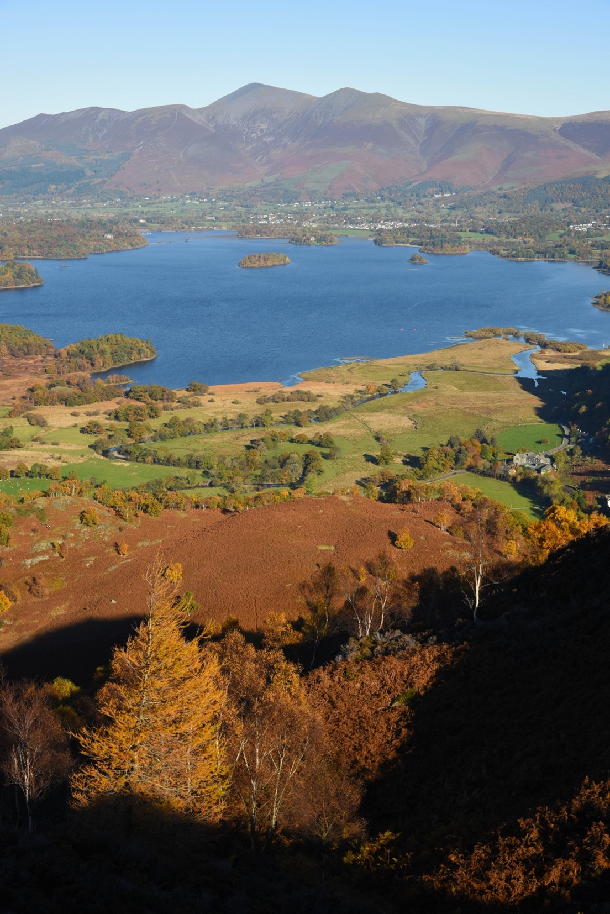
Skiddaw and Derwentwater from King’s How exemplifies a cultural landscape whereby humans and the natural world co-exist.

Executive Summary
Care for creation is central to Christian faith, discipleship and mission. This action plan challenges all Cumbrian churches and chapels, and their members, to take practical steps to reduce their carbon footprint, use their influence to bring about policy change, and be good stewards of God's world. It describes the negative impact that human-induced climate change is already having on our planet, while noting the encouragement and opportunities afforded by the 2015 Paris agreement. There are many ways in which individual Christians and church communities can act to make a difference and demonstrate care for our planet: from changing the lightbulbs to growing bee-friendly flowers, from installing solar panels to joining a car-share scheme, from signing up to Eco Church to switching investments away from fossil fuel funds. A full list of useful resources and further reading is provided at the end

'The earth is the Lord's and everything in it' (Psalm 24:1)
Caring for our environment is not an optional extra for Christians. It is central to our faith and discipleship. Our calling as Christians includes care for the earth, the 'common home' we share with other people and with all living creatures. Such care springs from the Gospel in many ways:
- gratitude to God for creation and for life itself
- awareness of the ways in which we and other living creatures are interdependent and form part of one whole
- recognition that every created thing is precious, to be valued and protected for itself
- acceptance of our human responsibility to be good stewards of God's good creation
- commitment to a fairer and more just future for the world and all its inhabitants
- care and compassion for the poor, the weak and the vulnerable, recognising that it is the poor who suffer first and most from environmental damage.
Christians are called to live and act in a way that brings about God's Kingdom, giving hope and healing to our earth and its people. We should always remember that God did not 'give' us the creation on earth: it remains God's creation. We are part of it and depend on other living things for the essentials of life.
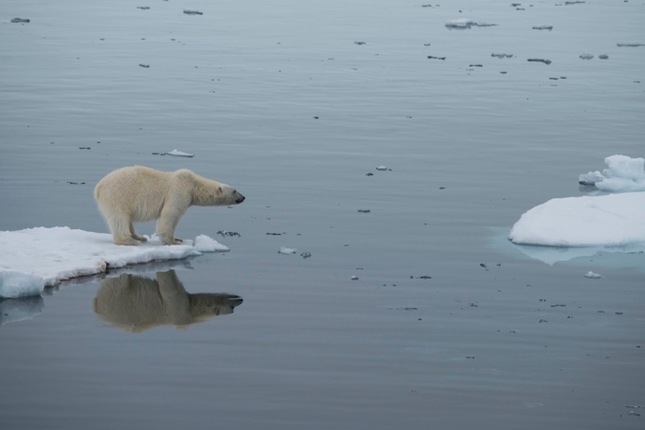
Even regions as remote as the high-Arctic are being affected by human-induced global warming. The polar bear is particularly vulnerable, as it depends on sea ice to hunt seals. The Arctic sea ice is rapidly diminishing as a consequence of warming, which is double the global average.
In Jesus Christ, we see God's overwhelming love for our world. In Jesus, God's Word became flesh, blessing our earth with divine presence. In Christ, God has reconciled the world to God's self. God's saving purpose is not just for the human individual, but for the whole of creation. But through God's redeeming love in Jesus, we have special responsibilities laid upon us.
A vital element of twenty-first century Christian faith, discipleship and mission should therefore be engagement with the big question of sustainable living. We must put our faith into action by loving our neighbours, among whom we must count all life on this planet. We must show that the Gospel is good news, not just for ourselves but for the whole of God's creation on earth. We must live in a way that is a blessing for all people and for the planet.
We need to see our care for creation as an integral part of loving our neighbours and following Christ faithfully.
The fifth 'Mark of Mission', developed by the Anglican Consultative Council since 1984 and subsequently adopted by many churches and denominations, states this goal:
'To strive to safeguard the integrity of creation, and sustain and renew the life of the earth'
This ACTION PLAN challenges all Cumbrian churches and chapels, and their members, to take practical steps to reduce their carbon footprint, use their influence to bring about policy change, and be good stewards of God's world.

The challenge of our time
The surface of the earth has been transformed by human action. No part of the earth's surface is immune from our activity. The living diversity of our planet is being eroded. The rate of extinction is now hundreds, if not thousands, times greater than before the dominance of the human species. If present trends continue, up to 25% of the world’s species will become extinct within the next few decades.
Climate change is the underlying environmental threat facing the earth, its people and the life with which we share our common home. Action to save particular species is futile if the habitat on which they depend is destroyed. Climate change is already having a massive impact on our planet and its living systems.
Global warming is largely down to human activity. Burning fossil fuels has increased the concentration of carbon dioxide in our atmosphere by 40% since pre-industrial times. This extra carbon dioxide is making our world warmer.
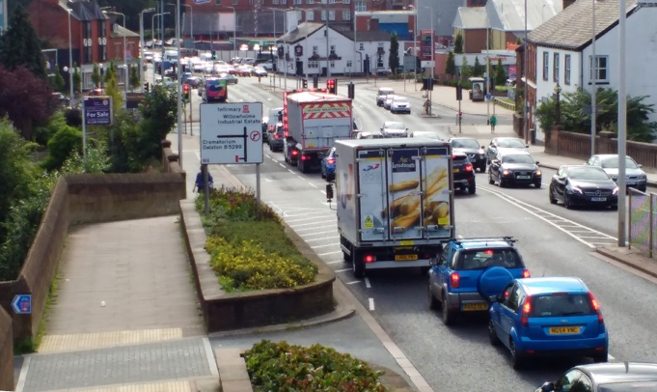
Traffic congestion in Carlisle
The effects of increasing carbon dioxide levels on climate are not controversial: 97% of active climate scientists are convinced that human-induced climate change is upon us.
Already, the earth is over 1°C warmer than in pre-industrial times. In 2016, 12 of the warmest years on record had occurred in the previous 16 years. Scientists and politicians have agreed that a temperature rise of 1.5°C is the maximum level to moderate the most catastrophic effects of rising temperatures. We are rapidly approaching that level of warming.
The target 1.5°C maximum temperature rise is a global average. Some places will see larger temperature increases. The polar regions will warm by much more than 1.5°C, resulting in melting sea ice, glaciers and permafrost, contributing to rising sea levels. The distribution and intensity of weather systems will change, leading to drought in some places and flooding in others.

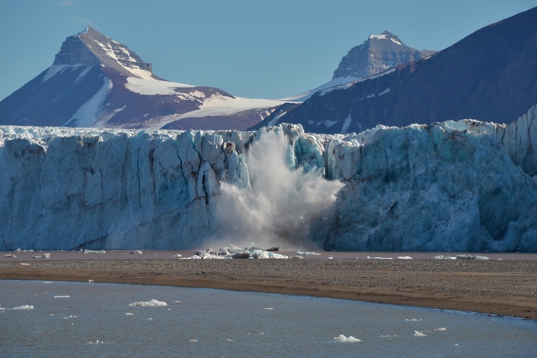
A calving glacier in Svalbard: glacier recession in the polar regions is contributing to sea-level rise at an accelerating rate
Places where agriculture is currently marginal could become deserts. Patterns of agriculture across the globe will change. Diseases and pests which have been confined to the tropics will spread into more temperate places.
Rising sea levels mean that low lying coastal regions will be increasingly prone to flooding. Much of the world’s population lives on coastal plains. For example, around 50% of the country of Bangladesh is less than 5m above sea level.
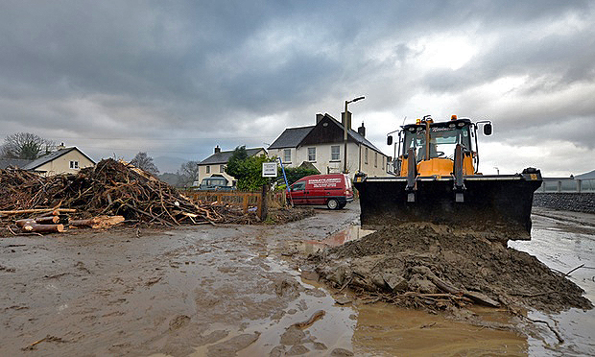
Extreme weather events, such as Storm Desmond in December 2015, are predicted by the Met Office to become more common. In Keswick, a massive clear-up operation was necessary to remove debris from flooded roads and homes.
Carbon dioxide makes water more acidic when it dissolves. Our oceans are becoming more acidic. This affects much sea life. We are already recording the death of many coral reefs as oceans warm and become more acidic.
There is no 'magic bullet' which will solve the climate change problem painlessly. In the UK, approximately one-third of our carbon dioxide emissions are due to industry, one-third comes from transport and one-third results from heating, lighting and supplying power to domestic and commercial premises. Controlling our emissions needs drastic action on all these fronts.
The encouraging news is that the overwhelming majority of the world community has now signed up to the international agreement adopted in Paris in 2015.

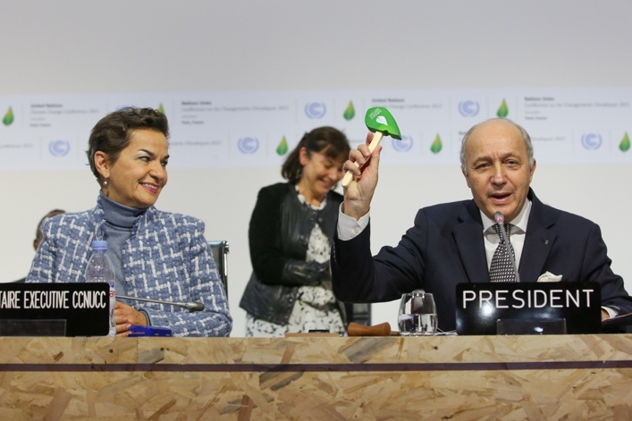
The Paris Agreement, signed by 195 countries, was a major step forward in tackling climate change (Source: climateoutreach.org).
This agreement is now in force. The world community has also agreed to phase out industrial chemicals that are even more potent greenhouse gases than carbon dioxide. But these measures will take time to take effect. We will all need to see a major change in our energy mix if we are to eliminate fossil fuel usage by 2050 as is vital in order to meet the 1.5ºC target.

What can I do to make a difference and care for God's creation?
Although it is easy to feel powerless in the face of the big challenges, there are many things that individual Christians can do to demonstrate their love for their neighbours and for the whole of creation.
'Take your everyday, ordinary life - your sleeping, eating, going-to-work and walking-around life - and place it before God as an offering.' (Romans 12:1-2, The Message)
Here are some suggested starting points:

Pray
- Include environmental issues and care for creation as a regular part of your prayers.
- Go for a 'prayer walk' around your local community and into some nearby beautiful place.
- Take time to enjoy and appreciate the wonder of God's good creation.
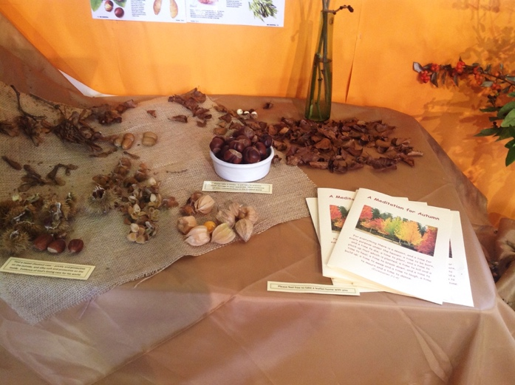
Autumn prayer station at Levens Church. As old leaves fall away, autumn signals spring with new leaf buds, and the production of seeds in summer, ready for the next growing season, all an indication of God's continuing love and care for his creation.

Be better informed
- Sign up to receive newsletters/ bulletins/briefings from Christian organ-isations that engage with environment issues, such as Christian Aid, CAFOD, Tearfund, Green Christian, Operation Noah, A Rocha (see the links at the end of this document).
- Find out if there is a 'Transition' group in your area - join in!
- Sign up to Cumbria Action for Sustainability.

Make lifestyle changes
- Think about what you eat: try to eat more local and seasonal food, eat less meat, use leftovers and cut down on food waste.
- Prepare meals from scratch instead of using ready meals.
- Teach children how to cook.
- Grow some of your own food.
- Buy less stuff, such as clothes, electrical goods, household items. Purchase new only when necessary.
- 'Reduce, Reuse, Recycle' and make good use of freecycle schemes for exchanging unwanted goods.
- Remember to take a basket or bag when you go shopping!

Reduce energy use in the home
- Change to low energy lighting.
- Turn off lights in empty rooms.
- Switch off appliances when not in use and avoid leaving them on standby.
- Improve thermal insulation, with lined curtains, draught excluders and secondary double glazing. Draw the curtains in the evening during colder months.
- Turn the heating thermostat down a degree or two and wear a jumper.
- Purchase electricity from a 100% renewables supplier.
- Consider installing solar panels to generate electricity.
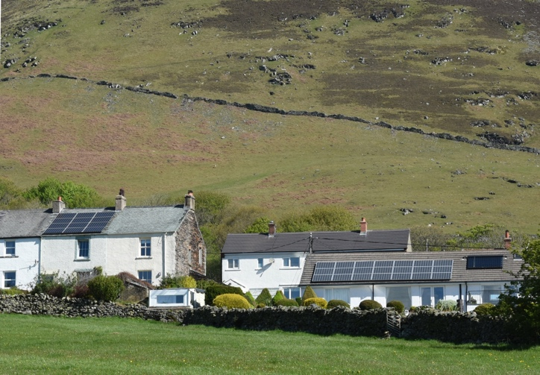
Installing solar roof panels on house roofs is one of many ways we can benefit the environment, and save money at the same time.

Reduce your travel carbon footprint
- Walk, cycle or take public transport, rather than hopping in the car.
- If you have to use the car, can you car-share?
- When buying a car, opt for a fuel-efficient model.
- Drive in a more environmentally friendly manner - stick to the speed limit, and be a smoother driver with less aggressive acceleration and braking.

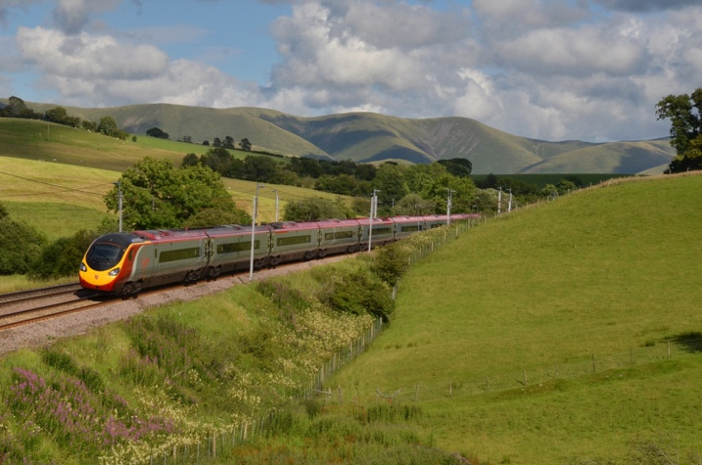
Using rail services rather than driving long distances is a good way of reducing our carbon footprint. Here a Glasgow-London train speeds past the Howgill Fells on the West Coast Mainline.
- Travel less - is that meeting/visit/shopping trip essential? Combine several tasks in one trip.
- Reduce or eliminate air travel. Take holidays in the UK, or explore Europe by train.
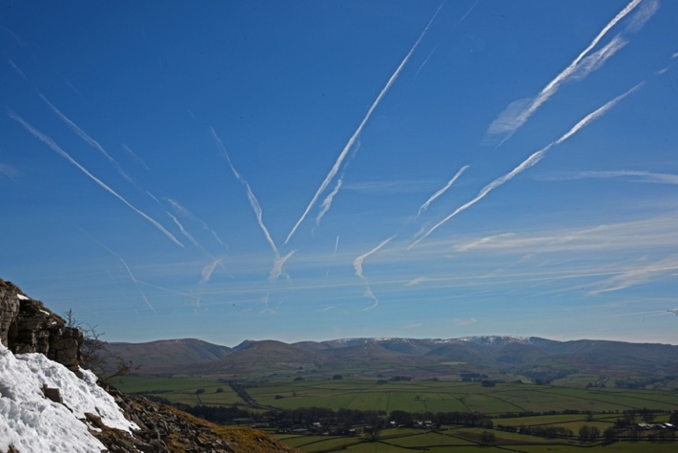
Air travel has one of the largest carbon footprints of all transport options. These contrails over the Howgill Fells, viewed from Great Asby Scar, show the intensity of air travel in the UK, and how they affect the clarity of the atmosphere.

Make space for nature.
- Create ‘wild space’ in your garden. Provide access for wild creatures such as hedgehogs.
- Cultivate butterfly-friendly and pollinator-friendly flowers.
- Support local conservation bodies.
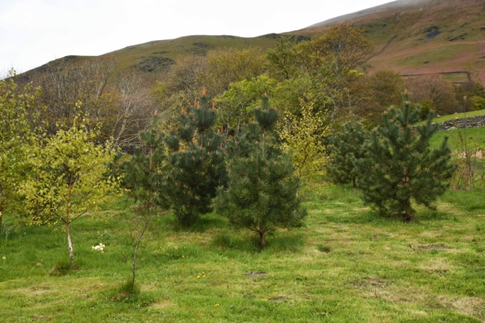
Tree-planting is a good way not only of providing a home for nature, but also is a mechanism that draws carbon dioxide out of the atmosphere, helping reduce the impact of global warming.

Put your money where your faith is
- Think about how you spend your money. Do you really need that new item? Can you choose a greener version? Can you borrow or share, instead of buying?
- Find out about 'green' and/or ethical savings and investment.
- If possible, move funds out of fossil fuel investments.
- Find out where your pension fund invests. How green are its credentials?

Influence others and campaign for a better world
- Start an eco-group or 'Green Team' at your local church.
- Persuade your church to register with Eco Church.
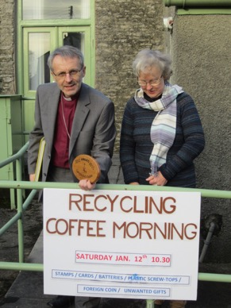
Presentation of St John’s Church, Levens, first Eco-Congregation award by Bishop Robert – with Reverend Canon Ruth Crossley.
- Sign up to climate change campaigns.
- Join with other Christians in your local area, to raise awareness and to campaign.
- Write to your MP with your concerns and hopes, pressing for strong UK support for international environmental action.
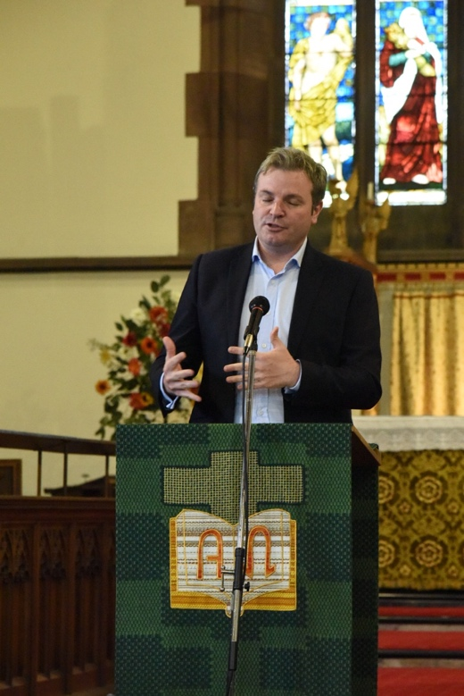
Engaging with politicians is an important way in influencing debate about environmental issues. Former Copeland MP, Jamie Reed, talks to a Climate Change event at St John’s Church in Keswick during Climate Action Week, October

What about my church?
A church is much more than a building; it is the gathered people of God in a community. Buildings are important as symbols of God’s kingdom on earth, but more important still are God's people as they grow in their discipleship and share in God's Mission. Our churches are called to care for the environment in four key ways:
- Prophetic: reminding people of their responsibility for our world and warning them of the consequences if these responsibilities are neglected.
- Pastoral: turning that prophetic message into practical action, by caring for the local and global environment and setting good examples that can be followed more widely.
- Healing: working to mend the damage done to their local environment, for example by turning their church grounds into havens for wildlife.
- Holiness: developing their church buildings and grounds as holy places, sacred spaces, where members and visitors can encounter the peace and grace of God.
We commend all churches to sign up to the Eco Church scheme. This is a progressive programme of awards for environmental awareness and action, starting at a very basic level and working up to more ambitious targets. A similar programme for Catholic communities is called Live Simply.
Think of ways in which your church community could strengthen its environmental action in the following areas:

Greening your church community
- Green your worship: make sure the environment features regularly in your prayers.
- Green your teaching: does preaching and teaching cover responsibilities towards creation as well as towards other people?
- Celebrate 'Creation Time' (1 September - 4 October) as a regular part of your church’s year.
- Encourage practical action. Help church members to share their ideas and experiences.
- Minimise carbon emitting transport: organise car-share schemes, and plan gatherings and meetings to reduce 'meeting miles'.
- Help church members to make care for the environment part of their daily lives, using the ideas set out above.

Greening your church buildings
- Audit your carbon emission sources (heating, lighting, electricity consumption etc). Identify your major sources of carbon emissions, and those most easily reduced. A number of easy-to-use carbon emission calculators are available on the web.
- Switch your electricity supplier to a 100% renewables supplier.
- Improve the insulation of your building.
- Consider installing solar panels to offset your electricity consumption.
- When your heating system needs renewal or upgrading, seek low carbon alternatives.
- Explore ground or air source heat pumps.
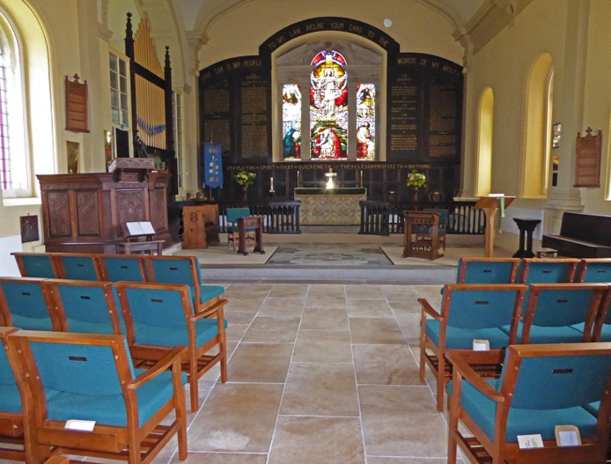
St Anne’s Church, Ings near Staveley, is an inspiring example of how an 18th century stone building can become much more energy efficient and comfortable, opening up the possibilities of greater community use. Here, an air-source heat pump and underfloor heating, together with double glazing have been installed.
- Remember that it is more effective and much cheaper to keep people feeling warm than to try and heat the entire building. Consider using under-pew heating or heated cushions on pews or chairs instead of switching the heating on.
- Switch to low energy light bulbs if you have not already done so. LED bulbs give instant bright light at a fraction of the energy consumed by traditional light bulbs.
- If you floodlight your building at night, reduce the hours. Better still, stop altogether.
- If your church has grounds or a churchyard, think about how you could manage them to make them environmentally friendly and an asset to the local community. Encourage wildlife and native flora. Allow trees to grow in appropriate locations, soaking up carbon dioxide, as well as making a pleasant ambience. Also avoid disturbing the soil of gardened areas in order to retain soil structure and therefore its carbon sequestration potential.
- Critically examine how your church financial reserves are invested. Question investment in environmentally damaging activities.

Influencing the wider church
Many churches belong to wider groupings on a county-wide or even national scale. Use your church’s influence to help others to become more environmentally aware. A few suggestions:
- Through your local Churches Together group, join with other churches in your area to raise awareness of environment issues, encourage engagement, and organise events.
- If you have a county or national governing body, ask them formally to adopt and endorse this environmental policy document.
- Lobby for governing bodies to disinvest from environmentally damaging activities.
- The national churches have an influence and profile beyond the reach of local congregations. Use the governance and representation schemes of your church to prod your national body to issue policy statements and comments on environmental matters.

Resources, links and further reading

Christianity and the environment
Sharing God's Planet, A Report from the Mission and Public Affairs Council of the Church of England (Church House Publishing 2005)
Planet Wise: Dare to Care for God's World, Dave Bookless (Inter-Varsity Press 2008)
Laudato Si' (Pope Francis's 2016 encyclical on the environment and climate change, downloadable from CAFOD website www.cafod.org.uk)
The John Ray Initiative (connecting environment, science and Christianity) http://www.jri.org.uk

Christian organisations (resources and campaigns)

Christian Aid www.christianaid.org.uk/climate
A Rocha (a Christian charity working for the protection and restoration of the natural world) http://arocha.org.uk
CAFOD (Catholic international development charity) www.cafod.org.uk One Climate, One World campaign
Operation Noah (Faith-motivated, Science-informed, Hope-inspired) www.operationnoah.org
Green Christian (a community of Christians seeking to live in accordance with ecological values) www.greenchristian.org.uk
Tearfund (Christian relief and development agency) www.tearfund.org

Campaigning for fossil free churches: http://brightnow.org.uk
Churches Together in Britain and Ireland (resources for Creation Time) https://ctbi.org.uk/category/spirituality-and-reflection/creation-time/
Forest Church (a fresh expression of church that encourages participation with nature) http://www.mysticchrist.co.uk/forest_church

Practical ideas

Eco Church www.ecochurch.arocha.org.uk

Live Simply awards: http://cafod.org.uk/Campaign/How-to-campaign/Livesimply-award

Church buildings http://www.churchcare.co.uk/shrinking-the-footprint

Churchyards http://www.caringforgodsacre.org.uk

Ethical savings and investments: https://www.triodos.co.uk/en/personal/

Ethical shopping: http://www.ethicalconsumer.org
Calculating your carbon footprint: http://www.carbonfootprint.com/calculator1.html or http://footprint.wwf.org.uk
How Bad are Bananas: the carbon footprint of everything, Mike Berners-Lee (Profile Books 2010)
Garden wildlife: https://www.rspb.org.uk or https://www.rhs.org.uk/science/conservation-biodiversity/wildlife/encourage-wildlife-to-your-garden/plants-for-pollinators

Climate Change
Introductory Climate Science: Global Warming Explained, Terry Sloan (2016, downloadable free from bookboon.com)
2071 The World We'll Leave our Grandchildren, Chris Rapley and Duncan Macmillan (John Murray 2015)

Sustainable living
Ecology Begins at Home, Archie Duncanson (Green Books 2007)
'Caring for the Earth: A Strategy for Sustainable Living' (IUCN, UNEP and WWF 1992)

'Transition' movement: www.transitionnetwork.org

Cumbria Action for Sustainability: cafs.org.uk

Find a local freecycle group at https://www.freecycle.org/browse/UK

Contacts
Pam Martin (pammartin47@gmail.com): our local representative of Eco Church in Cumbria, is happy to visit churches to help and encourage folk to join this scheme.
Revd Professor Ian N. James: Chair, “Cumbria Christians 4 Creation Care” dr.i.n.james@btinternet.com

